**I NDEX**

|  |  |  |  |
| --- | --- | --- | --- |
| **S. No.** | **Problem Description** | **Date of Execution** | **Sign.** |
| AP1 | **Explore the basic java program development scenario in Notepad++ and cmd by creating an Integer Adder. The adder prints sum of 5 integer numbers without using single variable where input will be taken through command line arguments.**   1. **Perform the above code using a function and call it in main().**      1. **Make another class and a function in it to perform the above task.** | 14/12/2021 |  |
| AP 2 | **Develop a Number Reciprocator java application to compute the sum of the reciprocals without using a single variable in the format:**  **1/1 + 1/2 + 1/3 + ... + 1/10** | 14/12/2021 |  |
| AP3 | **:- Demonstrate type conversion in a simple java program by casting and checking output in the following cases:-**   1. **Conversion of int to byte**      1. **Conversion of double to int**      1. **Conversion of double to byte**      1. **Conversion of int to char**      1. **Conversion of float to short** | 14/12/2021 |  |
| AP4 | **Construct a character counter that inputs a piece of text that is analyzed character by character to determine the vowels, spaces and letters used. Fill in the code that computes the number of spaces, vowels, and consonants.** | 14/12/2021 |  |
| AP5 | **Construct a number generator to accept three digits (i.e. 0 - 9) and print all its possible combinations. (For example if the three digits are 1, 2, 3 than all possible combinations are: 123, 132,213, 231, 312, 321.)** | 14/12/2021 |  |
| AP6 | **A java standalone application makes use of a parameterized method inside a class. Take the following case: Create a class Box and define a method in this class which will return the volume of the box. Initialize two objects for your class and print out the volumes respectively.** | 14/12/2021 |  |
| AP7  AP8 | **A java standalone application reads in a sentence from the user and prints it out with each word reversed, but with the words and punctuation in the original order.**  **Develop an employee pay generator that works on the following rules-**     1. **An employee gets paid (hours worked) × (base pay), for each hour up to 40 hours.** 2. **For every hour over 40, they get overtime = (base pay) × 1.5.**      1. **The base pay must not be less than the minimum wage ($8.00 an hour).**      1. **If it is, print an error. If the number of hours is greater than 60, print an error message.** | 14/12/2021  15/12/2021 |  |
| AP9 | **A Financial Calculator to calculate the SimpleInterest and CompoundInterest by taking command line values for principal, rate and time.**   1. **Extend the code to calculate ‘Final Value’ of investment (V) of an investment (principal P) compounded yearly for T years at interest rate R is given by the formula: V = P (1 + R)T** 2. **Perform the above code using a function and call it in main().**     **Make another class and a function in it to perform the above task.** | 15/12/2021 |  |
| AA1 | **A Gravity Calculator in java to compute the position of an object after falling for 10 seconds, outputting the position in meters.** | 15/12/2021 |  |
| AA2 | **A java application 'MyNumber.java" that performs following operations on a variable 'num' of type double. Code to include the following functionality:**   1. **Finds the round value of 'num' and stores the result in a variable numRound of type double.** 2. **Finds the ceil value of 'num' and stores the result in a variable numCeil of type double.** 3. **Finds the floor value of 'num' and stores the result in a variable numFloor of type double**   **Cast 'num' to type int and stores the result in a variable numInteger of type int.** | 15/12/2021 |  |
| PQ 5 | **Create an array to hold certain integer elements entered by the user. Search for a given element desired by the user in this array using Linear Search?** | 24/12/2021 |  |
| BP 1 | **A group of BVICAM friends decide to run the Airtel Delhi Half Marathon. Find the fastest runner. Print the name and his/her time (in minutes).** **Optional: Find the second fastest runner. Print the name and his/her time (in minutes).** | 24/12/2021 |  |
| BP 2 | **Create a class named DuplicateFinder which initializes an array of at least 15 elements. Define appropriate methods to print its elements and calculate duplicate elements if any. It should detail the number of duplicates along with their frequency of occurrence.** | 24/12/2021 |  |
| BP3 | **Define a class named VowelFilter which contains a static method named filterVowel(). This method receives a character array as argument and returns another array which contains only the non-vowel characters of the argument array.** | 24/12/2021 |  |
| BP4 | **Create a class named GradeExam to grade a multiple choice test. There are 20 students and 10 questions in the test. Each row records a student’s answers to the questions, as shown in the following array: Grade the students according to their score in the test?** | 27/12/2021 |  |
| BP5 | **In a GPS navigation system, Given a set of points, the closest-pair problem is to find the two points that are nearest to each other.** | 27/12/2021 |  |
| BP6 | **Develop a command line driven code to accept the following city name as argument in the command line and sort them in alphabetic order – City Name = Kolkata, Chennai, Mumbai, Delhi, Bangalore, Ahmedabad.** | 28/12/2021 |  |
| BP7 | **Create a Waffle Class having two data members flavor and price, being populated by a parameterized constructor. Create another class WaffleMain to compare the values and object context of Waffle class data members by equals() and ==. Extend the implementation to get desired results by overriding**  **a) equals()**  **b) toString()** | 28/12/2021 |  |
| BP8 | **Create a POC(Proof of Concept) to demonstrate usage of various functions of String Class like:- a) charAt()**  **b) length()**  **c) contains()**  **d) equals and ==**  **e) indexOf()**  **f) split()**  **g) toUpperCase()** | 31/12/2021 |  |
| BP9 | **array to provide the output given below (Take row count from user).**  **1**  **123**  **1234**  **12345**  **123456**  **1234567**  **1**  **12**  **123**  **1234**  **12345**  **123456**  **1234567** | 31/12/2021 |  |
| BA1 | **Create a stack to maintain plates in a birthday party. Ask the organizer how many plates do they want initially. Maintain track of each plate used and number of plates added. Finally print the number of total number of plates in the stack, plates used and number of plates left in the stack** | 5/1/2022 |  |
| PQ9 | **Create a class ToStringDemo that uses the toString method to convert a double number entered by the user to a String. Use appropriate methods to count the number of digits before and after the decimal point in the input number?** | 5/1/2022 |  |
| PQ10 | **Create a class called FileName to isolate the different parts of a FileName taken as an input from the user** | 5/1/2022 |  |
| PQ11 | **Create appropriate classes to reverse a palindrome using String class and StringBuilder. Try to compute which solution computes faster?** | 5/1/2022 |  |
| CP1 | **Design a class called DecipherCaesarCode to decipher the Caesar's code. The program shall prompts user for a ciphertext string consisting of mix-case letters only; compute the plaintext; and print the plaintext in uppercase. Design the solution with appropriate methods?** | 5/1/2022 |  |
| CP2 | **A word that reads the same backward as forward is called a palindrome, e.g., "mom", "dad", "racecar", "madam", and "Radar" (case-insensitive). Create a class called TestPalindromicWord, that prompts user for a word and**  **prints ""xxx" is|is not a palindrome".** | 5/1/2022 |  |
| CP3 | **A java based program which prompts user for the number of students in a class (a non-negative integer), and saves it in an int variable called numStudents. It then prompts user for the grade of each of the students (integer between 0 to 100) and saves them in an int array called grades. The program shall then compute and print the average (in double rounded to 2 decimal places) and minimum/maximum (in int).** | 8/1/2022 |  |
| CP4 | **Demonstrate the working of a Static Inner Class through a class Electronics and within it create Static Inner Class Television that has a method cost() which displays cost of television object passed in constructor of Television class. Demonstrate invoking inner class method with outer object when the method cost() is once a :-**  **a) Instance(Non static) method**  **b) Static method** | 8/1/2022 |  |
| CP5 | **Simulate a simple banking application. Provide for classes BankAccount. Account will be of two type- Savings and Current. There should be methods to open an account, close an account and perform withdraw, deposit and transfer operations on an account as abstract methods in Account and properly overridden with definition in Account Types. Test classes should instantiate Account Type Classes and provide a menu driven option for operations.** | 8/1/2022 |  |
| PQ12 | **Create a package hierarchy p1 and p2 and solve the Jagged array question in it?** | 9/1/2022 |  |
| CP6 | **Create a package called animals,let this package contain an interface called Animal that generalizes the eat and travel task of any animal. Implement the given interface in the same package animals and override the methods appropriately?** | 9/1/2022 |  |
| CP7 | **Create a package personpackage. This package contains a class Person with data members to represent firstName and lastName of a person and appropriate methods to read and display the same. Define appropriate class to test the above class outside the above package?** | 9/1/2022 |  |
| PQ | **Intoduction to ArrayList class** | 14/1/2022 |  |
| PQ13 | **Create a solution to sort movies on the basis of their year of release?** | 14/1/2022 |  |
| PQ14 | **Write a solution to sort movies by their rating and name?** | 14/1/2022 |  |
| CP8 | **Create an Array of Student class objects.**  **a) Sort them by roll number using Comparable Interface.**  **b) Perform sort based on alphabetic first name numbering using Comparator** | 14/1/2022 |  |
| CP9 | **Create an interface Relatable that compares the size of objects.Any class can implement Relatable if there is some way to compare the relative "size" of objects instantiated from the class. For strings, it could be number of characters; for books, it could be number of pages; for students, it could be weight; and so forth. For planar geometric objects, area would be a good choice while volume would work for three-dimensional geometric objects. All such classes can implement the isLargerThan() method. Create appropriate implementations.** | 14/1/2022 |  |
| CP10 | **Create an interface GeoAnalyzer with a constant PI and methods area() and perimeter(). Let Circle, Ellipse and rectangle implement this class. Define a class Geometry that assigns appropriate objects to GeoAnalyzer reference variable.** | 15/1/2022 |  |
| PQ16 | **Demonstrate use of try with multiple catch blocks?** | 20/1/2022 |  |
| PQ17 | **Write code to demonstrate try-catch and finally block?** | 20/1/2022 |  |
| PQ18 | **User Defined Exception Class** | 21/1/2022 |  |
| PQ19 | **Chained Exception Handling** | 21/1/2022 |  |
| PQ20 | **Rehtrowing an Exception** | 21/1/2022 |  |
| DP1 | **Extend your Gravity Calculator code (Assignment AA1) to handle exceptions through a try-catch finally block. Handle provision for a divide by zero scenarios caught by NumberFormatException. Explicitly invoke this exception in execution and observe the response.** | 21/1/2022 |  |
| DP2 | **Further extend your menu-driven Simple Calculator code (Assignment 2) by adding support a Custom Exception code that raises an ‘Invalid Numeral’ exception each time the user tries to enter any character except a number for calculation. Explicitly invoke this exception in execution and observe the response.** | 22/1/2022 |  |
| DP3 | **Create a class StudentRegistrationCheck that checks eligibility of a student for registration. If the student age<12 and marks<200 then the student is not eligible for registration. Design appropriate solution using exception handling?** | 22/1/2022 |  |
| DP4 | **An ExceptionPOC class is requesting a number between 1 and 10. Run the program again and enter 5.5. Although this number is between 1 and 10, the program will abort. Examine the error message. You should see the word Exception, the method where the exception occurred (main), the class name of the exception (InputMismatchException), as well as the call stack listing the method calls.**  **Add a try/catch block to catch and handle the InputMismatchException exception. Identify the statements that cause the error as well as the portions of the program that depend upon these statements. Enclose these statements within the try block. Follow the try block with the catch block given below. Note, the InputMismatchException class is defined in java.util and must be imported. Also, when the Scanner throws an InputMismatchException, the input token will remain in the buffer so that it can be examined by the program. Complete code by implementing the same using:-**  **a) Throws method declaration**  **b) Throw keyword** | 23/1/2022 |  |
| DP5 | **Extend CP5 (Bank application)with appropriate exception handling?** | 23/1/2022 |  |
| DP6 | **Create an Exception class InvalidProductException that can be thrown if a user adds an invalid product.** | 23/1/2022 |  |
| PQ21 | **Create three threads using the class Thread and then running them concurrently?** | 24/1/2022 |  |
| PQ22 | **Creating three threads using the Runnable interface and then running them concurrently.** | 24/1/2022 |  |
| PQ23 | **Retrieve id of currently executing thread?** | 24/1/2022 |  |
| PQ24 | **Use of yield(), stop() and sleep() methods** | 25/1/2022 |  |
| PQ25 | **Use of suspend() and resume() methods** | 25/1/2022 |  |
| PQ26 | **Setting priority to threads** | 25/1/2022 |  |
| PQ27 | **Joining of the threads** | 26/1/2022 |  |
| DP7 | **The application should print out “Mares do eat oats.” Is it guaranteed to always do this? If not, why not? Would it help to change the  parameters of the two invocations of Sleep? How would you guarantee that all changes to the message will be visible in the main thread?** | 27/1/2022 |  |
| DP8 | **Implement the producer consumer problem using multithreading in java. In computing, the producer–consumer problem (also known as the bounded- buffer problem) is a classic example of a multi-process synchronization problem. The problem describes two processes, the producer and the consumer, which share a common, fixed-size buffer used as a queue.**  **a) The producer’s job is to generate data, put it into the buffer, and start again.**  **b) At the same time, the consumer is consuming the data (i.e. removing it from the buffer), one piece at a time.**  **To make sure that the producer won’t try to add data into the buffer if it’s full and that the consumer won’t try to remove data from an empty buffer.** | 27/1/2022 |  |
| DP9 | **Create a Java application that executes concurrent transactions in a bank?** | 28/1/2022 |  |
| DP10 | **Create a list of numbers and then sort in ascending order as well as in descending order simultaneously.** | 28/1/2022 |  |
| PQ28 | **Create an ArrayList of CoffeeTypes and add elements to it, also sort the list using different mechanisms?** | 5/2/2022 |  |
| PQ29 | **The utility class java.util.Arrays and java.util.Collections provide many static method for the various algorithms such as sorting and searching. Use the Arrays.sort() and Collections.sort() methods to sort an array of Strings and a List of Integers, based on their Comparable<T>'s compareTo() method.** | 5/2/2022 |  |
| PQ30 | **write a Book class, and create a Set of Book objects.** | 5/2/2022 |  |
| PQ31 | **Demonstration of HashMap.** | 5/2/2022 |  |
| PQ32 | **Java program to demonstrate the working of ArrayList and LinkedList** | 5/2/2022 |  |
| EP1 | **Model Person with name and age.Manage instances of Person by ensuring that no two instances are duplicated?** | 652/2022 |  |
| EP2 | **Create a subclass of Person (in EP1 above), called ComparablePerson which implements Comparable<Person> interface, and try out the Collections.sort() and Collections.binarySearch() methods on the same.** | 5/2/2022 |  |
| EP3 | **Model AddressBookEntry that prints name,address and phone of a person. Allow comparison of AddressBookEntry to compare name in a case sensitive manner?** | 5/2/2022 |  |
| EP4 | **Counts the frequency of each of the words in a file given in the command-line,and save in a map of {word, freq}.** | 5/2/2022 |  |
|  |  |  |  |
|  |  |  |  |
|  |  |  |  |
|  |  |  |  |
|  |  |  |  |
|  |  |  |  |
|  |  |  |  |

# AP1 : - Explore the basic java program development scenario in Notepad++ and cmd by creating an Integer Adder. The adder prints sum of 5 integer numbers without using single variable where input will be taken through command line arguments.

# Perform the above code using a function and call it in main().

# 

# Make another class and a function in it to perform the above task.

# Solution:-

# class commandLine

# {

# void addition(int a , int b, int c, int d, int e)

# {

# int sum=a+b+c+d+e;

# System.out.println("Sum of 5 numbers is= "+ sum);

# }

# 

# }

# public class main

# {

# public static void main(String args[])

# {

# commandLine obj= new commandLine();

# 

# 

# obj.addition(Integer.parseInt(args[0]),Integer.parseInt(args[1]),Integer.parseInt(args[2]),Integer.parseInt(args[3]),Integer.parseInt(args[4]));

# }

# }

# OUTPUT :-

# 

# AP2:- Develop a Number Reciprocator java application to compute the sum of the reciprocals without using a single variable in the format:

# 1/1 + 1/2 + 1/3 + ... + 1/10

# Solution:-

# class series

# {

# public static void main(String args[])

# { float sum=0,x;

# System.out.println("Series is...");

# for(int i=0;i<9;i++)

# {

# System.out.print("1/" + args[i] + " + " );

# }

# System.out.println("1/"+args[9]);

# 

# for(int i=0;i<10;i++)

# { x=1/Float.parseFloat(args[i]);

# sum=sum+x;

# }

# System.out.println("Sum of the series is= "+ sum);

# }

# }

# Output:-

# 

# AP3 :- Demonstrate type conversion in a simple java program by casting and checking output in the following cases:-

# Conversion of int to byte

# 

# Conversion of double to int

# 

# Conversion of double to byte

# 

# Conversion of int to char

# 

# Conversion of float to short

# Solution:-

# class conversion

# {

# public static void main(String args[])

# {

# int a= 3;

# double b= 3.0;

# float c= 4;

# byte d=(byte)a;

# int e=(int)b;

# byte f=(byte)b;

# char g=(char)a;

# short h=(short)c;

# System.out.println("Conversion of int to byte = "+ d);

# System.out.println("Conversion of double to int = "+ e);

# System.out.println("Conversion of double to byte = "+ f);

# System.out.println("Conversion of int to char = "+ g);

# System.out.println("Conversion of float to short = "+ h);

# 

# 

# }

# }

# OUTPUT:-

# 

# AP4:- Construct a character counter that inputs a piece of text that is analyzed character by character to determine the vowels, spaces and letters used. Fill in the code that computes the number of spaces, vowels, and consonants.

# SOLUTION:-

# public class count

# {

# public static void main(String args[])

# {

# String text = "To be or not to be, that is the question;"+"Whether this nobler in the mind to suffer"+" the slings and arrows of outrageous fortune,"+" or to take arms against a sea of troubles,"+" and by opposing end them?";

# text=text.toLowerCase();

# int len=text.length();

# int v=0,c=0,s=0;

# for(int i=0;i<len;i++)

# {

# if(text.charAt(i)=='a' || text.charAt(i)=='e' ||text.charAt(i)=='i' ||text.charAt(i)=='o' || text.charAt(i)=='u' )

# v++;

# if(text.charAt(i)==' ')

# s++;

# }

# c=len-(v+s);

# System.out.println("Length of the text= "+ len);

# System.out.println("Total number of vowels are= "+ v);

# System.out.println("Total number of consonants are= "+ c);

# System.out.println("Total number of spaces are= "+ s);

# 

# }

# }

# 

# OUTPUT

# 

# AP5:-

# Construct a number generator to accept three digits (i.e. 0 - 9) and print all its possible combinations. (For example if the three digits are 1, 2, 3 than all possible combinations are: 123, 132,213, 231, 312, 321.)

# SOLUTION :-

# import java.util.Scanner;

# class generator

# {

# public static void main(String[] args)

# {

# int i,j,k,n;

# int[] num= new int[3];

# Scanner scan=new Scanner(System.in);

# System.out.print("Enter 3 digits(0-9)= ");

# 

# for(n=0;n<3;n++)

# {

# num[n]=scan.nextInt();

# }

# scan.close();

# for(i=0;i<3;i++)

# { for(j=0;j<3;j++)

# {

# for(k=0;k<3;k++)

# {

# if(i==j || i==k || j==k)

# {

# continue;

# }

# System.out.println(num[i]+" "+num[j]+" "+num[k]);

# }

# }

# 

# }

# }

# }

# OUTPUT:-

# 

# AP6:-

# A java standalone application makes use of a parameterized method inside a class. Take the following case: Create a class Box and define a method in this class which will return the volume of the box. Initialize two objects for your class and print out the volumes respectively.

# SOLUTION:-

# import java.util.Scanner;

# class box

# { float volume(float len, float br , float ht)

# {

# float vol;

# vol=len*br*ht;

# return vol;

# 

# }

# public static void main(String args[])

# { box box1= new box();

# box box2= new box();

# float l1 , b1, h1, l2, b2, h2 , vol1, vol2;

# Scanner scan=new Scanner(System.in);

# System.out.print("Enter the length , breadth, height of first box in meter= ");

# l1 = scan.nextInt(); b1 = scan.nextInt(); h1 = scan.nextInt();

# 

# System.out.print("Enter the length , breadth, height of second box in meter= ");

# l2 = scan.nextInt(); b2 = scan.nextInt(); h2 = scan.nextInt();

# 

# vol1=box1.volume(l1,b1,h1);

# vol2=box2.volume(l2,b2,h2);

# 

# System.out.println("Volume of the first box is = "+vol1+" meter cube ");

# System.out.println("Volume of the second box is = "+vol2+" meter cube");

# }

# }

# OUTPUT:-

# 

# AP7:-

# A java standalone application reads in a sentence from the user and prints it out with each word reversed, but with the words and punctuation in the original order.

# SOLUTION:-

# import java.util.Scanner;

# class reverse

# { public static String reverseWord(String str)

# { String[] words =str.split(" ");

# String revStr="";

# for(int i=0;i<words.length;i++)

# {

# String word =words[i];

# String revWord="";

# for(int j=word.length()-1; j>=0; j--)

# {

# revWord= revWord + word.charAt(j);

# }

# revStr= revStr + revWord + " ";

# }

# return revStr;

# }

# public static void main(String [] args)

# { String str;

# Scanner s= new Scanner(System.in);

# System.out.print("Enter the string to be reversed= ");

# str= s.nextLine();

# s.close();

# String reversed= reverseWord(str);

# System.out.println("The original string is = "+str);

# System.out.println("The reversed string is = "+reversed);

# 

# }

# 

# 

# }

# OUTPUT :-

# 

# AP 8:-

# Develop an employee pay generator that works on the following rules-

# 

# An employee gets paid (hours worked) × (base pay), for each hour up to 40 hours.

# For every hour over 40, they get overtime = (base pay) × 1.5.

# 

# The base pay must not be less than the minimum wage ($8.00 an hour).

# 

# If it is, print an error. If the number of hours is greater than 60, print an error message.

# SOLUTION:-

# import java.util.Scanner;

# class employee

# {

# void salary(int hours , int basePay)

# {

# int overTime;

# double salary;

# if(hours <= 40)

# {

# salary= hours * basePay;

# }

# 

# else

# {

# overTime = hours - 40;

# salary = (40*basePay) + (overTime * basePay * 1.5);

# }

# 

# System.out.print("Salary is = "+salary);

# }

# 

# public static void main(String [] args)

# { int hours, basePay ;

# employee e= new employee();

# Scanner s= new Scanner(System.in);

# System.out.print("Enter the base pay in dollars=");

# basePay= s.nextInt();

# if(basePay < 8)

# {

# System.out.print("Base pay can not be less than $8.00...");

# }

# else

# {

# System.out.print("Enter total hours worked= ");

# hours = s.nextInt();

# if(hours > 60)

# {

# System.out.print("Total hours can not be greater than 60...");

# }

# 

# else

# {

# e.salary(hours , basePay);

# }

# 

# }

# 

# }

# }

# OUTPUT:-

# 

# 

# AP 9:- A Financial Calculator to calculate the SimpleInterest and CompoundInterest by taking command line values for principal, rate and time.

# Extend the code to calculate ‘Final Value’ of investment (V) of an investment (principal P) compounded yearly for T years at interest rate R is given by the formula: V = P (1 + R)T

# Perform the above code using a function and call it in main().

# 

# Make another class and a function in it to perform the above task.

# SOLUTION :-

# import java.lang.Math;

# class interest

# {

# void Interest(double p,double r, double t)

# {

# double si = (p*r*t)/100;

# double amt= p* Math.pow(1+ r/100,t);

# double ci= amt - p;

# System.out.println("Simple interest = "+ si);

# System.out.println("Compound interest = "+ ci);

# System.out.println("Amount after compound interest = "+amt);

# 

# }

# }

# class AP9

# {

# public static void main(String args[])

# {

# double p= Long.parseLong(args[0]);

# double r= Integer.parseInt(args[1]);

# double t= Integer.parseInt(args[2]);

# interest i= new interest();

# i.Interest(p,r,t);

# }

# 

# }

# Output:-

# 

# AA-1 :- A Gravity Calculator in java to compute the position of an object after falling for 10 seconds, outputting the position in meters. The formula in Math notation is:

# x(t) = 0.5 × at 2 + vit + xi

# 

# Variable Meaning Value

# a ,Acceleration (m/s 2)         -9.81

# t ,Time (s) 10

# 

# vi , Initial velocity (m/s)            0

# xi , Initial position 0

# Soln:-

# import java.util.Scanner;

# class AA1

# {

# public static void main(String args[])

# {

# double g = 9.8 ;

# double t;

# double x , xi , vi;

# Scanner s=new Scanner(System.in);

# System.out.println("Enter the initial velocity(m/s)= ");

# vi= s.nextDouble();

# System.out.println("Enter the initial position(m)= ");

# xi= s.nextDouble();

# System.out.println("Enter the time in( secs)= ");;

# t= s.nextDouble();

# x=vi*t + 0.5*g*t*t + xi;

# 

# System.out.println("Position of the object after "+ t +"secs= "+x);

# 

# 

# }

# }

# OUTPUT:-

# 

# AA2:- A java application 'MyNumber.java" that performs following operations on a variable 'num' of type double. Code to include the following functionality:

# Finds the round value of 'num' and stores the result in a variable numRound of type double.

# Finds the ceil value of 'num' and stores the result in a variable numCeil of type double.

# Finds the floor value of 'num' and stores the result in a variable numFloor of type double .

# Cast 'num' to type int and stores the result in a variable numInteger of type int.

# Soln:-

# import java.util.Scanner;

# import java.lang.Math;

# class AA2

# {

# public static void main(String args[])

# { double num;

# Scanner s= new Scanner(System.in);

# System.out.print("Enter the number to be worked upon = ");

# num=s.nextDouble();

# double numRound, numCeil , numFloor;

# int numInteger;

# numRound = Math.round(num);

# numCeil= Math.ceil(num);

# numFloor= Math.floor(num);

# numInteger= (int)num;

# System.out.println("Number after rounding it off = " + numRound);

# System.out.println("Number after performing ceil operation = " + numCeil);

# System.out.println("Number after performing floor operation = " + numFloor);

# System.out.println("Number after type casting it into int = " + numInteger);

# 

# 

# }

# }

# OUTPUT:-

# 

PQ5:- **Create an array to hold certain integer elements entered by the user. Search for a given element desired by the user in this array using Linear Search?**

# Soln:-

# import java.lang.String;

# import java.util.Scanner;

# class PQ5

# {

# public static void main(String args[])

# { Scanner s= new Scanner(System.in);

# int arr[]=new int[7];

# int num;

# System.out.print("Enter the elements of the arrray= ");

# 

# for(int i=0;i<arr.length;i++)

# {

# arr[i]=s.nextInt();

# }

# System.out.print("Enter the element to be searched for= ");

# num=s.nextInt();

# for(int i =0 ; i< arr.length ; i++)

# {

# if(arr[i]==num)

# {

# System.out.print("Element found at "+(i+1) + " th place");

# break;

# }

# 

# }

# 

# }

# }

# OUTPUT:-

# 

# 

# BP1- A group of BVICAM friends decide to run the Airtel Delhi Half Marathon. Find the fastest runner. Print the name and his/her time (in minutes).

# Optional: Find the second fastest runner. Print the name and his/her time (in minutes)

# Soln:-

# class BP1

# { int times[]={341,273,278,329,445,402,388,275,243,334,412};

# String names[]={"Elena","Thomas","Hamilton","Suzie","phil","Matt","Alex","Emma","John","James","Jane"};

# public static void main(String args[])

# {

# BP1 obj= new BP1();

# int fPlace=obj.times[0] , sPlace=obj.times[0],len;

# len= obj.times.length;

# String fName=obj.names[0] , sName=obj.names[0];

# for(int i=1;i<len;i++)

# {

# if(fPlace > obj.times[i] )

# {

# fPlace=obj.times[i];

# fName=obj.names[i];

# }

# 

# }

# System.out.println("Fastest runner is " + fName + " ,Completed the marathon in "+ fPlace + " mins");

# 

# for(int i=1;i<len;i++)

# {

# if(sPlace > obj.times[i] && obj.times[i]!=fPlace)

# {

# sPlace=obj.times[i];

# sName=obj.names[i];

# }

# 

# }

# System.out.println("Second Fastest runner is " + sName + " ,Completed the marathon in "+ sPlace + " mins");

# }

# }

# OUTPUT:-

# 

# BP2:- Create a class named DuplicateFinder which initializes an array of at least 15 elements. Define appropriate methods to print its elements and calculate duplicate elements if any. It should detail the number of duplicates along with their frequency of occurrence.

# Soln:-

# import java.util.Scanner;

# class duplicateFinder

# { int arr[]= new int[15];

# void input()

# { Scanner s=new Scanner(System.in);

# System.out.println("Enter 15 elements...");

# for(int i=0;i<15; i++)

# {

# arr[i]=s.nextInt();

# }

# }

# 

# void duplicate()

# { int num,count;

# int [] fr = new int [arr.length]; //fr will store frequencies of elements

# int visited = -1;

# for(int i=0;i<arr.length; i++)

# { count=1;

# for(int j=i+1;j<arr.length;j++)

# {

# if(arr[i]==arr[j])

# {

# count++;

# fr[j]= visited; // to avoid counting same element again

# }

# }

# if(fr[i]!= visited)

# fr[i]=count;

# }

# 

# System.out.println("-------------------------------------");

# System.out.println("Element | Frequency");

# System.out.println("-------------------------------------");

# for(int i=0 ;i<fr.length;i++)

# {

# if(fr[i]!=visited)

# System.out.println(" "+ arr[i] + " | " + fr[i]);

# }

# System.out.println("-------------------------------------");

# }

# 

# 

# 

# }

# 

# 

# class BP2

# {

# public static void main(String args[])

# {

# duplicateFinder dp=new duplicateFinder();

# dp.input();

# dp.duplicate();

# }

# }

# 

# OUTPUT:-

# 

**BP 3 :- Define a class named VowelFilter which contains a static method named filterVowel(). This method receives a character array as argument and returns another array which contains only the non-vowel characters of the argument array.**

# SOLN:-

# import java.util.Scanner;

# class BP3

# { static int count;

# static char[] filterVowel(char[] str)

# { int j=0;

# char[] str1=new char[str.length];

# for(int i=0;i<str.length;i++)

# {

# if(str[i]=='a' || str[i]=='e' || str[i]=='i' || str[i]=='o' || str[i]=='u' || str[i]=='A' || str[i]=='E' || str[i]=='I' || str[i]=='O' || str[i]=='U' )

# continue;

# else

# {

# str1[j]=str[i];

# j++;

# }

# }

# count=j;

# return str1;

# }

# 

# public static void main(String[] args)

# { char[] str= new char[10];

# char[] ans= new char[10];

# Scanner s = new Scanner(System.in);

# System.out.print("Enter the elements of array = ");

# for(int i=0 ; i<10; i++)

# {

# str[i]=s.next().charAt(0);

# }

# s.close();

# ans= filterVowel(str);

# BP3 obj=new BP3();

# System.out.println("Altered array is...");

# for (int i=0; i< obj.count;i++)

# System.out.print(ans[i]);

# 

# }

# 

# }

# OUTPUT:-

# 

# BP4:- Create a class named GradeExam to grade a multiple choice test. There are 20 students and 10 questions in the test. Each row records a student’s answers to the questions, as shown in the following array: Grade the students according to their score in the test?

# Soln:-

# import java.util.Scanner;

# class BP4

# {

# public static void main(String[] args)

# {

# char[][] answers= {

# {'A' , 'B' , 'C' , 'C', 'C' , 'D', 'A' , 'E' , 'A' , 'D'},

# {'D' , 'B' , 'D' , 'C', 'C' , 'D', 'A' , 'E' , 'A' , 'D'},

# {'D' , 'B' , 'D' , 'E', 'C' , 'A', 'A' , 'E' , 'A' , 'D'},

# {'D' , 'B' , 'D' , 'C', 'C' , 'D', 'A' , 'E' , 'A' , 'D'},

# {'D' , 'D' , 'D' , 'C', 'C' , 'D', 'A' , 'E' , 'A' , 'D'},

# {'D' , 'B' , 'D' , 'C', 'C' , 'D', 'A' , 'E' , 'A' , 'D'},

# {'D' , 'B' , 'D' , 'E', 'C' , 'D', 'A' , 'E' , 'A' , 'D'},

# {'D' , 'B' , 'D' , 'C', 'C' , 'D', 'A' , 'E' , 'A' , 'D'},

# {'D' , 'B' , 'D' , 'C', 'C' , 'D', 'A' , 'E' , 'A' , 'D'},

# {'D' , 'B' , 'C' , 'C', 'C' , 'D', 'A' , 'E' , 'A' , 'D'},

# {'D' , 'A' , 'D' , 'C', 'C' , 'E', 'A' , 'E' , 'A' , 'D'},

# {'D' , 'B' , 'D' , 'C', 'C' , 'D', 'A' , 'E' , 'A' , 'D'},

# {'D' , 'B' , 'D' , 'C', 'C' , 'D', 'A' , 'E' , 'A' , 'D'},

# {'D' , 'B' , 'D' , 'C', 'C' , 'D', 'A' , 'E' , 'A' , 'D'},

# {'D' , 'B' , 'D' , 'C', 'A' , 'D', 'A' , 'E' , 'A' , 'D'},

# {'D' , 'B' , 'D' , 'C', 'C' , 'D', 'A' , 'E' , 'A' , 'D'},

# {'D' , 'B' , 'D' , 'C', 'C' , 'D', 'A' , 'E' , 'A' , 'D'},

# {'D' , 'B' , 'D' , 'D', 'C' , 'D', 'A' , 'E' , 'A' , 'D'},

# {'D' , 'A' , 'A' , 'C', 'C' , 'D', 'A' , 'E' , 'A' , 'D'},

# {'A' , 'B' , 'D' , 'C', 'C' , 'A', 'A' , 'E' , 'A' , 'D'} };

# Scanner s= new Scanner(System.in);

# char[] key={'D' , 'B' , 'D' , 'C', 'C' , 'D', 'A' , 'E' , 'A' , 'D'};

# 

# for(int i=0 ; i<answers.length; i++)

# {

# int correctCount=0;

# for (int j=0;j<answers[i].length; j++)

# {

# if(answers[i][j]==key[j])

# correctCount++;

# }

# System.out.println("Student " +( i+1) + " Scored "+ correctCount + " marks");

# }

# }

# }

# SOLN:-

# 

**BP5:- In a GPS navigation system, Given a set of points, the closest-pair problem is to find the two points that are nearest to each other.**

**SOLN:-**

**import java.util.Scanner;**

**class BP5**

**{ public static double distance(double x1, double y1, double x2 , double y2)**

{

return Math.sqrt((x2-x1)*(x2-x1) + (y2-y1)*(y2-y1));

}

**public static void main(String[] args)**

{

Scanner input= new Scanner(System.in);

System.out.print("Enter the number of points= ");

int numberOfPoints= input.nextInt();

double[][] points =new double[numberOfPoints][2];;

System.out.println("Enter the points...");

for(int i=0; i<points.length ; i++)

{

points[i][0]=input.nextDouble();

points[i][1]=input.nextDouble();

}

int p1=0 , p2=1; //initial two poinmts

double shortestDistance= distance(points[p1][0] , points[p1][1] , points[p2][0], points[p2][1]); //initialize shortest distance

//compute distance of every two points

for(int i=0;i<points.length ; i++)

{

for(int j=i+1; j< points.length; j++)

{

double distance = distance(points[i][0] , points[i][1] , points[j][0], points[j][1]); //find distance

if(shortestDistance > distance)

{

p1=i;

p2=j;

shortestDistance=distance;

}

}

}

System.out.println("The closest two points are ( " + points[p1][0] + " , " + points[p1][1] + ") and (" +points[p2][0] + " , " + points[p2][1] + ")");

}

}

**OUTPUT:-**

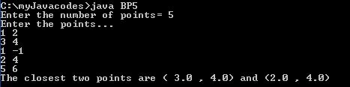

BP6:- **Develop a command line driven code to accept the following city name as argument in the command line and sort them in alphabetic order – City Name = Kolkata, Chennai, Mumbai, Delhi, Bangalore, Ahmedabad.**

# SOLN:-

# import java.util.Arrays;

# class sort

# {

# void sort(String[] cities)

# {

# for (int i=0;i< cities.length; i++)

# {

# for (int j=i+1;j<cities.length ; j++)

# {

# if(cities[i].compareTo(cities[j])>0)

# {

# String temp=cities[i];

# cities[i]=cities[j];

# cities[j]=temp;

# }

# }

# }

# 

# System.out.println("Sorted array of citites is...");

# System.out.println(Arrays.toString(cities));

# }

# }

# class BP6

# {

# public static void main(String args[])

# {

# String[] cities=new String[6];

# for(int i=0;i<6;i++)

# cities[i]=args[i];

# sort s=new sort();

# s.sort(cities);

# }

# }

# OUTPUT:-

# BP7:- Create a Waffle Class having two data members flavor and price, being populated by a parameterized constructor. Create another class WaffleMain to compare the values and object context of Waffle class data members by equals() and ==. Extend the implementation to get desired results by overriding

# a) equals()

# b) toString()

# SOLN:-

# class waffle

# {

# String flavour;

# double price;

# waffle(String flavour, double price)

# {

# this.flavour= flavour;

# this.price= price;

# }

# 

# public boolean equals(waffle w)

# {

# return ((flavour.compareTo(w.flavour)==0) && (price==w.price) );

# }

# 

# public String toString()

# {

# return ("Your waffle is " + flavour + " and price is = " + price );

# }

# }

# class BP7

# {

# public static void main(String[] args)

# {

# waffle w1=new waffle("chocolate",50);

# waffle w2=new waffle("brownie",70);

# waffle w3=new waffle("choco chip",80);

# waffle w4=new waffle("choco chip",80);

# System.out.println("Printing objects using .toString() method and overrided toString() method...");

# System.out.println("Object w1:- " + w1.toString());

# System.out.println("Object w2:- " + w2 );

# System.out.println("Object w3:- " + w3.toString());

# System.out.println("Object w4:- " + w4 );

# System.out.println("Comparing object w1 and w2 using '==' ... " );

# if(w1==w2)

# {

# System.out.println("Equal...");

# }

# else

# {

# System.out.println("Not Equal...");

# }

# 

# System.out.println("comapring w3 with w4 using equals() method..." );

# if(w3.equals(w4))

# { System.out.println("Equal...");

# }

# else

# {

# System.out.println("Not Equal...");

# }

# 

# }

# }

# OUTPUT:-

# BP8:- Create a POC(Proof of Concept) to demonstrate usage of various functions of String Class like:- a) charAt()

# b) length()

# c) contains()

# d) equals and ==

# e) indexOf()

# f) split()

# g) toUpperCase()

# SOLN:-

# class BP8

# {

# public static void main(String[] args)

# {

# String str= new String("Hello java , nice to meet you");

# String str1= new String("Hello java , nice to meet you");

# System.out.println("Length of the string entered = "+str.length());

# System.out.println("Check wheather nice to meet is contained or not :- " + str.contains("nice to meet"));

# System.out.println("Check wheather string is equal to another string or not using equals() :- " + str.equals(str1));

# System.out.println("Check wheather string is equal to another string or not using == operator :- " + (str==str1)+" because string re created in non pool");

# System.out.println("Index of character o :- "+ str.indexOf('o'));

# 

# String[] arr= str.split(" ");

# System.out.println("Array after splitting the string...");

# for (int i=0; i<arr.length;i++)

# {

# System.out.println(arr[i]);

# }

# 

# System.out.println("String in uppercase :- "+ str.toUpperCase());

# }

# }

# OUTPUT:-

# BP9:- Pattern to provide the output given below (Take row count from user).

# 1

# 123

# 1234

# 12345

# 123456

# 1234567

# 1

# 12

# 123

# 1234

# 12345

# 123456

# 1234567

# SOLN:-

# class BP9

# {

# public static void main(String[] args)

# {

# int i,j;

# for (i=1;i<=7;i++)

# {

# for(int k=1;k<=6;k++)

# {

# System.out.print(" ");

# }

# for(j=1;j<=i;j++)

# {

# System.out.print(j);

# }

# System.out.println();

# }

# 

# for(i=1;i<=7;i++)

# { int k=1;

# for(j=1;j<=7;j++)

# {

# if(i+j > 7)

# {

# System.out.print(k);

# k++;

# }

# else

# System.out.print(" ");

# 

# }

# System.out.println();

# }

# }

# }

# OUTPUT:-

BA1:- **Create a stack to maintain plates in a birthday party. Ask the organizer how many plates do they want initially. Maintain track of each plate used and number of plates added. Finally print the number of total number of plates in the stack, plates used and number of plates left in the stack**

# SOLN:-

# import java.util.*;

# import java.io.*;

# class BA1

# {

# public static void main(String[] args)

# { int ch,push=0,pop=0,temp;

# Stack<Integer> stack = new Stack<Integer>();

# System.out.println("How many plates you want to push initially= ");

# Scanner s= new Scanner(System.in);

# int pushInit= s.nextInt();

# temp=pushInit;

# for (int i=1 ; i <= pushInit ; i++)

# {

# stack.push(i);

# 

# }

# 

# System.out.println("Do you want to use plates? ");

# System.out.println("Press 1 for yes and any othear number to proceed...");

# ch=s.nextInt();

# 

# if(ch==1)

# { do

# {

# stack.pop();

# pop++;

# System.out.println("Do you want to use more plates? ");

# System.out.println("Press 1 for yes and any other number for no...");

# ch=s.nextInt();

# }while(ch==1) ;

# }

# 

# 

# System.out.println("Do you want to enter more plates on the stack?");

# System.out.println("Press 1 for yes and any other number for no...");

# ch=s.nextInt();

# if(ch==1)

# {

# do

# {

# stack.push(pushInit+1);

# pushInit+=1;

# push++;

# System.out.println("Do you want to add more plates on stack? ");

# System.out.println("Press 1 for yes and any other number for no...");

# ch=s.nextInt();

# }while(ch==1) ;

# 

# }

# 

# 

# System.out.println("Total number of plates initially inserted= " + temp);

# System.out.println("Total number of plates used= "+ pop);

# System.out.println("Total number of plates added overall = "+ (temp+push));

# System.out.println("Total number of plates left in the stack= " + ((temp+push)- pop));

# 

# 

# }

# }

# Output:-

# 

**PQ9:- Create a class ToStringDemo that uses the toString method to convert a double number entered by the user to a String. Use appropriate methods to count the number of digits before and after the decimal point in the input number?**

**Soln:-**

**import java.util.Scanner;**

**class PQ9**

{ **String toString(double d)**

{

String s= Double.toString(d);

return s;

}

**void count(String s)**

{

int dot=s.indexOf('.');

System.out.println("Digits before decimal= "+ dot);

System.out.println("Digita after decimal= " + (s.length()-1-dot));

}

**public static void main(String[] args)**

{ Scanner s= new Scanner(System.in);

PQ9 obj=new PQ9();

double d;

System.out.println("Enter a decimal number = ");

d=s.nextDouble();

String str= obj.toString(d);

obj.count(str);

}

}

**Output:-**

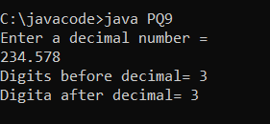

**PQ10:- Create a class called FileName to isolate the different parts of a FileName taken as an input from the user.**

**Soln:-**

**class fileName**

{

private String fullPath;

private char pathSeparator , extensionSeparator;

**public fileName(String str, char sep , char ext)**

{

fullPath = str;

pathSeparator = sep;

extensionSeparator = ext;

}

**public String extension()**

{

int dot= fullPath.lastIndexOf(extensionSeparator);

return fullPath.substring(dot+1);

}

**public String filename()**

{

int dot = fullPath.lastIndexOf(extensionSeparator);

int sep = fullPath.lastIndexOf(pathSeparator);

return fullPath.substring(sep+1 , dot);

}

**public String path()**

{

int sep = fullPath.lastIndexOf(pathSeparator);

return fullPath.substring(0,sep);

}

}

**class PQ10**

{

**public static void main(String[] args)**

{

final String fpath= "/home/user/index.html";

fileName myHomePage= new fileName(fpath, '/' , '.');

System.out.println("Extension = " + myHomePage.extension());

System.out.println("Filename = " + myHomePage.filename());

System.out.println("path = " + myHomePage.path());

}

}

***OUTPUT:-***

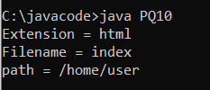

**PQ11:- Create appropriate classes to reverse a palindrome using String class and StringBuilder. Try to compute which solution computes faster?**

**Soln:-**

***class PQ11***

***{***

***public static void main(String[] args)***

{ long startTime= System.currentTimeMillis();

String str= "Dot saw i was tod";

int len= str.length();

char[] charArray= new char[len];

for(int i=0; i< len ; i++)

charArray[i]= str.charAt(len-1-i);

String reverse= new String(charArray);

System.out.println("Reversed palindrome string using String class:- "+ reverse);

System.out.println("Time taken to reverse the string using String class is = "+ (System.currentTimeMillis()-startTime) + " ms");

startTime= System.currentTimeMillis();

StringBuilder str1= new StringBuilder(str);

str1.reverse();

System.out.println("Reversed palindrome string using StringBuilder class :- " + str1);

System.out.println("Time taken to reverse the string using StringBuilder class is = "+ (System.currentTimeMillis()-startTime) + " ms");

}

}

**Output:-**

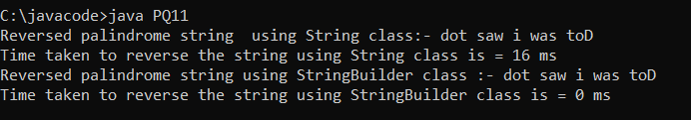

**CP1:- Design a class called DecipherCaesarCode to decipher the Caesar's code. The program shall prompts user for a ciphertext string consisting of mix-case letters only; compute the plaintext; and print the plaintext with each letter shifted by 4 bits. Design the solution with appropriate methods?**

**Soln:-**

**class CP1**

**{ public static StringBuffer encrypt(String text, int s)**

{ char ch;

StringBuffer result= new StringBuffer();

for(int i=0; i<text.length(); i++)

{

if(Character.isUpperCase(text.charAt(i)))

{

ch= (char)(((int)text.charAt(i) + s -65) %26 + 65);

result.append(ch);

}

else

{

ch= (char)(((int)text.charAt(i) + s -97) %26 + 97);

result.append(ch);

}

}

return result;

}

public static void main(String[] args)

{

String text="AtTaCKaToNcEz";

int s=4;

System.out.println("Text = " + text);

System.out.println("Shift by = " + s + " characters");

System.out.println("Cipher = "+ encrypt(text,s));

}

}

**OUTPUT:-**

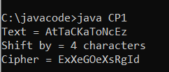

**CP2:- A word that reads the same backward as forward is called a palindrome, e.g., "mom", "dad", "racecar", "madam", and "Radar" (case-insensitive). Create a class called TestPalindromicWord, that prompts user for a word and prints ""xxx" is|is not a palindrome".**

**Soln:-**

**import java.util.Scanner;**

**class CP2**

**{**

**public static void main(String[] args)**

{

String str;

int j=0;

Scanner s = new Scanner(System.in);

System.out.println("Enter the string to be checked= ");

str=s.nextLine();

char []temp= new char[str.length()];

for(int i=str.length()-1; i>=0;i--)

{

temp[j]= str.charAt(i);

j++;

}

String str2= new String(temp);

System.out.println("Reverse string= " + str2);

if(str2.equalsIgnoreCase(str))

{

System.out.println(str + " is palindrome");

}

else

System.out.println(str + " is not palindrome");

}

}

**OUTPUT:-**

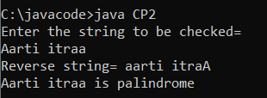

**CP3:- A java based program which prompts user for the number of students in a class (a non-negative integer), and saves it in an int variable called numStudents. It then prompts user for the grade of each of the students (integer between 0 to 100) and saves them in an int array called grades. The program shall then compute and print the average (in double rounded to 2 decimal places) and minimum/maximum (in int).**

**Soln:-**

import java.util.Scanner;

class CP3

{ public static void max_min(int[] grades)

{

int max=grades[0],min=grades[0];

int i;

for(i=1;i< grades.length ; i++)

{

if(max<grades[i])

max=grades[i];

if(min>grades[i])

min=grades[i];

}

System.out.println("Maximum grade is = " + max);

System.out.println("Minimum grade is = " + min);

}

public static void main(String[] args)

{

Scanner s= new Scanner(System.in);

int numStudents,temp;

double avg=0;

System.out.println("Enter the number of students in the class= ");

numStudents= s.nextInt();

int[] grades=new int[numStudents];

if(numStudents < 0)

System.out.println("Invalid number...");

else

{

System.out.println("Enter the grades of each student(0 t0 100)...");

for(int i=0;i< numStudents; i++)

{ temp=s.nextInt();

if(temp<0 || temp >100)

{ i--;

System.out.println("Invalid grade, enter again...");

}

else

{

grades[i]=temp;

avg+=grades[i];

}

}

}

System.out.println("Average grade = " + String.format("%.2f",(avg/numStudents)));

max_min(grades);

}

}

**OUTPUT:-**

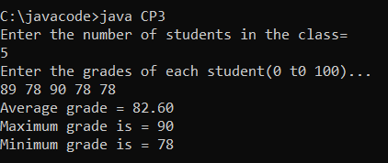

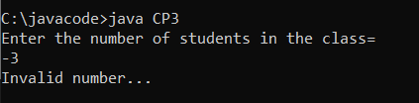

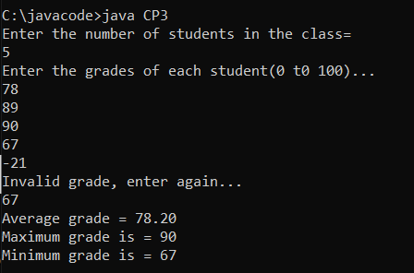

**CP4:- Demonstrate the working of a Static Inner Class through a class Electronics and within it create Static Inner Class Television that has a method cost() which displays cost of television object passed in constructor of Television class. Demonstrate invoking inner class method with outer object when the method cost() is once a :-**

**a) Instance(Non static) method**

**b) Static method**

**SOLN:-**

**import java.lang.*;**

**import java.util.*;**

**class electronics**

**{**

**static class television**

{

static television objref;

int priceTv;

**television(int price)**

{

priceTv= price;

}

**television(television obj)**

{

objref = obj;

}

**public void cost()**

{

System.out.println("Cost of Tv = " + priceTv);

}

**public static void cost2()**

{

System.out.println("Cost of TV using static method= " + objref.priceTv);

}

}

}

**class CP4**

**{**

**public static void main(String[] args)**

{

electronics.television etobj= new electronics.television(200);

etobj.cost();

electronics.television etobj2= new electronics.television(etobj);

etobj2.cost();

electronics.television.cost2();

}

}

**OUTPUT:-**

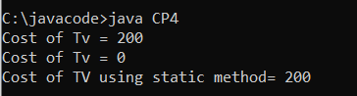

**CP5:-**

**Soln:-**

***import java.util.Scanner;***

***abstract class account***

***{***

***abstract void createAccount();***

***abstract void update(int acc, double a, char ch);***

***abstract void display();***

***}***

***class bankAccount extends account***

{

int acctNo;

String name;

double amt;

String acctType;

**void createAccount()**

{

Scanner s = new Scanner(System.in);

System.out.println("Enter the account type(saving / current) = ");

acctType = s.nextLine();

System.out.println("Enter the account number(...");

acctNo=s.nextInt();

s.nextLine();

System.out.println("Enter your name ...");

name=s.nextLine();

System.out.println("Enter the amount with which you want to create the account(minimun = 1000rs )...");

amt=s.nextDouble();

System.out.println("Account created...");

}

**void update(int acc , double a , char ch)**

{

if(acc== acctNo)

{

if(ch=='d' || ch=='D' )

amt += a;

else if(ch=='w' || ch=='W' || ch=='t' || ch== 'T')

{

if(amt>=1000)

{ amt -=a;

System.out.println("Amount updated...");

}

else

System.out.println("Insufficient balance...");

}

else System.out.println("Wrong input");

}

else System.out.println("Account number does not exist...");

}

**void display()**

{

System.out.println("Account no. = "+ acctNo);

System.out.println("Name = " + name );

System.out.println("Balance = " + amt);

}

}

class CP5

{

**public static void main(String[] args)**

{

Scanner s= new Scanner(System.in);

bankAccount b= new bankAccount();

int ch;

do{

System.out.println("1. To create an account.");

System.out.println("2. To update money or transfer money");

System.out.println("3. To display details of the account");

System.out.println("4.Exit");

System.out.println(" Enter your choice(1 -4 ) = ");

ch=s.nextInt();

if(ch==1)

{

b.createAccount();

}

else if(ch==2)

{

char code ;

double amt;

int account;

System.out.println("Enter the account number = ");

account = s.nextInt();

System.out.println("Enter amount = ");

amt=s.nextInt();

System.out.println("Enter D/W/T (deposite /withdraw / tranfer)= ");

code= s.next().charAt(0);

b.update(account , amt , code);

}

else if(ch==3)

{

b.display();

}

else if(ch==4) System.out.println("Terminating");

else if(ch!=4) System.out.println("Wrong choice...");

}while(ch!=4);

}

}

**OUTPUT:-**

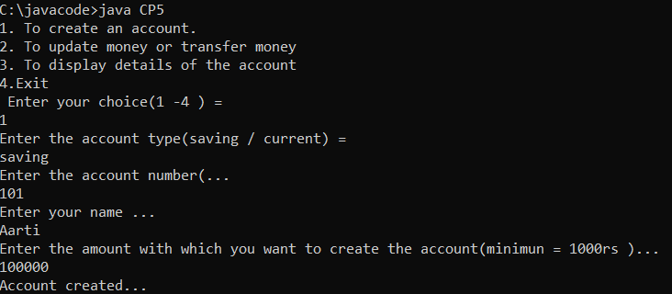

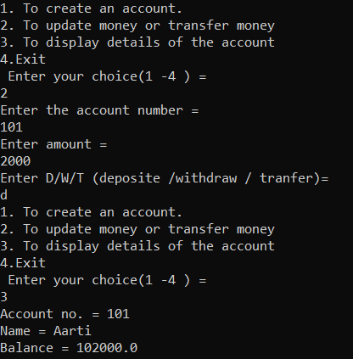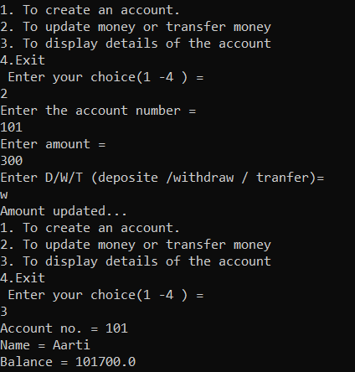

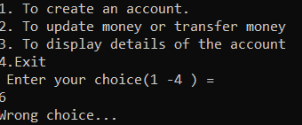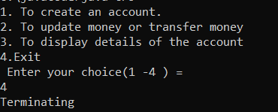

**PQ12:- Create a package hierarchy p1 and p2 and solve the Jagged array question in it**

**SOLN:-**

**package p1.p2;**

**class PQ12**

**{**

**public static void main(String args[])**

{

int r=7;

int arr[][]= new int[r][];

for(int i=0; i<arr.length; i++)

{

arr[i]= new int[i+1];

}

for(int i=0;i<arr.length;i++)

{

for(int j=0 ; j<arr[i].length; j++)

{

arr[i][j]=j+1;

}

}

System.out.println("Contents of jaggaed array...");

for(int i=0;i<arr.length;i++)

{

for(int j=0 ; j< arr[i].length; j++)

{

System.out.print(arr[i][j] + " ");

}

System.out.println();

}

}

}

**OUTPUT:-**

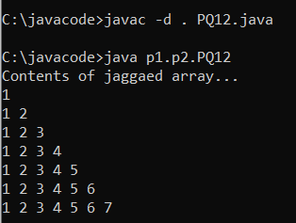

**CP6:-** **Create a package called animals,let this package contain an interface called Animal that generalizes the eat and travel task of any animal. Implement the given interface in the same package animals and override the methods appropriately?**

**SOLN:-**

**package animals; steps to run code**

**public interface animal**

1. Create folder in c drive with name= animal

{

2. Create folder in animal folder with

void eat();

name=animals(package name)

void travel();

3. Create java file in animals folder (package )

}

4. Create another java file importing package

___________________________________________________ in animal folder.

**import animals.animal;**

5. Comile file containing package

compile file importing package.

**public class CP6_dog implements animal**

{

(interface and classes should be public in

**public void eat()**

package file)

{

6. Run both the files.

System.out.println("Dog eats bone.");

}

**public void travel()**

{

System.out.println("Dog travel on four legs.");

}

**public static void main(String[] args)**

{

CP6_dog dog= new CP6_dog();

dog.eat();

dog.travel();

}

}

**OUTPUT:-**

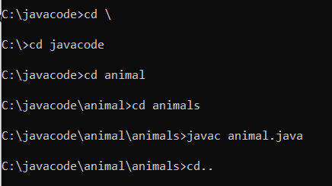

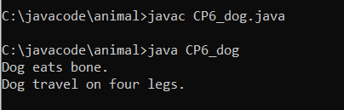

**CP7:- Create a package personpackage. This package contains a class Person with data members to represent firstName and lastName of a person and appropriate methods to read and display the same. Define appropriate class to test the above class outside the above package?**

**SOLN:-**

**package personPackage;**

**public class person**

{

String firstName;

String lastName;

**public void read(String firstName , String lastName) //method should be public**

{

this.firstName = firstName;

this.lastName = lastName;

}

**public void display() //method should be public**

{

System.out.println("Full name is = "+ firstName + " " + lastName);

}

}

__________________________________________________

**import personPackage.person;**

**class CP7 extends person**

**{**

**public static void main(String[] args)**

{

CP7 per= new CP7();

per.read("Aarti","bansal");

per.display();

}

}

**Output:-**

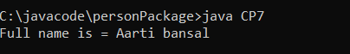

**PQ:- Introduction to ArrayList class.**

**Soln:-**

**import java.io.*;**

**import java.util.*;**

**class arrayList**

**{**

**public static void main(String[] args)**

{

int n=5; //size of array list;

ArrayList<Integer> array= new ArrayList<Integer>(n);

//Appending new elements

for(int i=1;i<=n;i++)

{

array.add(i);

}

//Printing elements

System.out.println(array);

//remove element at index 3

array.remove(3);

//Displaying the array list after deletion

System.out.println(array);

//Printing the elements one by one

for(int i=0;i<array.size();i++)

{

System.out.println(array.get(i)+" ");

}

}

}

Output:-

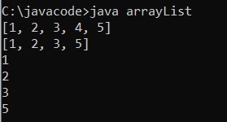

**PQ 13:- Create a solution to sort movies on the basis of their year of release?**

**SOLN:-**

**import java.io.*;**

**import java.util.*;**

**class Movie implements Comparable<Movie>**

{

private double rating;

private String name;

private int year;

**public int compareTo(Movie m)** //used to sort movies by year

{

return this.year - m.year;

}

**Movie(String name, double rating, int year)** //ctr

{

this.name=name;

this.year=year;

this.rating=rating;

}

**public double getRating()**

{

return rating;

}

**public int getYear()**

{

return year;

}

**public String getName()**

{

return name;

}

}

//Driver class

**class PQ13**

**{**

**public static void main(String[] args)**

{

ArrayList<Movie> list=new ArrayList<Movie>();

list.add(new Movie("Fight club",8.5,2005));

list.add(new Movie("Shutter Island",9,2003));

list.add(new Movie("scream",8.7,1997));

list.add(new Movie("Joker",9,2021));

Collections.sort(list); //sort method call compareTo method of comparable interface

System.out.println("Movies after sorting...");

for(Movie movie:list)

{

System.out.println(movie.getName()+" "+movie.getRating()+" "+movie.getYear());

}

}

}

OUTPUT:-

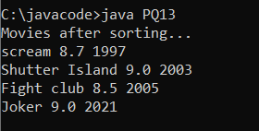

**PQ14:- Write a solution to sort movies by their rating and name?**

**SOLN:-**

**import java.util.*;**

**import java.io.*;**

**class Movie implements Comparable<Movie>**

{

private double rating;

private String name;

private int year;

**public int compareTo(Movie m)**

{

return this.year - m.year;

}

**public Movie(String nm, double rt, int yr)**

{

this.name = nm;

this.rating = rt;

this.year = yr;

}

**public double getRating()** { return rating; }

**public String getName**() { return name; }

**public int getYear()** { return year; }

}

**//comparing movies by their rating**

**class ratingCompare implements Comparator<Movie>**

{

public int compare(Movie m1, Movie m2)

{

if(m1.getRating() < m2.getRating())

{

return -1;

}

if(m1.getRating() > m2.getRating())

return 1;

else return 0;

}

}

**//comparing the movies by their names**

**class nameCompare implements Comparator<Movie>**

{

**public int compare(Movie m1,Movie m2)**

{

return m1.getName().compareTo(m2.getName());

}

}

**class PQ14**

{

**public static void main(String[] args)**

{

ArrayList<Movie> list=new ArrayList<Movie>();

list.add(new Movie("Fight club",8.5,2005));

list.add(new Movie("Shutter Island",9,2003));

list.add(new Movie("scream",8.7,1997));

list.add(new Movie("Joker",9,2021));

System.out.println("Sorted by rating...");

ratingCompare rc=new ratingCompare();

Collections.sort(list,rc);

for(Movie movie:list)

System.out.println(movie.getRating() + " " + movie.getName() + " " +movie.getYear());

System.out.println("\nSorted by name");

nameCompare nameCompare = new nameCompare();

Collections.sort(list, nameCompare);

for (Movie movie: list)

System.out.println(movie.getName() + " " + movie.getRating() + " " +movie.getYear());

//sorted by year using comparable

System.out.println("\nSorted by year");

Collections.sort(list);

for (Movie movie: list)

System.out.println(movie.getYear() + " " +movie.getRating() + " " +movie.getName()+" ");

}

}

OUTPUT:-

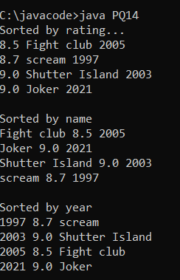

**CP8:- Create an Array of Student class objects.**

**a) Sort them by roll number using Comparable Interface.**

**b) Perform sort based on alphabetic first name numbering using Comparator**

**SOLN:-**

**import java.util.*;**

**import java.io.*;**

**class Student implements Comparable<Student>**

{

private int rollNo;

private String name;

private double marks;

**public int compareTo(Student stu)**

{

return this.rollNo-stu.rollNo;

}

**Student(int rollNo,String name,double marks)**

{

this.rollNo = rollNo;

this.name=name;

this.marks=marks;

}

**int getRollNo()**

{ return rollNo;}

**String getName()**

{ return name;}

**double getMarks()**

{ return marks;}

}

**class nameCompare implements Comparator<Student>**

{

**public int compare(Student s1, Student s2)**

{

return s1.getName().compareTo(s2.getName());

}

}

**class CP8**

**{**

**public static void main(String[] args)**

**{**

ArrayList<Student> list= new ArrayList<Student>();

list.add(new Student(1,"Tom",450));

list.add(new Student(3,"Mike",500));

list.add(new Student (4,"Sam",451));

list.add(new Student (2,"Jim",525));

list.add(new Student (5,"Jenny",459));

System.out.println("Sorted by Roll No...");

Collections.sort(list);

for(Student stu:list)

{

System.out.println(stu.getRollNo()+" "+stu.getName()+" "+stu.getMarks());

}

System.out.println("Sorted by name...");

nameCompare nc=new nameCompare();

Collections.sort(list,nc);

for(Student stu:list)

{

System.out.println(stu.getRollNo()+" "+stu.getName()+" "+stu.getMarks());

}

}

}

OUTPUT:-

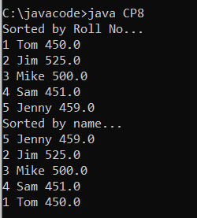

**CP9:- Create an interface Relatable that compares the size of objects.Any class can implement Relatable if there is some way to compare the relative "size" of objects instantiated from the class. For strings, it could be number of characters; for books, it could be number of pages; for students, it could be weight; and so forth. For planar geometric objects, area would be a good choice while volume would work for three-dimensional geometric objects. All such classes can implement the isLargerThan() method. Create appropriate implementations.**

**SOLN:-**

**package Relate;**

**public interface Relatable**

{

public int isLargerThan(Relatable other);

}

**import Relate.Relatable;**

**class RectanglePlusCp9 implements Relatable**

{

public int length=0;

public int breadth=0;

**public RectanglePlusCp9(int l,int b)**

{

length= l;

breadth=b;

}

**public int getArea()**

{

return length*breadth;

}

**public int isLargerThan(Relatable other)**

{

RectanglePlusCp9 otherRect=(RectanglePlusCp9)other;

if(this.getArea() < otherRect.getArea())

return -1;

else if(this.getArea() > otherRect.getArea())

return 1;

else return 0;

}

**public static void main(String[] args)**

{

RectanglePlusCp9 r1=new RectanglePlusCp9(8,10);

RectanglePlusCp9 r2=new RectanglePlusCp9(3,9);

RectanglePlusCp9 r3=new RectanglePlusCp9(6,9);

r1.getArea();

r2.getArea();

r3.getArea();

if(r1.isLargerThan(r2)==1)

{

System.out.println("Rectangle 1 is greater than rectangle 2");

}

else

System.out.println("Rectangle 1 is not greater than rectangle 2");

if(r2.isLargerThan(r3)==1)

{

System.out.println("Rectangle 2 is greater than rectangle 3");

}

else

System.out.println("Rectangle 2 is not greater than rectangle 3");

}

}

OUTPUT:-

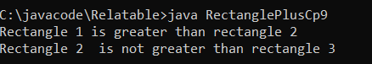

**CP10:- Create an interface GeoAnalyzer with a constant PI and methods area() and perimeter(). Let Circle, Ellipse and rectangle implement this class. Define a class Geometry that assigns appropriate objects to GeoAnalyzer reference variable.**

**SOLN:-**

interface GeoAnalyzer

{

final static float pi=3.142f;

float area();

float perimeter();

void display(float a,float p);

}

class circle implements GeoAnalyzer

{

float radius;

circle(float r)

{

radius=r;

}

public float area()

{

return (pi*radius*radius);

}

public float perimeter()

{

return (2*pi*radius);

}

public void display(float a,float p)

{

System.out.println("Area of circle is= "+ a);

System.out.println("Perimeter of circle is= "+ p);

}

}

class ellipse implements GeoAnalyzer

{

float major;

float minor;

ellipse(float m,float n)

{

major=m;

minor=n;

}

public float area()

{

return (pi*major*minor);

}

public float perimeter()

{

return (pi*(major+minor));

}

public void display(float a,float p)

{

System.out.println("Area of ellipse is= "+ a);

System.out.println("Perimeter of elipse is= "+ p);

}

}

class rectangle implements GeoAnalyzer

{

float length;

float width;

rectangle(float l,float w)

{

length=l;

width=w;

}

public float area()

{

return (length*width);

}

public float perimeter()

{

return (2*(length+width));

}

public void display(float a,float p)

{

System.out.println("Area of rectangle is= "+ a);

System.out.println("Perimeter of rectangle is= "+ p);

}

}

class CP10

{

public static void main(String[] args)

{

circle c=new circle(5.2f);

ellipse e=new ellipse(4.5f,3.6f);

rectangle r= new rectangle(6.5f,4.3f);

GeoAnalyzer geoItem;

geoItem=c;

geoItem.display(geoItem.area(),geoItem.perimeter());

geoItem=e;

geoItem.display(geoItem.area(),geoItem.perimeter());

geoItem=r;

geoItem.display(geoItem.area(),geoItem.perimeter());

}

}

OUTPUT:-

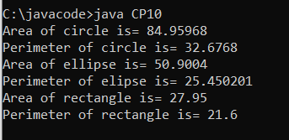

PQ16:-  **Demonstrate use of try with multiple catch blocks?**

public class PQ16

{

public static void main(String[] args)

{

try { String[] str= {"Aarti","Bansal"};

int i=str.length;

String myString[]=new String[] {"Aarti"}; //#1 exception

if(myString[0].equals("java"))

System.out.println("First word is java....");

System.out.println("Numbe rof words= "+ i);

int x=12/i; //#2 eception

int y[]= {555,999};

y[i]=x; //#3 exception

}

catch(ArithmeticException e)

{

System.out.println("Div by 0 : "+e); //#2

}

catch(NullPointerException e)

{

System.out.println("A null pointer exception : "+e); //#1

}

catch(ArrayIndexOutOfBoundsException e)

{

System.out.println("Array Index out of bounds : "+e); //#3

}

}

}

OUTPUT:-

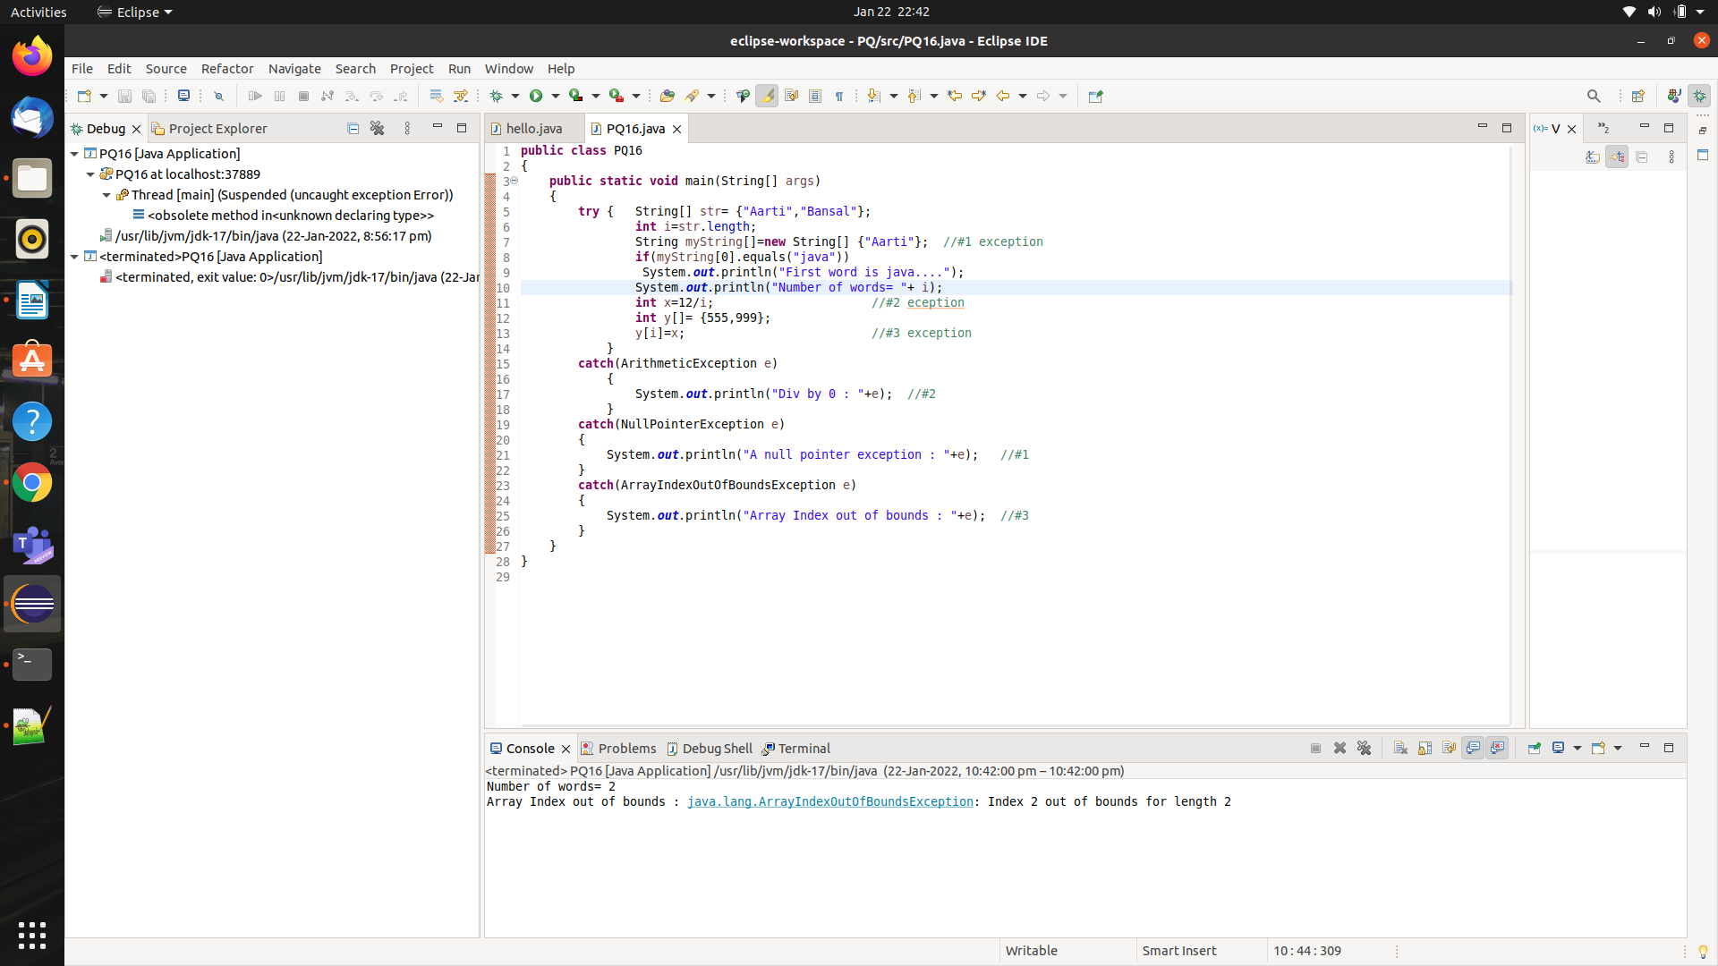

PQ17:- **Write code to demonstrate try-catch and finally block?**

**SOLN:-**

public class PQ17 {

public static void main(String[] args) {

try

{

System.out.println("First statement of try block");

int num=45/0;

System.out.println(num);

}

catch(ArrayIndexOutOfBoundsException e)

{

System.out.println("Array Index Out Of bound Exception");

}

finally

{ System.out.println();

System.out.println("Finally block");

}

System.out.println("Out of try catch finally block");

//this will not be executed because exception is not caught

//If Arithmetic exception is caught then only rest of the code is executed.

}

}

OUTPUT: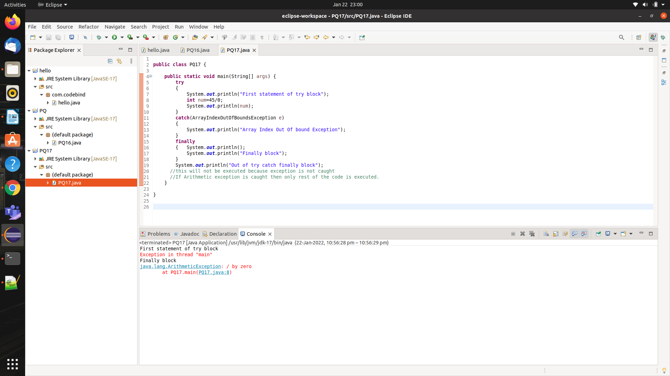-

PQ18:- **User Defined Exception Class**

**SOLN:-**

class MyException extends Exception

{

String str1;

MyException(String str2)

{

str1=str2;

}

public String toString()

{

return ("MyException occured " + str1);

}

}

public class PQ18

{

public static void main(String[] args)

{

try

{

System.out.println("Starting of try block");

throw new MyException("This is my error message");

}

catch(MyException exp)

{

System.out.println("Catch block");

System.out.println(exp);

}

}

}

OUTPUT:-

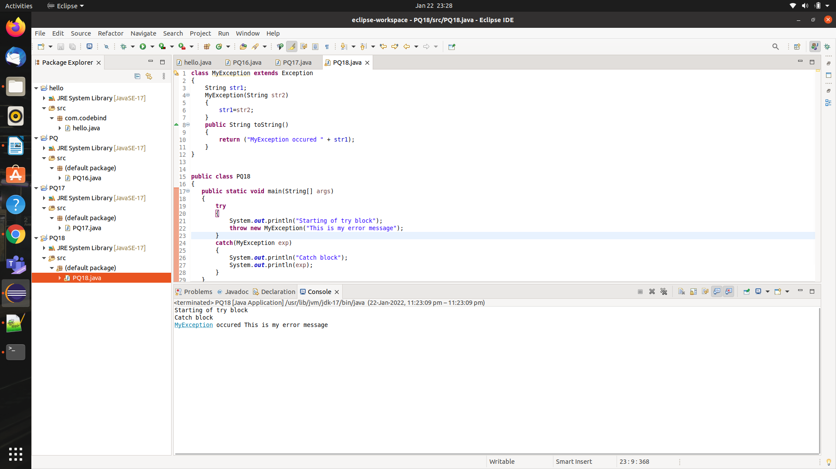

PQ19:- **Chained Exception Handling**

**SOLN:-**

public class PQ19

{

public static void main(String[] args)

{

try

{

NumberFormatException ex=new NumberFormatException("Exception");

//setting a cause of the exception

ex.initCause(new NullPointerException("This is actual cause of the exception"));

throw ex;

}

catch(NumberFormatException|ArithmeticException ex)

{

System.out.println(ex);

System.out.println(ex.getCause());

}

}

}

OUTPUT:-

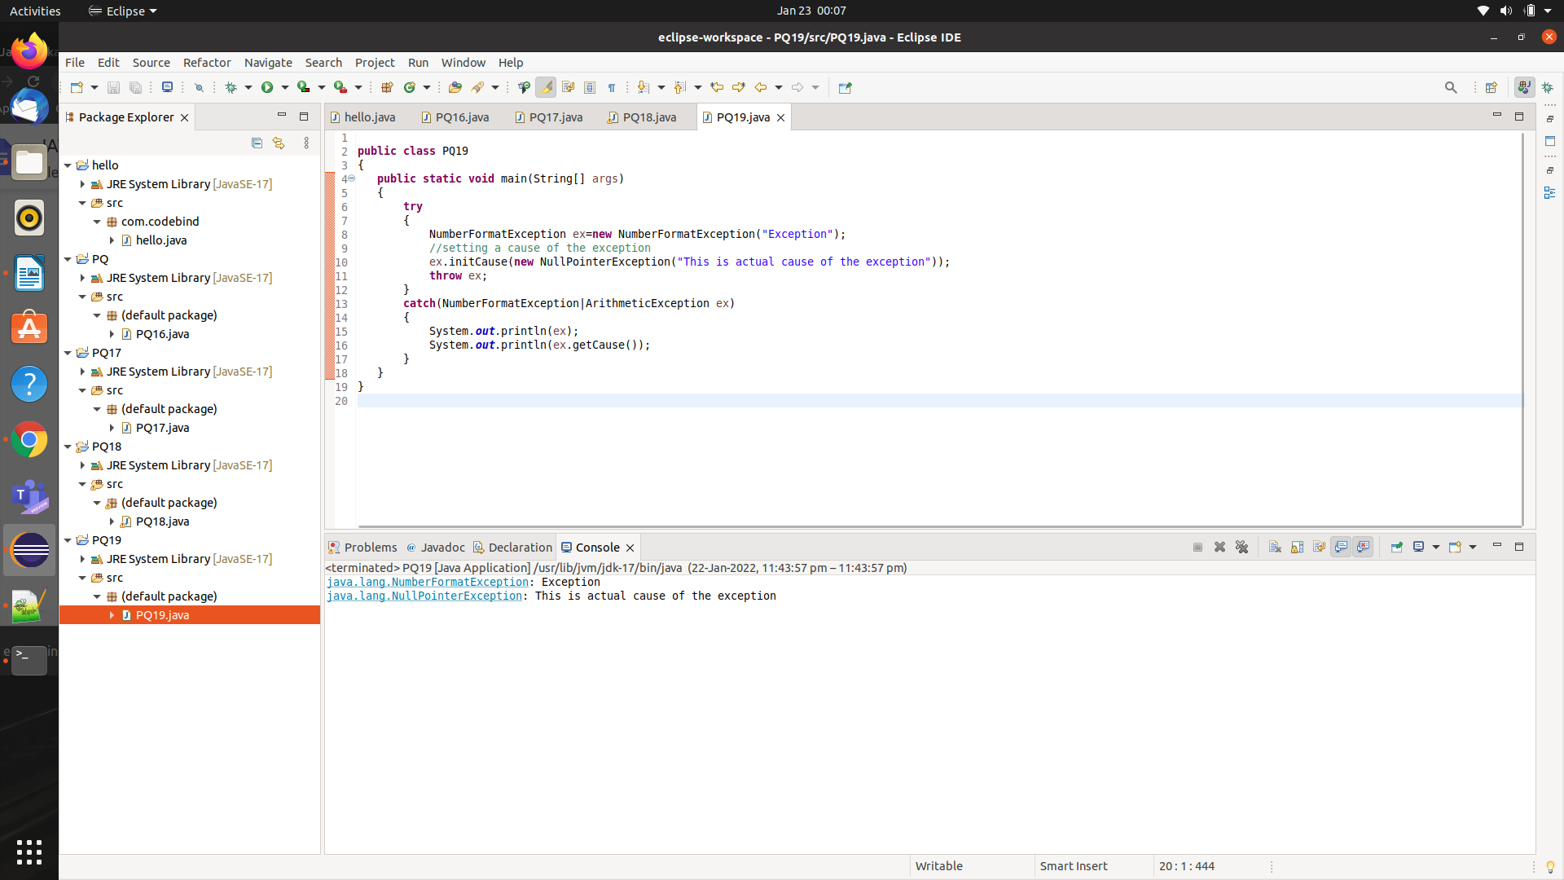

PQ20:- **Rethrowing an Exception**

**SOLN:-**

public class PQ20

{

static void divide()

{

int x,y,z;

try

{

x=6;

y=0;

z=x/y;

System.out.println(x+"/"+y+" = " +z);

}

catch(ArithmeticException e)

{

System.out.println("Exception caught in divide() method");

System.out.println("Can not divide by zero in integer division");

throw e; //re-throws an exception

}

}

public static void main(String[] args)

{

System.out.println("Start of main()");

try

{

divide();

}

catch(ArithmeticException e)

{

System.out.println("Rethrown exception caught in main()");

System.out.println(e);

}

}

}

OUTPUT:-

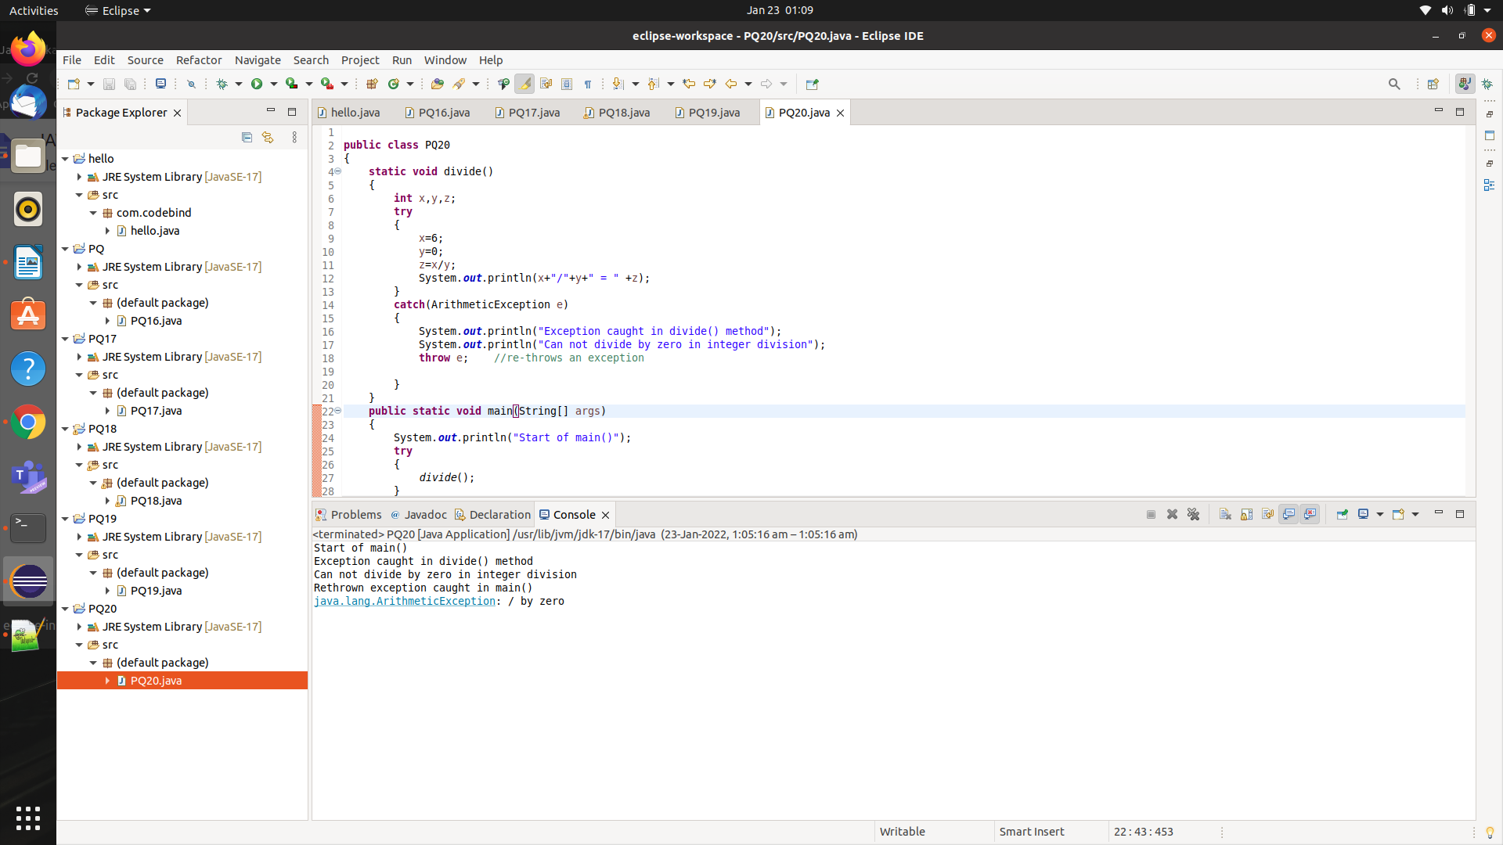

**DP1:-****Extend your Gravity Calculator code (Assignment AA1) to handle exceptions through a try-catch finally block. Handle provision for a divide by zero scenarios caught by NumberFormatException. Explicitly invoke this exception in execution and observe the response.**

**SOLN:-**

import java.util.*;

public class DP1

{

public static void main(String[] args) throws Exception

{

double acc=-9.81,iniVel=0.0,iniPos=0.0,time=0.0,finPos;

Scanner s=new Scanner(System.in);

try

{

System.out.println("Enter initial velocity(in m/s)= ");

iniVel=s.nextDouble();

System.out.println("Enter initial position(in m)= ");

iniPos=s.nextDouble();

System.out.println("Enter time = ");

time=s.nextDouble();

finPos=0.5*acc*(Math.pow(time,2)) + iniVel*time + iniPos;

System.out.println("The objec's position after "+time+" seconds= "+finPos+" m");

System.out.println("Enter two numbers= ");

int a=s.nextInt();

int b=s.nextInt();

if(b==0)

throw new NumberFormatException();

System.out.println(a+"/"+b+" = "+ (a/b));

}

catch(InputMismatchException|NumberFormatException e)

{

System.out.println("Exception occured : "+e);

}

}

}

OUTPUT:-

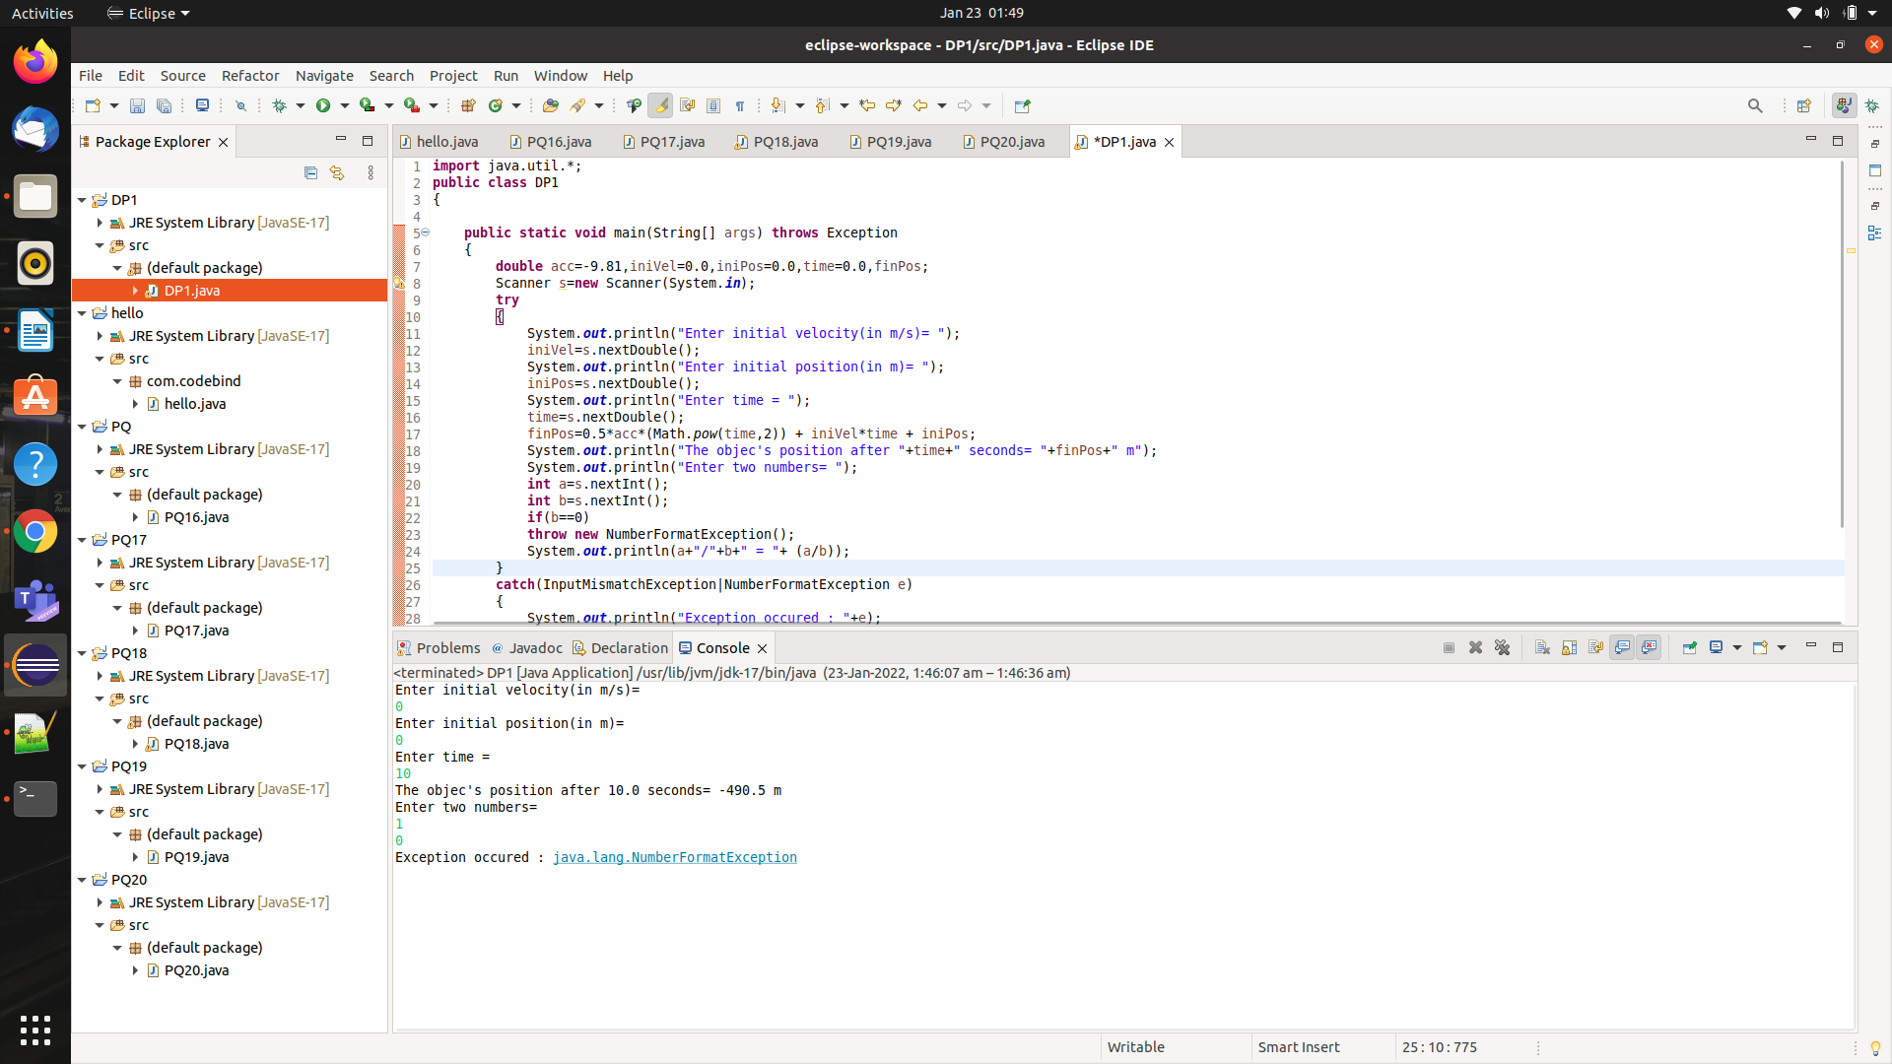

**DP2:-** **Further extend your menu-driven Simple Calculator code (Assignment 2) by adding support a Custom Exception code that raises an ‘Invalid Numeral’ exception each time the user tries to enter any character except a number for calculation. Explicitly invoke this exception in execution and observe the response.**

**SOLN:-**

**import java.util.Scanner;**

**class MyException extends Exception**

{

public String toString()

{

return ("Invalid number");

}

}

**public class DP2**

{

**public static void main(String[] args)**

{

int ch,flag=0;

String a,b,str="";

Scanner s=new Scanner(System.in);

System.out.println("Enter 2 numbers to be operated= ");

try

{

a=s.nextLine();

b=s.nextLine();

str=str+a+b;

for(int i=0;i<str.length();i++)

{

if(Character.isDigit(str.charAt(i)) == false)

flag=1;

}

if(flag==1)

throw new MyException();

else

{

int a1=Integer.parseInt(a);

int b1=Integer.parseInt(b);

System.out.println("1.Add.");

System.out.println("2.subtract");

System.out.println("3. Multiply.");

System.out.println("4. Divide.");

System.out.println("Enter your choice(1-4)= ");

ch=s.nextInt();

switch(ch)

{

case 1: System.out.println("Answer = " + (a1+b1));

break;

case 2: System.out.println("Answer = " + (a1-b1));

break;

case 3: System.out.println("Answer = " + (a1*b1));

break;

case 4: System.out.println("Answer = " + ((double)a1/(double)b1));

break;

default : System.out.println("Wrong choice");

}

}

}

catch(MyException e)

{

System.out.println(e);

}

catch(ArithmeticException e)

{

System.out.println("Can't divide by 0...");

System.out.println(e);

}

finally

{

System.out.println("Program terminated...");

}

}

}

OUTPUT:-

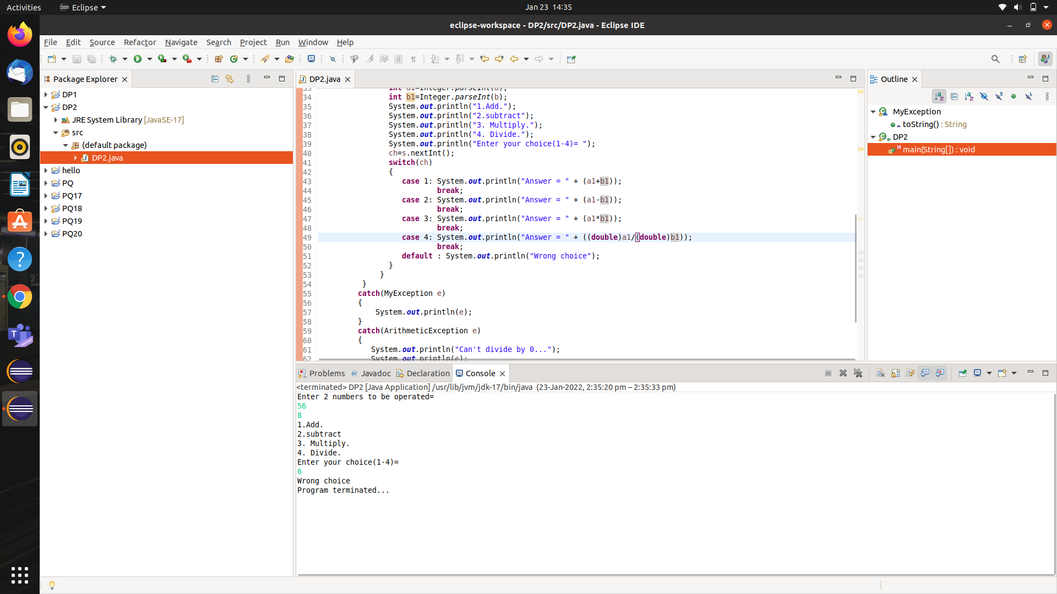 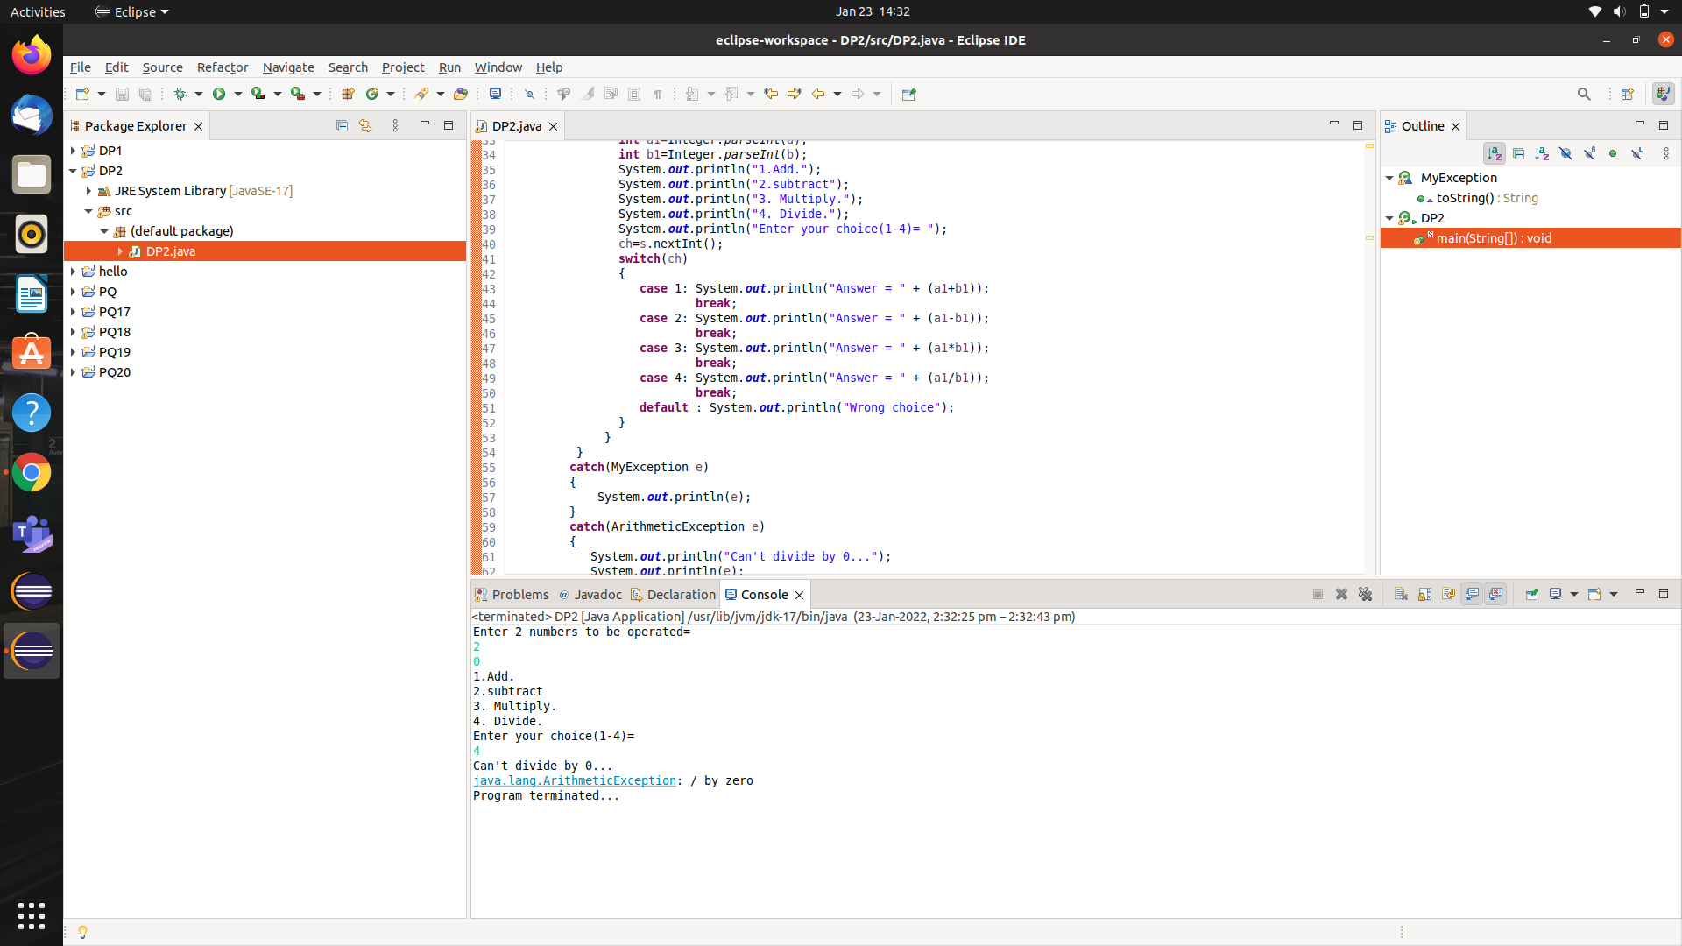

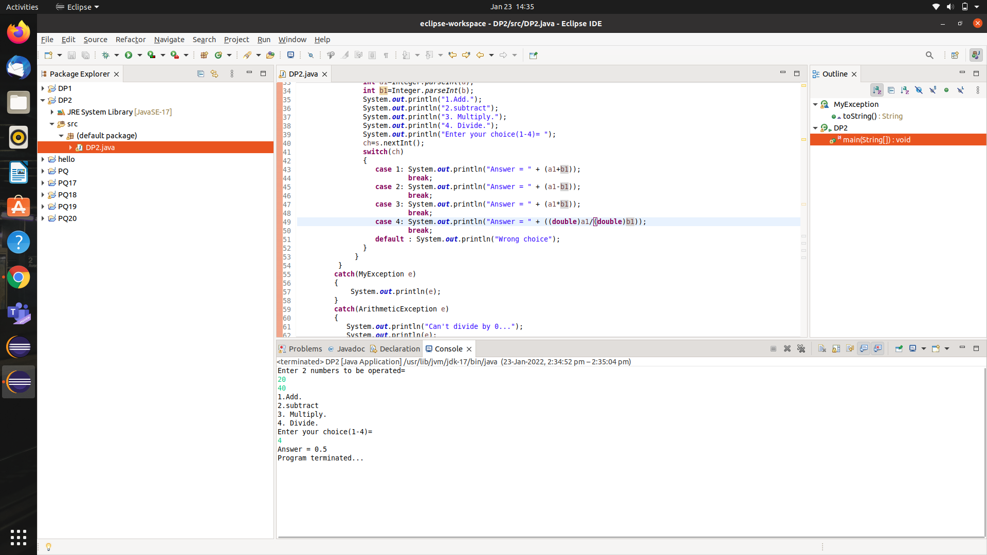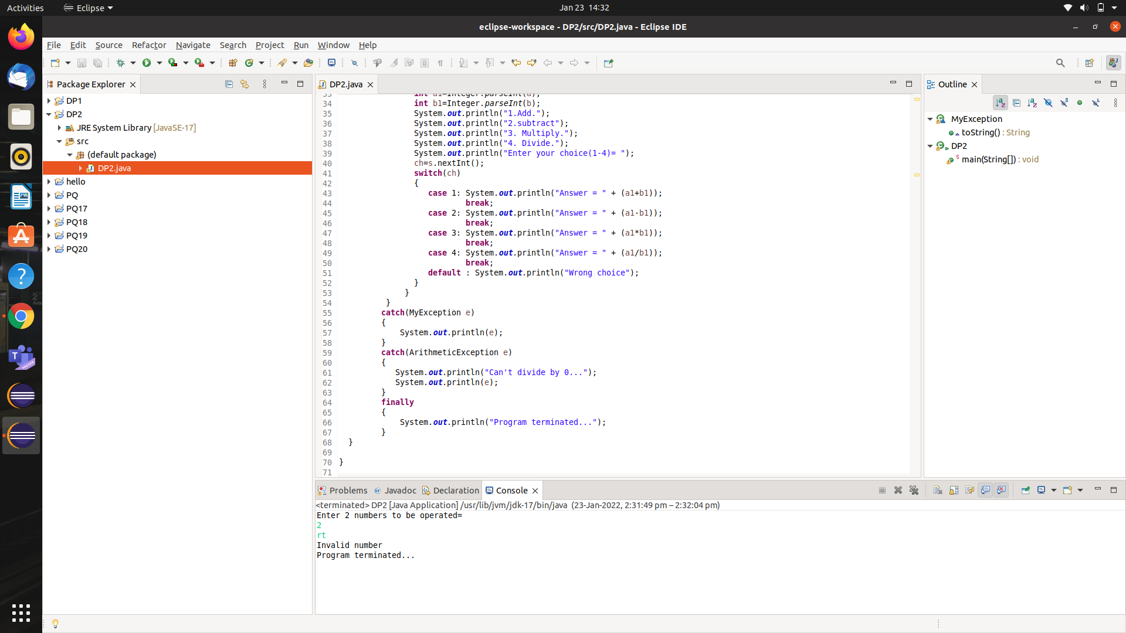

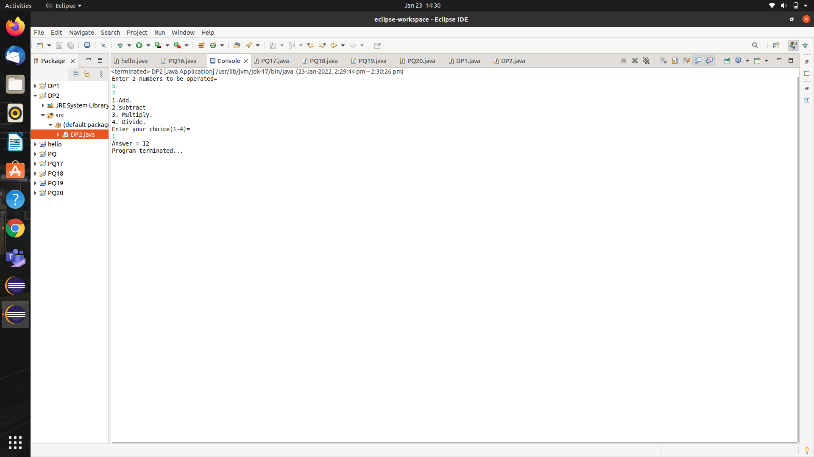

**DP3:-** **Create a class StudentRegistrationCheck that checks eligibility of a student for registration. If the student age<12 and marks<200 then the student is not eligible for registration. Design appropriate solution using exception handling?**

**SOLN:-**

**import java.util.Scanner;**

**class MyException extends Exception**

{

public String toString()

{

return ("Candidate is not eligible for the registration...");

}

}

**public class DP3**

{

int age;

float marks;

**public static void main(String[] args)**

{

DP3 stu=new DP3();

Scanner s=new Scanner(System.in);

try

{

System.out.println("Enter the age of the student= ");

stu.age=s.nextInt();

System.out.println("Enter the marks of the student = ");

stu.marks=s.nextFloat();

if(stu.age<12 || stu.marks < 200)

throw new MyException();

else

System.out.println("Candidate is eligible for the registration...");

}

catch(MyException e)

{

System.out.println(e);

}

}

}

OUTPUT:

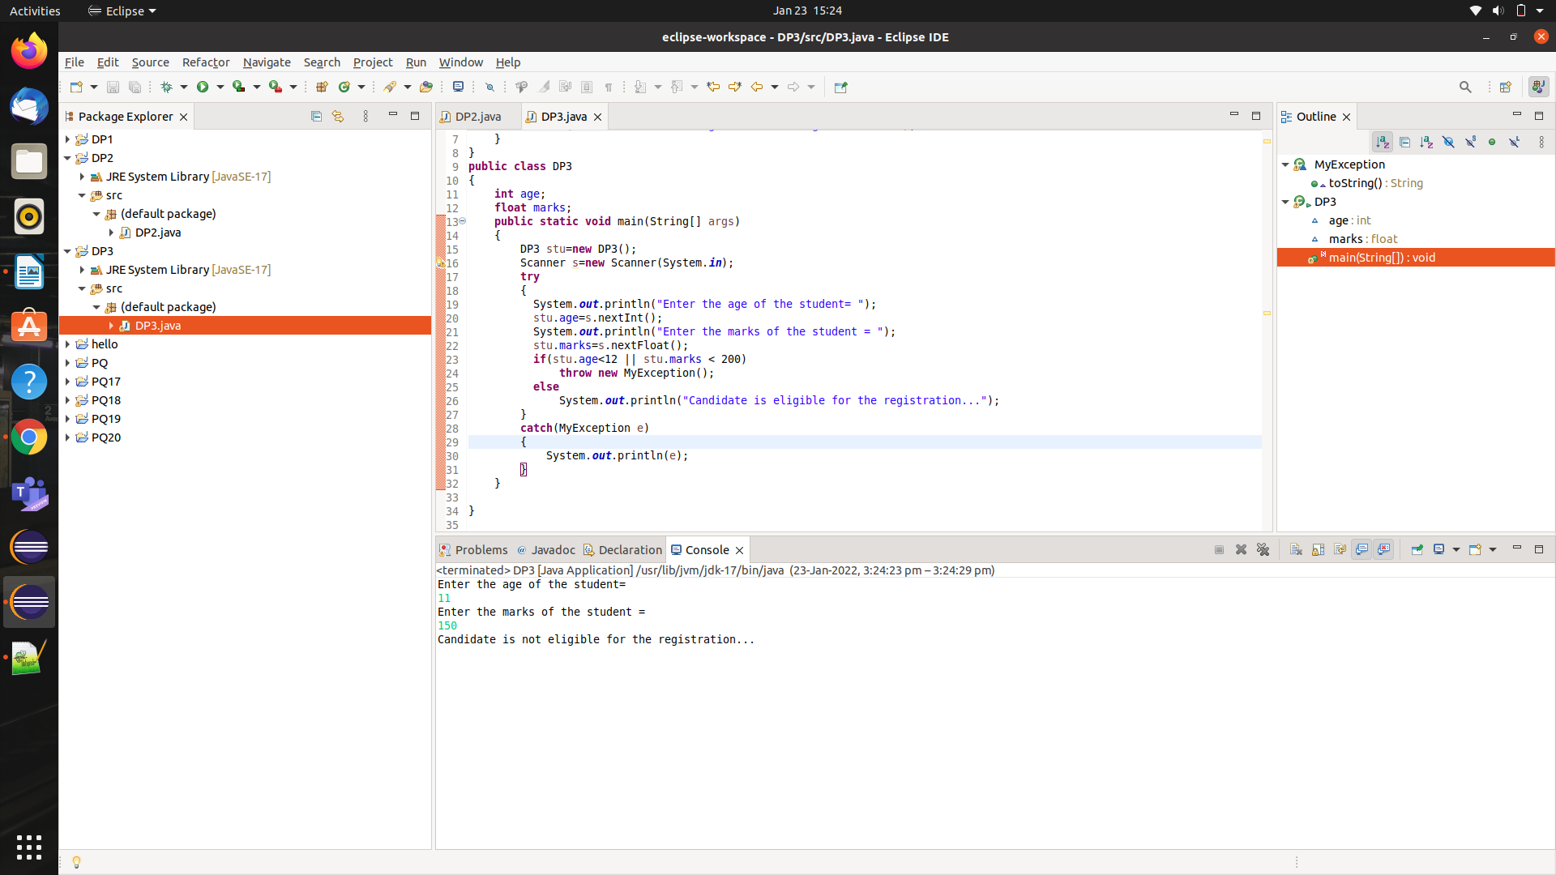

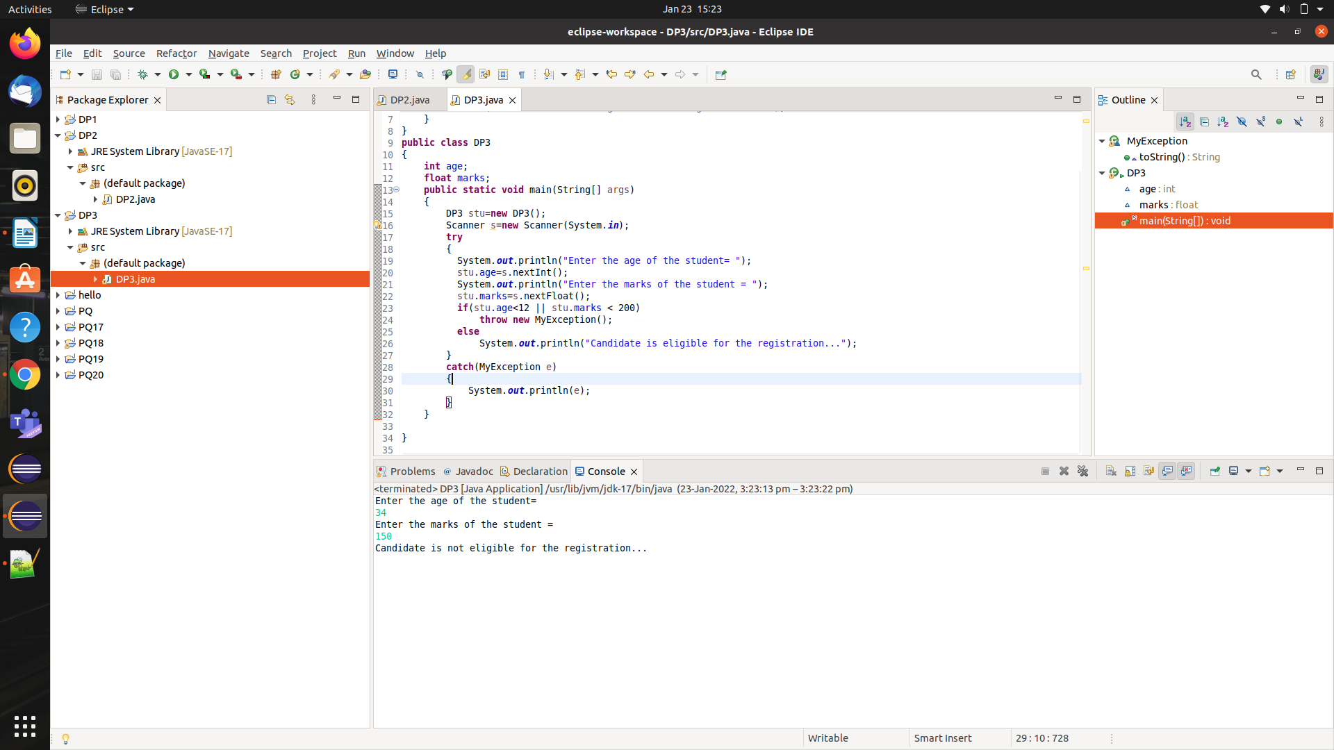

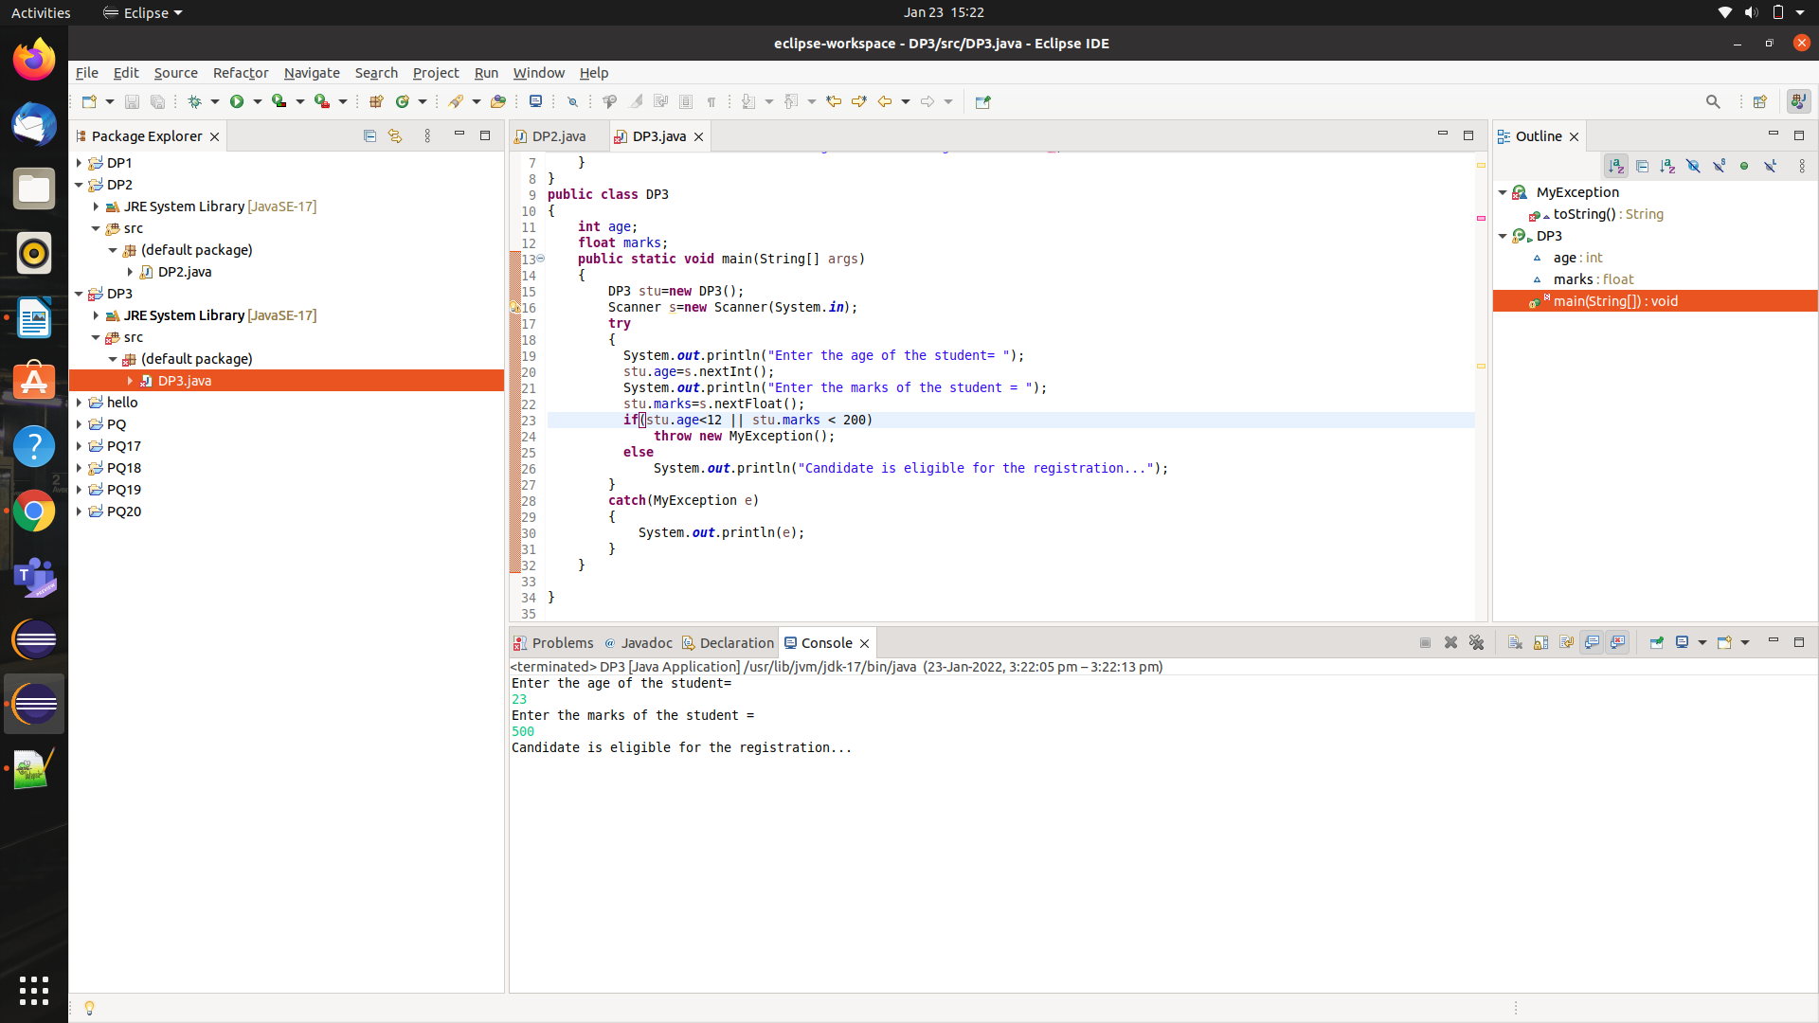

**DP4:-****An ExceptionPOC class is requesting a number between 1 and 10. Run the program again and enter 5.5. Although this number is between 1 and 10, the program will abort. Examine the error message. You should see the word Exception, the method where the exception occurred (main), the class name of the exception (InputMismatchException), as well as the call stack listing the method calls.**

**Add a try/catch block to catch and handle the InputMismatchException exception. Identify the statements that cause the error as well as the portions of the program that depend upon these statements. Enclose these statements within the try block. Follow the try block with the catch block given below. Note, the InputMismatchException class is defined in java.util and must be imported. Also, when the Scanner throws an InputMismatchException, the input token will remain in the buffer so that it can be examined by the program. Complete code by implementing the same using:-**

**a) Throws method declaration**

**b) Throw keyword**

SOLN:-

**import java.util.Scanner;**

**class InputMismatchException**

{

int except() throws Exception

{

Scanner s= new Scanner(System.in);

System.out.println("Enter a number between 1 to 10 = ");

int num=s.nextInt();

return num;

}

}

**public class DP4**

**{**

**public static void main(String[] args)**

{

try

{

InputMismatchException ex=new InputMismatchException();

System.out.println("Number : "+ex.except());

}

catch(Exception e)

{

e.printStackTrace(); //gives the description of the error

System.out.println("Exception occured : "+e);

}

}

}

OUTPUT:-

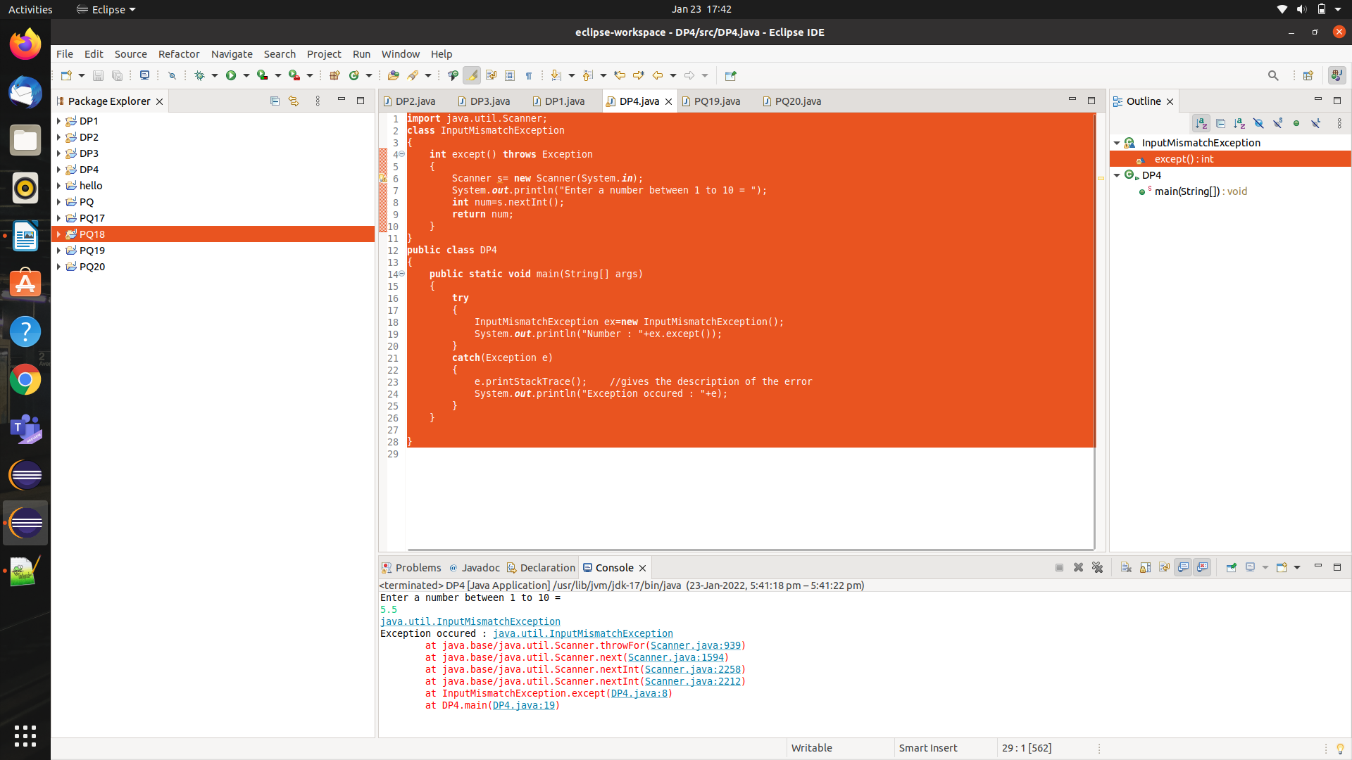

**DP5:-** **Extend CP5 (Bank application)with appropriate exception handling?**

**SOLN:-**

import java.util.Scanner;

class InputMismatchException extends Exception

{

public InputMismatchException(String str)

{

super(str);

}

}

abstract class account

{

abstract void savingAccount();

abstract void currentAccount();

abstract void update(int acc, double a, char ch);

abstract void display();

}

class bankAccount extends account

{

int acctNo;

String name;

double amt;

String acctType;

public void savingAccount()

{

Scanner s = new Scanner(System.in);

try {

System.out.println("Enter the account number...");

acctNo=s.nextInt();

if(acctNo<1)

throw new InputMismatchException("Account number can not be negative or zero...");

s.nextLine(); //to get name because nextLine doesn't work after nextInt()

System.out.println("Enter your name ...");

name=s.nextLine();

System.out.println("Enter the amount with which you want to create the account(minimun = 1000rs )...");

amt=s.nextDouble();

if(amt<1000)

throw new InputMismatchException("Minimum amount should be 1000 rs");

System.out.println("Account created...");

}

catch(InputMismatchException e)

{

System.out.println("Exception occured : " + e);

}

}

public void currentAccount()

{

Scanner s = new Scanner(System.in);

try {

System.out.println("Enter the account number...");

acctNo=s.nextInt();

if(acctNo<1)

throw new InputMismatchException("Account number can not be negative or zero...");

s.nextLine(); //to get name because nextLine doesn't work after nextInt()

System.out.println("Enter your name ...");

name=s.nextLine();

System.out.println("Enter the amount with which you want to create the account(minimun = 500s )...");

amt=s.nextDouble();

if(amt<500)

throw new InputMismatchException("Minimum amount should be 500 rs");

System.out.println("Account created...");

}

catch(InputMismatchException e)

{

System.out.println("Exception occured : " + e);

}

}

public void update(int acc , double a , char ch)

{

if(acc== acctNo)

{

if(ch=='d' || ch=='D' )

amt += a;

else if(ch=='w' || ch=='W' || ch=='t' || ch== 'T')

{

if(amt>=1000)

{ amt -=a;

System.out.println("Amount updated...");

}

else

System.out.println("Insufficient balance...");

}

else System.out.println("Wrong input");

}

else System.out.println("Account number does not exist...");

}

public void display()

{

System.out.println("Account no. = "+ acctNo);

System.out.println("Name = " + name );

System.out.println("Balance = " + amt);

}

}

class DP5

{

public static void main(String[] args)

{

Scanner s= new Scanner(System.in);

bankAccount b= new bankAccount();

int ch;

do{

System.out.println("1. To create a saving account.");

System.out.println("2. To update money or transfer money");

System.out.println("3. To display details of the account");

System.out.println("4.Exit");

System.out.println("5. To create a current account.");

System.out.println(" Enter your choice(1 -5) = ");

ch=s.nextInt();

if(ch==1)

{

b.savingAccount();

}

else if(ch==2)

{

char code ;

double amt;

int account;

System.out.println("Enter the account number = ");

account = s.nextInt();

System.out.println("Enter amount = ");

amt=s.nextInt();

System.out.println("Enter D/W/T (deposite /withdraw / transfer)= ");

code= s.next().charAt(0);

b.update(account , amt , code);

}

else if(ch==3)

{

b.display();

}

else if(ch==4) System.out.println("Terminating");

else if(ch==5)

{

b.currentAccount();

}

else

System.out.println("Wrong choice...");

}while(ch!=4);

}}OUTPUT:-

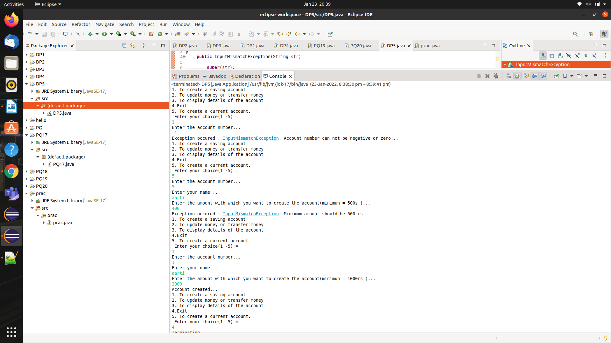

**DP6:-** **Create an Exception class InvalidProductException that can be thrown if a user adds an invalid product.**

SOLN:-

import java.util.*;

class InvalidProductException extends Exception

{

InvalidProductException(String s)

{

super(s);

}

}

class DP6

{

void productCheck(int weight) throws InvalidProductException

{

if(weight>100)

throw new InvalidProductException("Product Invalid...");

else

System.out.println("Valid product");

}

public static void main(String[] args)

{

Scanner sc = new Scanner(System.in);

System.out.println("Enter the weight of product: ");

int weight = sc.nextInt();

DP6 pro = new DP6();

try

{

pro.productCheck(weight);

}

catch(InvalidProductException e)

{

System.out.println("Exception Occurred: "+e);

}

}

}

OUTPUT:-

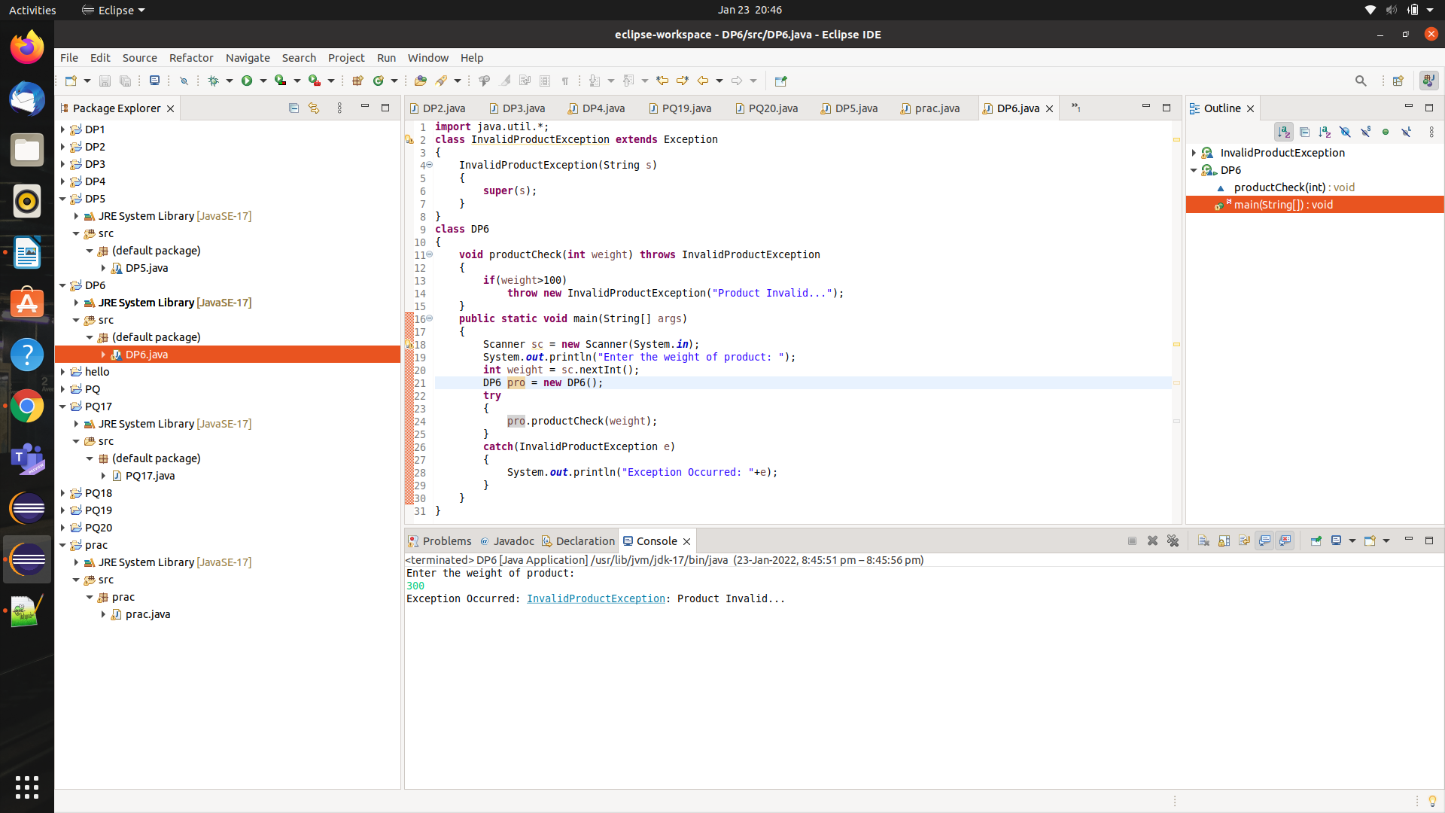

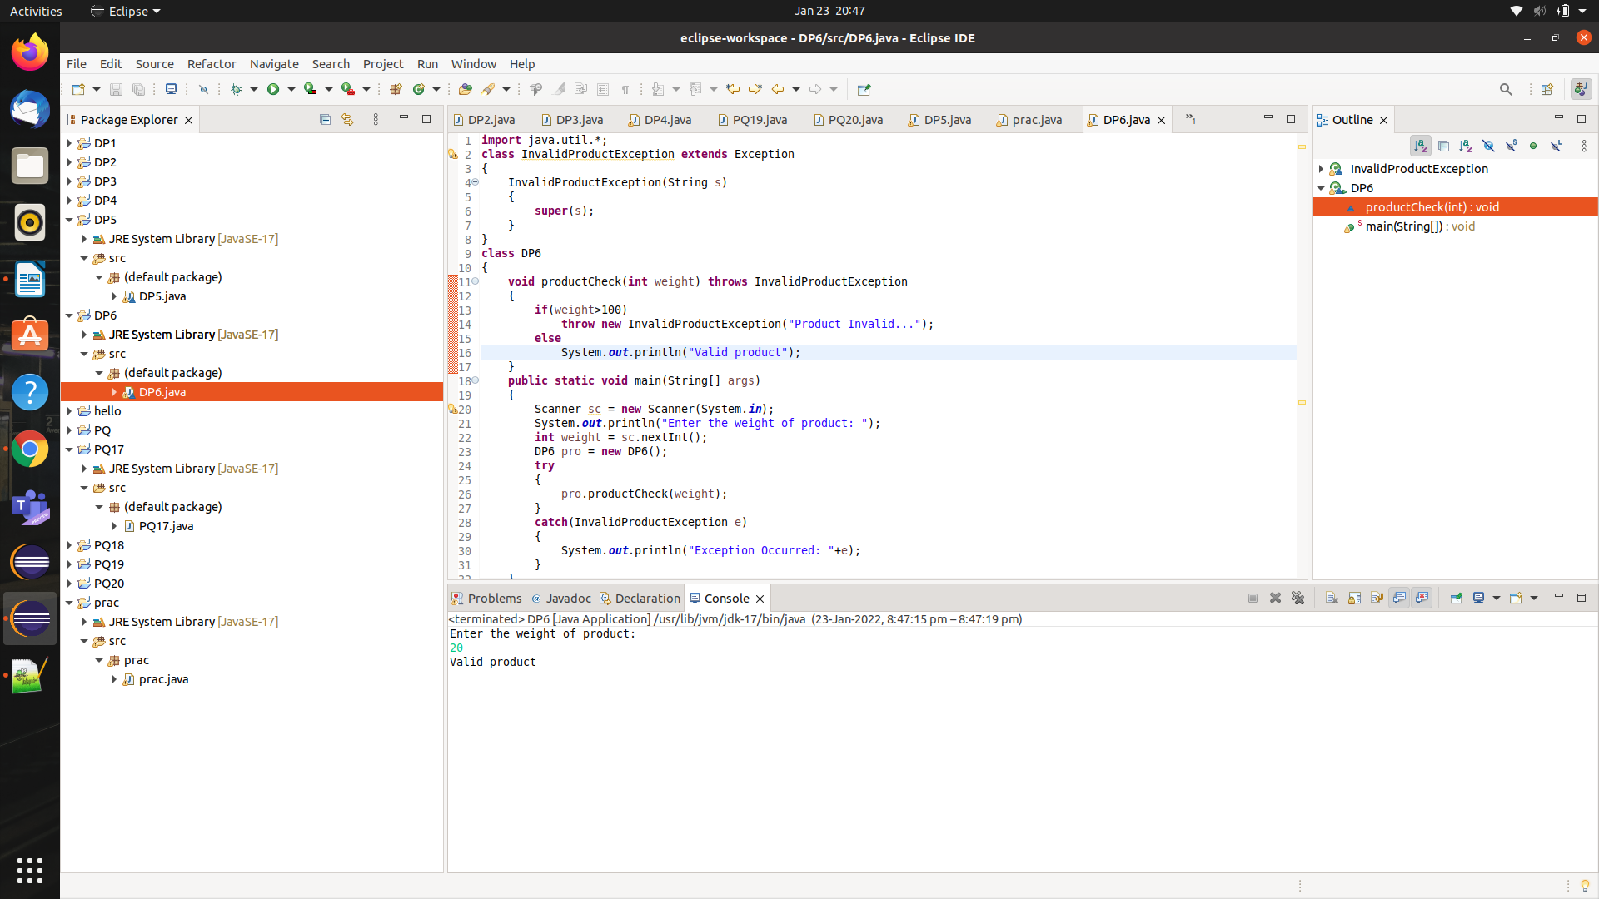

PQ21:- **Create three threads using the class Thread and then running them concurrently?**

**SOLN:-**

**class** ThreadA **extends** Thread

{

**public** **void** run()

{

**for**(**int** i=1;i<=5;i++)

{

System.***out***.println("From thread A with i = "+ (-1*i));

}

System.***out***.println("Exiting from thread A...");

}

}

**class** ThreadB **extends** Thread

{

**public** **void** run()

{

**for**(**int** j=1;j<=5;j++)

{

System.***out***.println("From thread B with j = "+ (2*j));

}

System.***out***.println("Exiting from thread B...");

}

}

**class** ThreadC **extends** Thread

{

**public** **void** run()

{

**for**(**int** k=1;k<=5;k++)

{

System.***out***.println("From thread C with k = "+ (2*k - 1));

}

System.***out***.println("Exiting from thread c...");

}

}

**public** **class** PQ21

{

**public** **static** **void** main(String[] args)

{

ThreadA a= **new** ThreadA();

ThreadB b= **new** ThreadB();

ThreadC c= **new** ThreadC();

a.start();

b.start();

c.start();

System.***out***.println("Mukltithreading is over...");

}

}

OUTPUT:-

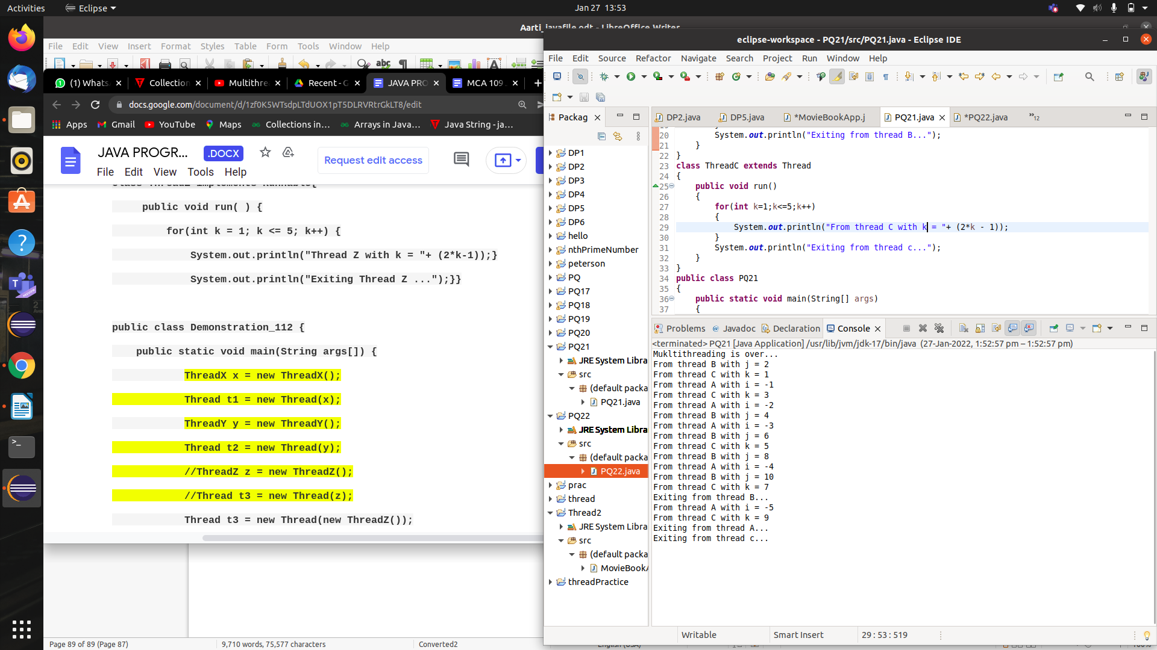

PQ22:-**Creating three threads using the Runnable interface and then running them concurrently.**

**SOLn:-**

**class** ThreadX **implements** Runnable

{

**public** **void** run()

{

**for**(**int** i=1;i<=5;i++)

{

System.***out***.println("Thread X with i = "+ (-1*i));

}

System.***out***.println("Exiting Thread X ...");

}

}

**class** ThreadY **implements** Runnable

{

**public** **void** run()

{

**for**(**int** j=1;j<=5;j++)

{

System.***out***.println("Thread X with j = "+ (2*j));

}

System.***out***.println("Exiting Thread Y ...");

}

}

**class** ThreadZ **implements** Runnable

{

**public** **void** run()

{

**for**(**int** k=1;k<=5;k++)

{

System.***out***.println("Thread X with k = "+ (-1*k));

}

System.***out***.println("Exiting Thread Z ...");

}

}

**public** **class** PQ22

{

**public** **static** **void** main(String[] args)

{

ThreadX x= **new** ThreadX();

Thread t1=**new** Thread(x);

ThreadY y= **new** ThreadY();

Thread t2 = **new** Thread(y);

Thread t3= **new** Thread(**new** ThreadZ());

t1.start();

t2.start();

t3.start();

System.***out***.println("Multithreading is over...");

}

}

**OUTPUT:-**

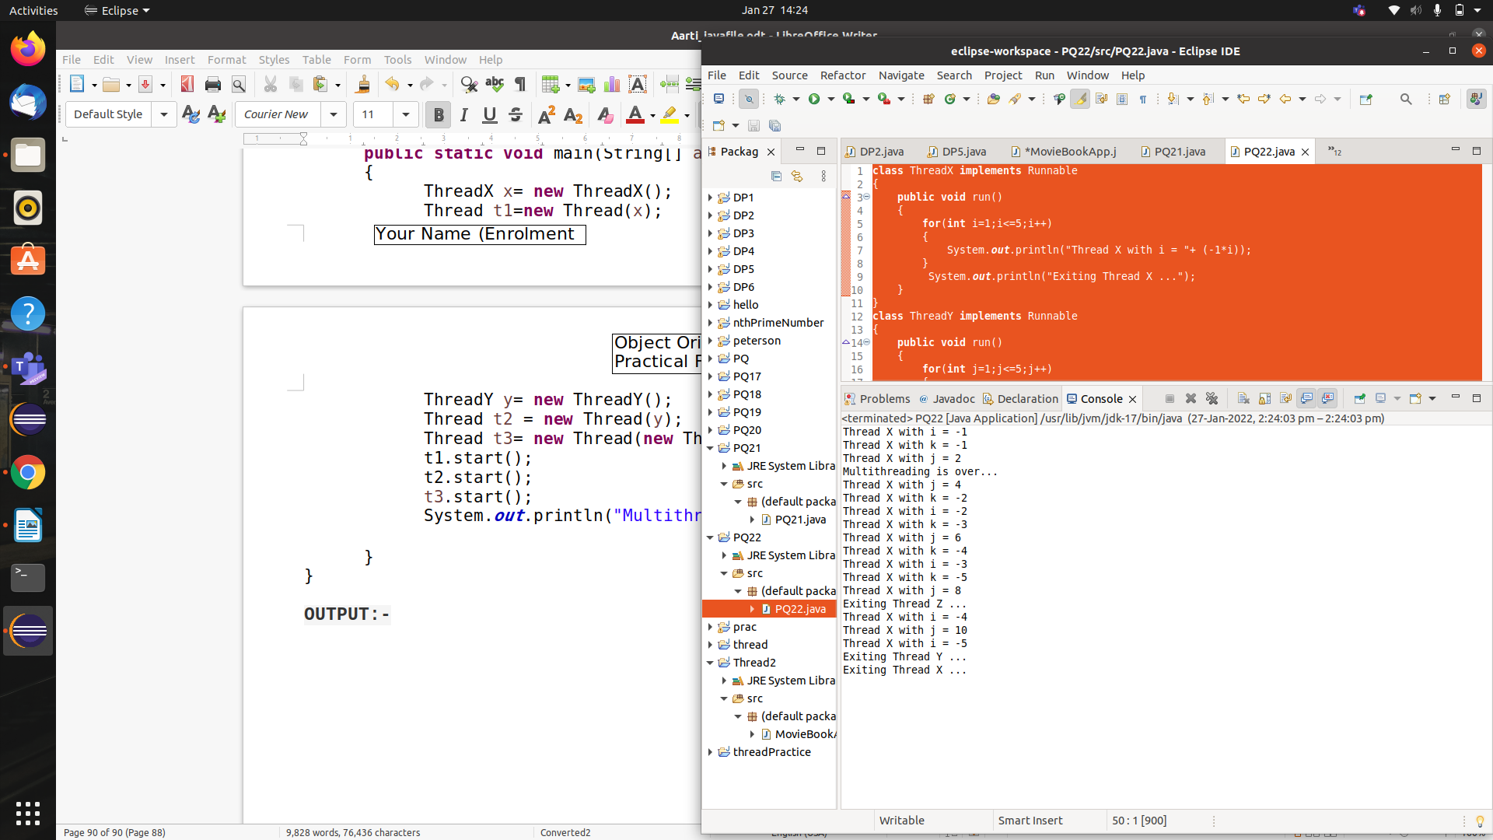

PQ23:- **Retrieve id of currently executing thread?**

SOLN:-

**class** ThreadId **extends** Thread

{

**public** **void** run()

{

System.***out***.println("Thread "+Thread.*currentThread*().getId()+" is running");

}

}

**public** **class** PQ23

{

**public** **static** **void** main(String[] args)

{

**int** n=8; //number of threads

**for**(**int** i=0;i<8;i++)

{

ThreadId object = **new** ThreadId();

object.start();

}

}

}

OUTPUT:-

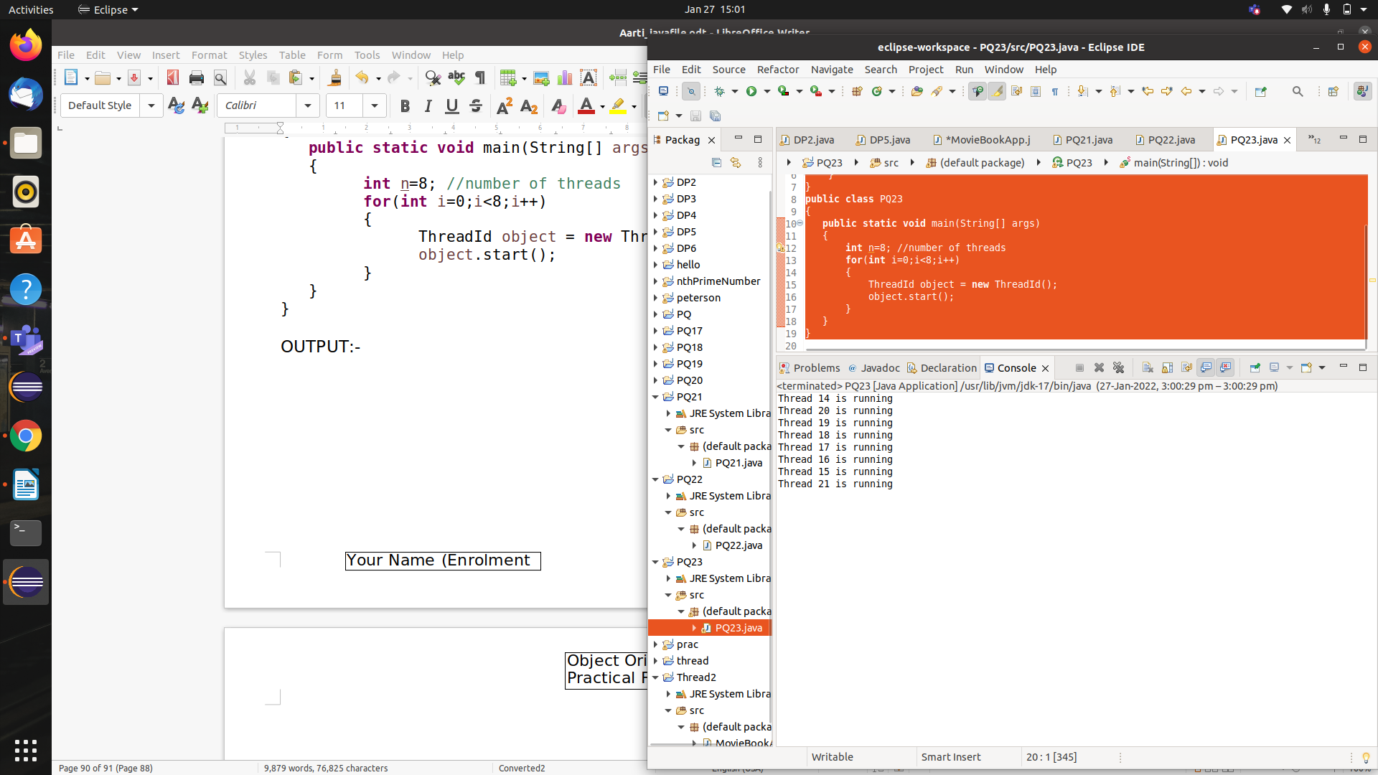

PQ24:- **Use of yield(), stop() and sleep() methods**

**Soln:-**

**class** PQ24 **extends** Thread

{

**public** **void** run()

{

**for**(**int** i=1;i<=5;i++)

{

System.***out***.println(Thread.*currentThread*().getName()+" - " + i);

}

}

**public** **static** **void** main(String[] args)

{

PQ24 t= **new** PQ24();

t.start();

**for**(**int** i=1;i<=5;i++)

{

Thread.*yield*(); //depends upon thread scheduler to accept the hint

System.***out***.println("Main Thread : " +i);

}

}

}

OUTPUT:-

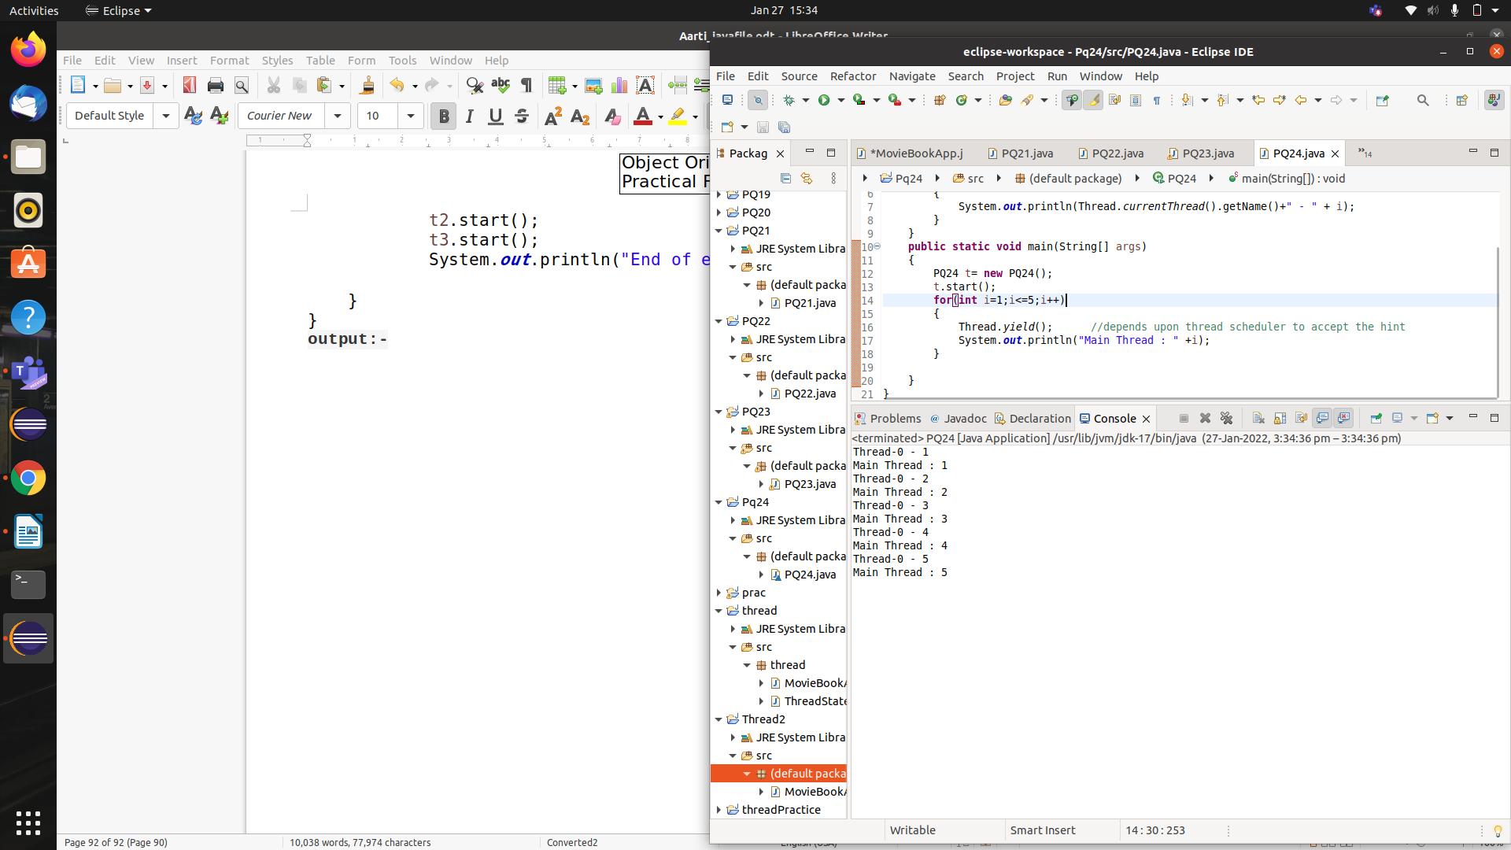

PQ25:-**Use of suspend() and resume() methods**

SOLN:-

**class** Thread1 **extends** Thread

{

**public** **void** run()

{

**try**

{

System.***out***.println (" First thread starts running" );

*sleep*(10000);

System.***out***.println (" First thread finishes running" );

}

**catch**(Exception e){ }

}

}

**class** Thread2 **extends** Thread

{

**public** **void** run( )

{

**try**

{

System.***out***.println ( "Second thread starts running");

System.***out***.println ( "Second thread is suspended itself ");

~~suspend~~( );

System.***out***.println (" Second thread runs again" );

}

**catch**(Exception e){ }

}

}

**public** **class** PQ25

{

**public** **static** **void** main(String[] args)

{

**try**

{

Thread1 first = **new** Thread1();

Thread2 second = **new** Thread2();

first.start();

second.start();

System.***out***.println("Revive the second thread...");

second.~~resume~~();

System.***out***.println("Second thread went for 5 secs...");

second.*sleep*(5000);

System.***out***.println("Wake up 2nd thread and finishes running...");

System.***out***.println("Demonstration is finished");

}

**catch**(Exception e)

{}

}

}

OUTPUT:-

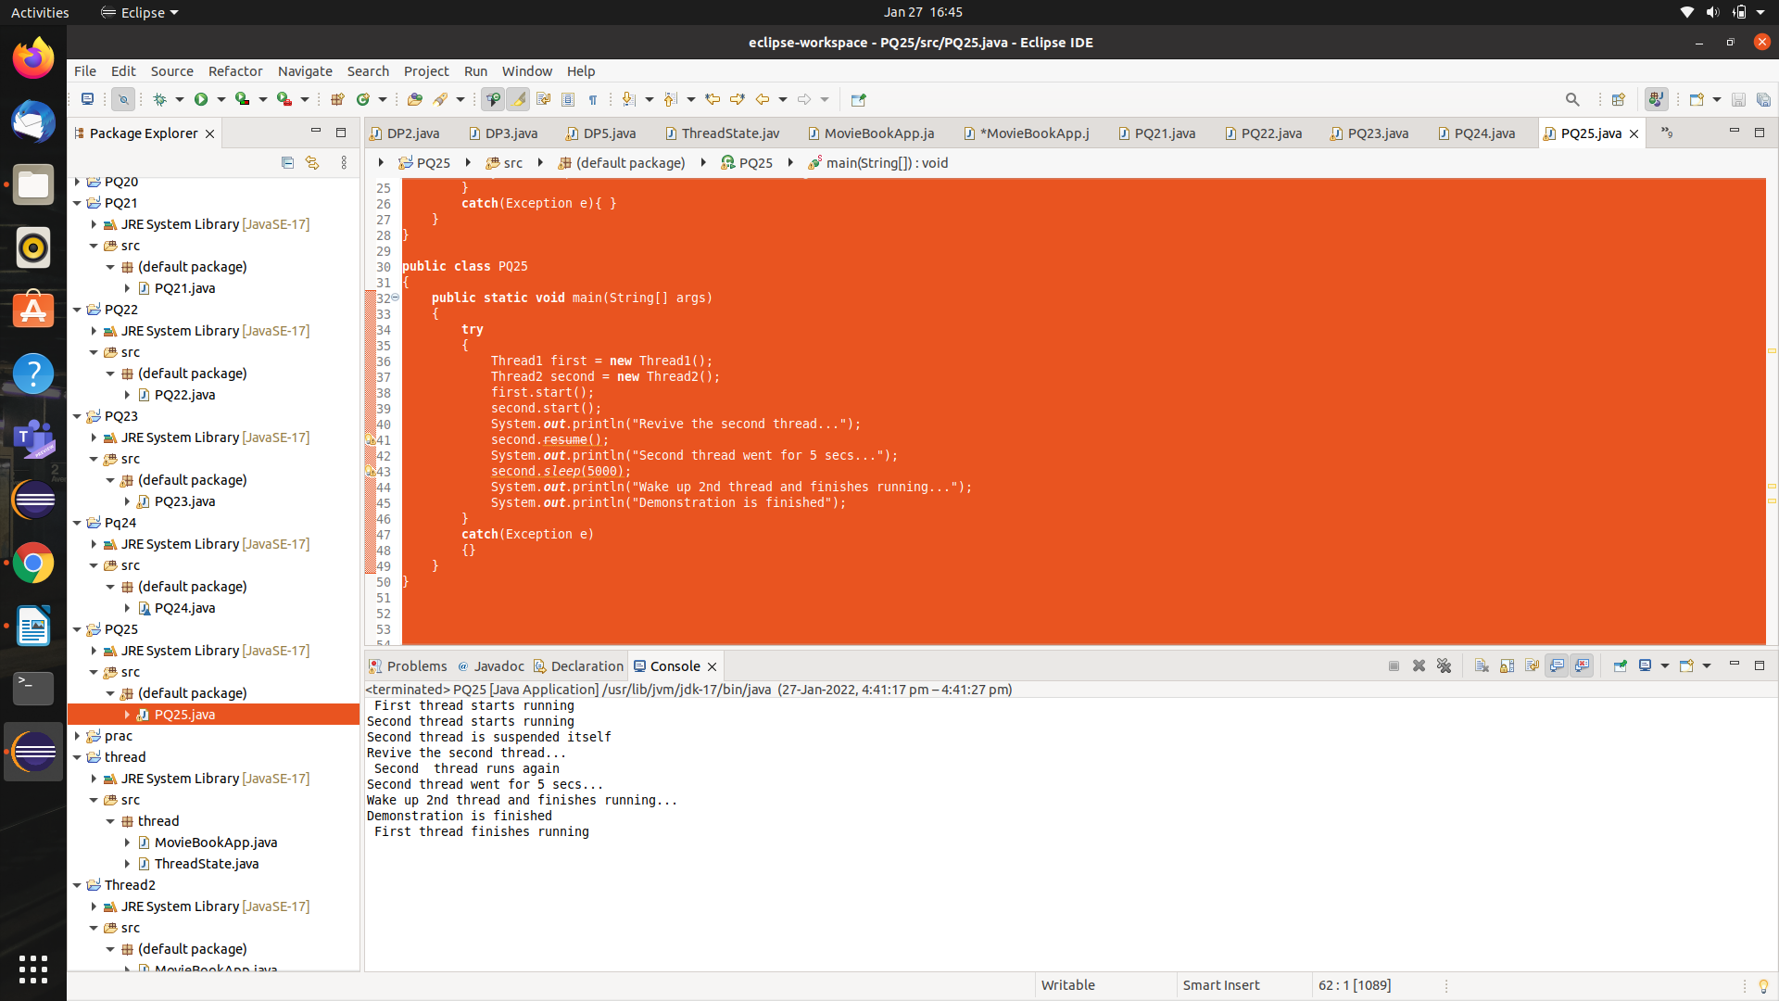

PQ26:- **Setting priority to threads**

**SOLN:-**

**class** test **extends** Thread

{

**public** **void** run()

{

System.***out***.println("Child Thread's priority is (inherited from parent thread which is main)= " + Thread.*currentThread*().getPriority());

Thread.*currentThread*().setPriority(Thread.***MIN_PRIORITY***);

System.***out***.println("priority of child thread after changing it = " + Thread.*currentThread*().getPriority());

}

}

**public** **class** PQ26

{

**public** **static** **void** main(String [] args)

{

test t1= **new** test();

System.***out***.println("Default priority of main thread is = " + Thread.*currentThread*().getPriority());

Thread.*currentThread*().setPriority(Thread.***MAX_PRIORITY***);

System.***out***.println("priority of main thread after changing it = " + Thread.*currentThread*().getPriority());

t1.start();

}

}

OUTPUT:-

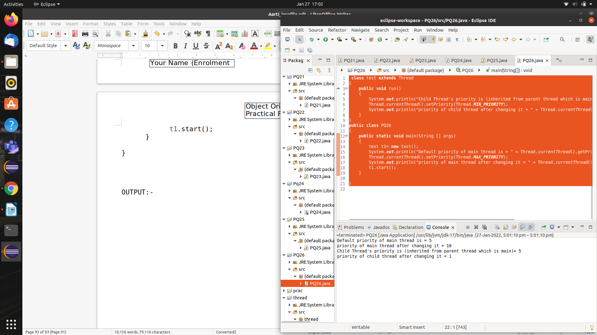

PQ27:- **Joining of the threads**

**SOLN:-**

**class** test **extends** Thread

{

**public** **void** run()

{

**try**

{

**for**(**int** i=1;i<=5;i++)

{

System.***out***.println("Child Thread : "+ i);

Thread.*sleep*(1000);

}

}

**catch**(InterruptedException e)

{

}

}

}

**public** **class** PQ27

{

**public** **static** **void** main(String[] args) **throws** InterruptedException

{

test t=**new** test();

t.start();

t.join();

**try**

{

**for**(**int** i=1;i<=5;i++)

{

System.***out***.println("main Thread : "+ i);

Thread.*sleep*(1000);

}

}

**catch**(InterruptedException e)

{

}

}

}

OUTPUT:-

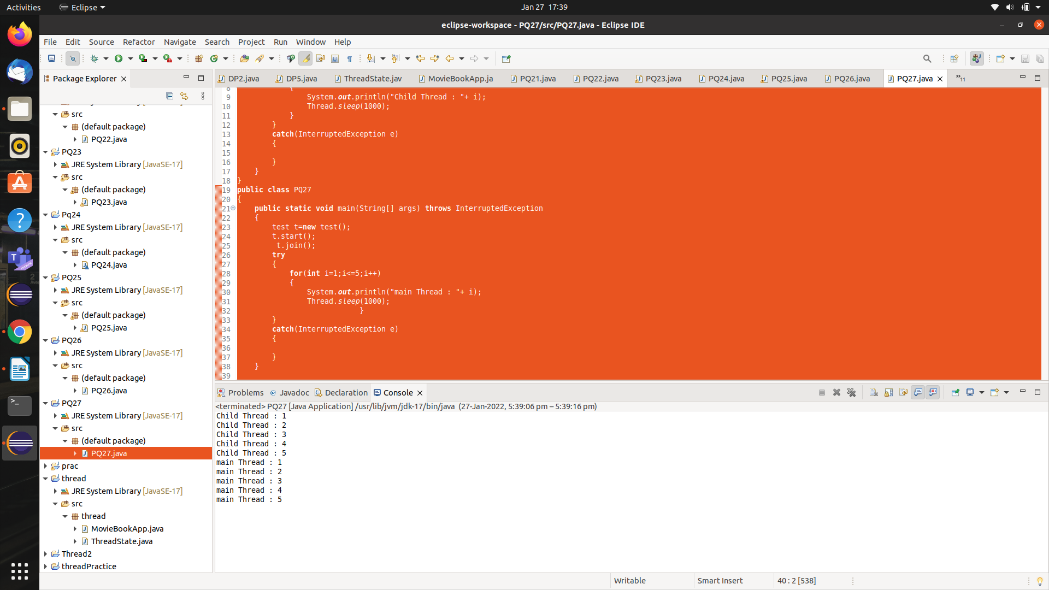

DP7:- The application should print out “Mares do eat oats.” Is it guaranteed to always do this? If not, why not? Would it help to change the  parameters of the two invocations of Sleep? How would you guarantee that all changes to the message will be visible in the main thread?

SOLN:-

**public** **class** DP7 {

**static** String *message*;

**private** **static** **class** CorrectorThread **extends** Thread

{

**public** **void** run()

{

**try**

{

*sleep*(1000);

}

**catch** (InterruptedException e)

{

}

// Key statement 1:

*message* = "Mares do eat oats.";

}

}

**public** **static** **void** main(String[] args) **throws** InterruptedException {

(**new** CorrectorThread()).start();

*message* = "Mares do not eat oats.";

Thread.*sleep*(2000);

// Key statement 2:

System.***out***.println(*message*);

}

}

OUTPUT:-

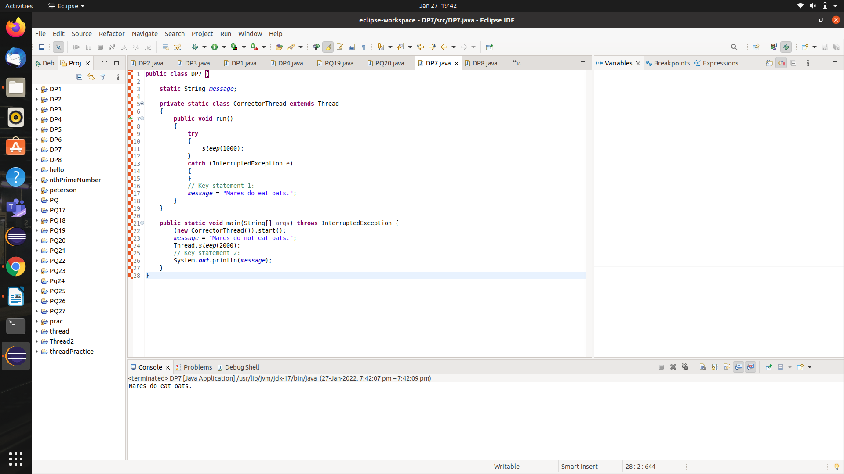

***→ The program will almost always print out “Mares do eat oats”. However this result is not guaranteed because there is no happens-before relationship between “key statement 1” and “key statement 2”. Remember, a happens-before relationship is about visibilty, not sequence.***

***Changing the arguments of two sleep invocations does not help either, since this does nothing to guarantee a happens-before relationship.***

**DP8:-** **Implement the producer consumer problem using multithreading in java. In computing, the producer–consumer problem (also known as the bounded- buffer problem) is a classic example of a multi-process synchronization problem. The problem describes two processes, the producer and the consumer, which share a common, fixed-size buffer used as a queue.**

**a) The producer’s job is to generate data, put it into the buffer, and start again.**

**b)At the same time, the consumer is consuming the data (i.e. removing it from the buffer), one piece at a time.**

**To make sure that the producer won’t try to add data into the buffer if it’s full and that the consumer won’t try to remove data from an empty buffer.**

SOLN:-

**import** java.lang.Thread;

**class** Producer **extends** Thread {

Thread t1;

StringBuffer buffer;

Producer() {

// Initializing the buffer

buffer = **new** StringBuffer(5);

// Creating a new thread with

// the current object

t1 = **new** Thread(**this**);

}

// Overriding the run method

**public** **void** run() {

**for** (**int** i = 0; i < 5; i++) {

buffer.append(i);

System.***out***.println("Produced:- " + i);

**try** {

Thread.*sleep*(1000);

} **catch** (Exception e) {

e.printStackTrace();

}

}

System.***out***.println("\nBuffer is FUll");

Consumer c = **new** Consumer(**this**);

t1 = **new** Thread(c);

t1.start();

}

}

**class** Consumer **extends** Thread {

Producer p;

Consumer(Producer temp) {

p = temp;

}

// Overriding the run method

**public** **void** run() {

**for** (**int** i = 0; i < p.buffer.length(); i++) {

System.***out***.println("Consumed:- " + p.buffer.charAt(i));

**try** {

Thread.*sleep*(1000);

} **catch** (Exception e) {

e.printStackTrace();

}

}

System.***out***.println("\nBuffer is Empty");

}

}

**public** **class** DP8

{

**public** **static** **void** main(String[] args) {

Producer p = **new** Producer();

p.start();

}

}

OUTPUT:-

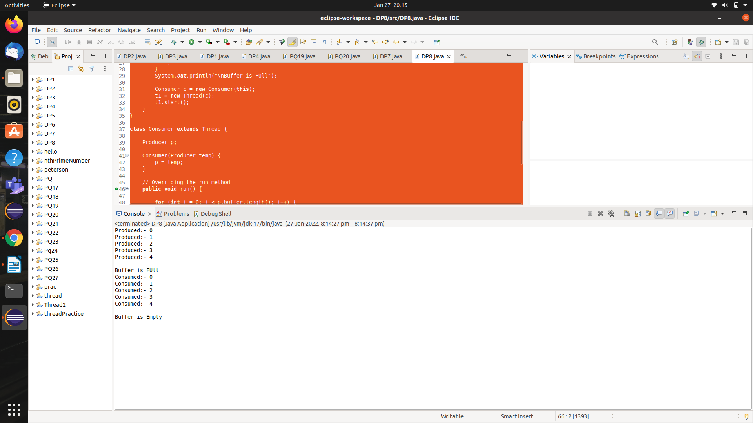

DP9:-Create a Java application that executes concurrent transactions in a bank?

SOLN:-

**class** Account

{

**public** **int** balance;

**public** **int** accountNo;

**void** displayBalance()

{

System.***out***.println("Account No : "+ accountNo + " , Balance : "+balance);

}

**synchronized** **void** deposit(**int** amount)

{

balance = balance + amount;

System.***out***.println(amount+" is deposited");

displayBalance();

}

**synchronized** **void** withdraw(**int** amount)

{

balance=balance-amount;

System.***out***.println(amount+" is withdrawn");

displayBalance();

}

}

**class** TransactionDeposit **implements** Runnable

{

**int** amount;

Account accountX;

TransactionDeposit(Account x,**int** amount)

{

accountX=x;

**this**.amount=amount;

**new** Thread(**this**).start();

}

**public** **void** run()

{

accountX.deposit(amount);

}

}

**class** TransactionWithdraw **implements** Runnable

{

**int** amount;

Account accountY;

TransactionWithdraw(Account y,**int** amount)

{

accountY=y;

**this**.amount=amount;

**new** Thread(**this**).start();

}

**public** **void** run()

{

accountY.withdraw(amount);

}

}

**public** **class** DP9

{

**public** **static** **void** main(String[] args)

{

Account abc=**new** Account();

abc.balance=1000;

abc.accountNo=111;

TransactionDeposit t1;

TransactionWithdraw t2;

t1=**new** TransactionDeposit(abc,500);

t2=**new** TransactionWithdraw(abc,900);

}

}

output:-

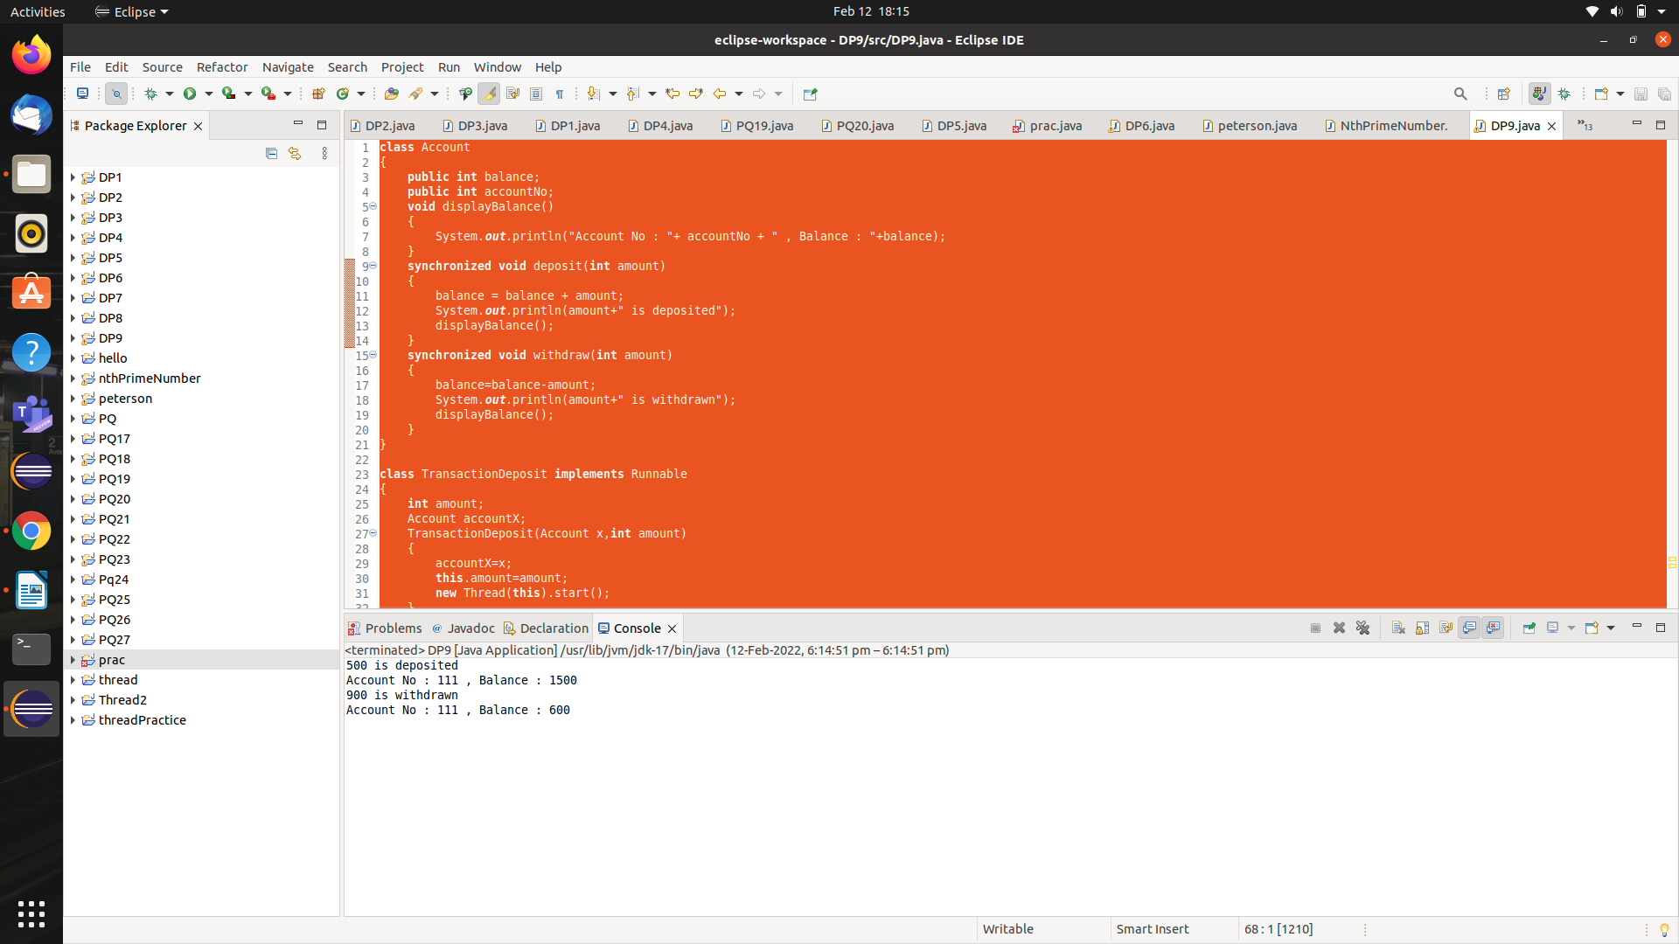

DP10:- **Create a list of numbers and then sort in ascending order as well as in descending order simultaneously.**

SOLN:-

**import** java.util.*;

**class** Numbers

{

**public** **int** result[] =**new** **int**[10];

**void** displayListOfNos()

{

System.***out***.print("Numbers stored in the array : ");

**for**(**int** idx=0;idx<10;idx++)

{

System.***out***.print(result[idx]+" ");

}

System.***out***.println();

}

**void** fillTheArray(**int** aUpperLimit,**int** aArraySize)

{

**if**(aUpperLimit<=0)

{

**throw** **new** IllegalArgumentException("upper limit must be positive: "+aUpperLimit);

}

**if**(aArraySize<=0)

{

**throw** **new** IllegalArgumentException("Array size must be greater than zero. ");

}

Random generator = **new** Random();

**for**(**int** idx=0;idx<aArraySize;idx++)

{

result[idx]=generator.nextInt(aUpperLimit);

}

displayListOfNos();

}

**synchronized** **void** sortAscending()

{

System.***out***.println("After sorting in ascening order...");

**int** temp;

**for** (**int** i = 0; i < result.length; i++)

{

**for** (**int** j = i+1; j < result.length; j++)

{

**if**(result[i] > result[j])

{

temp = result[i];

result[i] = result[j];

result[j] = temp;

}

}

}

displayListOfNos();

}

**synchronized** **void** sortDescending()

{

System.***out***.println("After sorting in descening order...");

**int** temp;

**for** (**int** i = 0; i < result.length; i++)

{

**for** (**int** j = i+1; j < result.length; j++)

{

**if**(result[i] < result[j])

{

temp = result[i];

result[i] = result[j];

result[j] = temp;

}

}

}

displayListOfNos();

}

}

**class** ArrangementAscending **implements** Runnable

{

Numbers n1;

ArrangementAscending(Numbers n)

{

n1=n;

**new** Thread(**this**).start();

}

**public** **void** run()

{

n1.sortAscending();

}

}

**class** ArrangementDescending **implements** Runnable

{

Numbers n2;

ArrangementDescending(Numbers n)

{

n2=n;

**new** Thread(**this**).start();

}

**public** **void** run()

{

n2.sortDescending();

}

}

**public** **class** DP10 {

**public** **static** **void** main(String[] args)

{

Numbers n=**new** Numbers();

n.fillTheArray(20,10);

ArrangementAscending a1=**new** ArrangementAscending(n);

Thread t1=**new** Thread(a1);

ArrangementDescending a2=**new** ArrangementDescending(n);

Thread t2=**new** Thread(a2);

}

}

OUTPUT:-

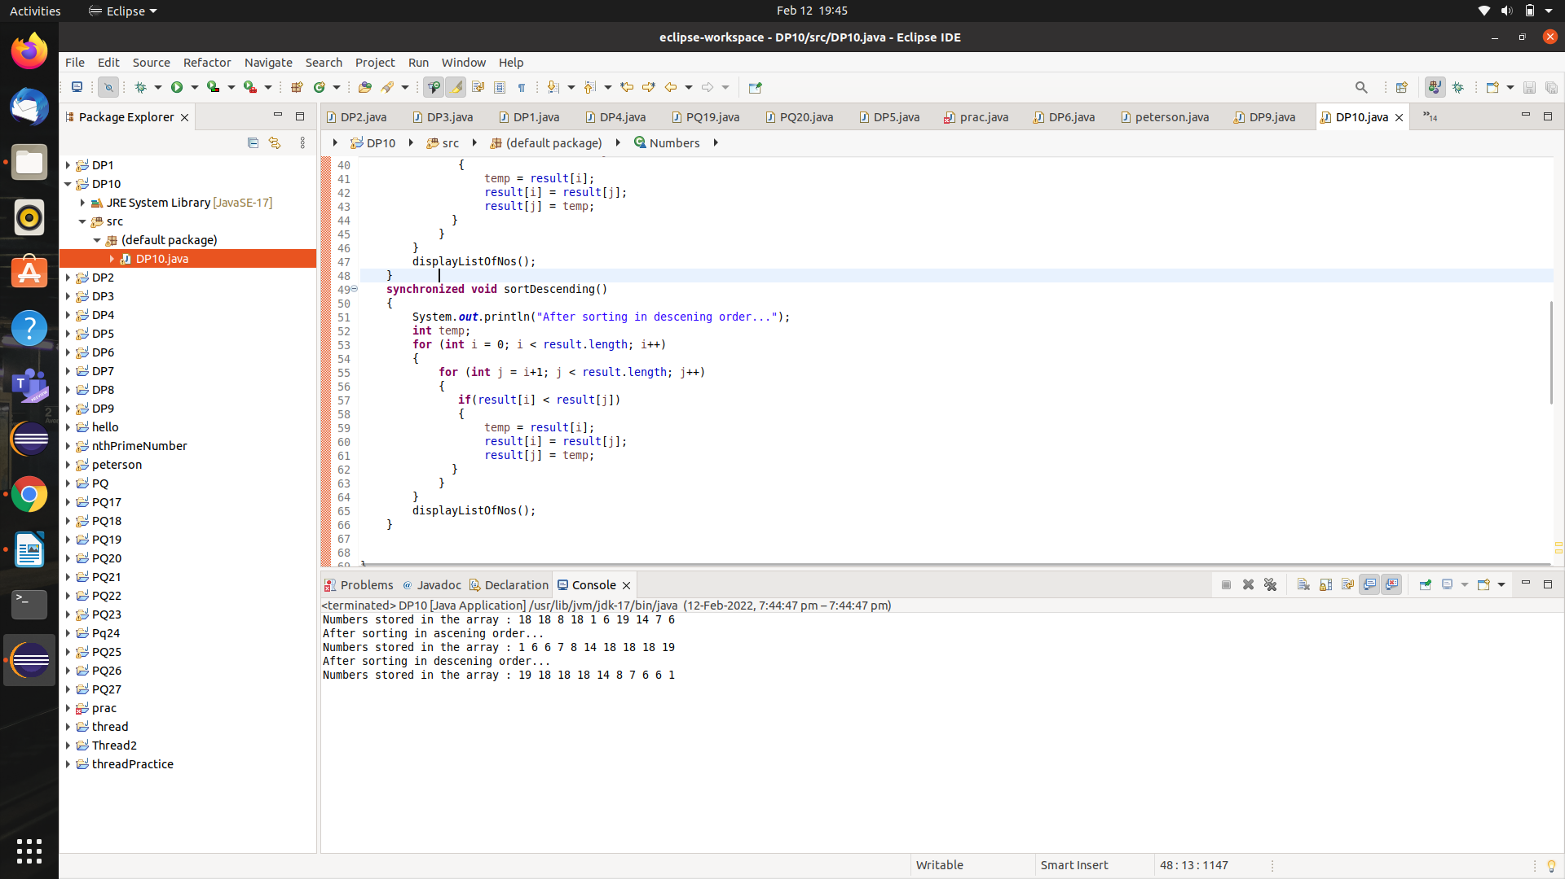

**PQ 28:-**  **Create an ArrayList of CoffeeTypes and add elements to it, also sort the list using different mechanisms?**

SOLN:-

**import** java.util.List;

**import** java.util.ArrayList;

**import** java.util.Iterator;

**public** **class** PQ28

{

**public** **static** **void** main(String[] args)

{

List<String> coffeeList = **new** ArrayList<>();

coffeeList.add("espresso");

coffeeList.add("latte");

coffeeList.add("cappuccino");

System.***out***.println("Printing the list...");

System.***out***.println(coffeeList);

System.***out***.println("Traversing using Iterator...");

Iterator<String> itr= coffeeList.iterator();

**while**(itr.hasNext())

{

String str=itr.next();

System.***out***.println(str);

}

System.***out***.println("Traversing using for-each...");

**for**(String str:coffeeList)

{

System.***out***.println(str.toUpperCase());

}

System.***out***.println("Traversing using for loop...");

**for**(**int** i=0;i<coffeeList.size();i++)

{

System.***out***.println(coffeeList.get(i).substring(0,3));

}

}

}

OUTPUT:-

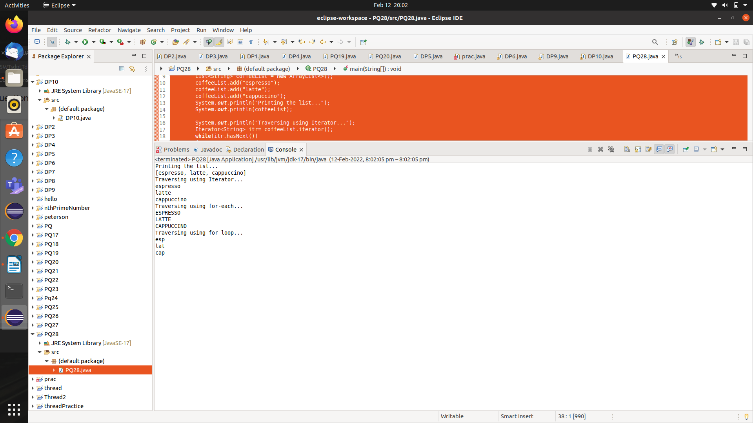

**PQ29:-** **The utility class java.util.Arrays** **and java.util.Collections** **provide many static** **method for the various algorithms such as sorting and searching. Use the Arrays.sort()** **and Collections.sort()** **methods to sort an array of Strings and a List** **of Integers, based on their Comparable<T>'s compareTo()** **method.**

**SOLN:-**

**import** java.util.*;

**public** **class** PQ29

{

**public** **static** **void** main(String[] args)

{

String[] array= {"Hello","hello","Hi","HI","Hello"}; //duplicate elements

System.***out***.println("Original array: "+Arrays.*toString*(array));

Arrays.*sort*(array); //mutable

System.***out***.println("Array afer sorting: "+Arrays.*toString*(array));

//Arrays must be sorted for binary search

System.***out***.println("Finding Hello using Binary search: "+Arrays.*binarySearch*(array, "Hello"));

System.***out***.println("Finding HELLO using Binary search: "+Arrays.*binarySearch*(array, "HELLO"));

// Sort/search a List<Integer> using Collections.sort() and Collections.binarySearch()

List<Integer> list=**new** ArrayList<>();

list.add(22);

list.add(11);

list.add(44);

list.add(11); // duplicate element

System.***out***.println("Original list: "+list);

Collections.*sort*(list);

System.***out***.println("List after using sort() method : "+list); //[11, 11, 22, 44]

System.***out***.println("Finding 22 using Binary search: "+Collections.*binarySearch*(list, 22)); //2

System.***out***.println("Finding 35 using Binary search: "+Collections.*binarySearch*(list, 35)); //-4

}

}

OUTPUT:-

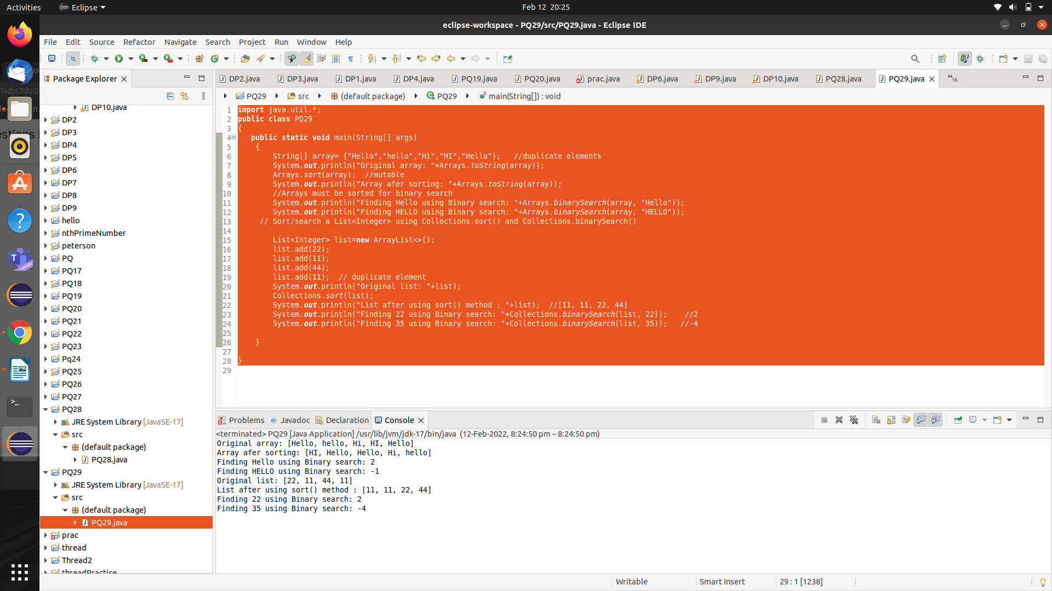

**PQ30:-** **write a Book** **class, and create a Set** **of Book** **objects.**

**SOLN:-**

**import** java.util.*;

**class** Book

{

**private** **int** id;

**private** String title;

**public** Book(**int** id, String title)

{ // constructor

**this**.id = id;

**this**.title = title;

}

@Override

**public** String toString()

{ // describe itself

**return** id + ": " + title;

}

// Two books are equal if they have the same id

@Override

**public** **boolean** equals(Object o)

{

**return** o != **null** && o **instanceof** Book && **this**.id == ((Book)o).id;

}

// To be consistent with equals(). Two objects which are equal have the same hash code.

@Override

**public** **int** hashCode()

{

**return** id;

}

/*We need to provide an equals() method, so that the Set implementation can test for equality and duplication. In this example,

we choose the id as the distinguishing feature. We override equals() to return true if two books have the same id.

We also override the hashCode() to be consistent with equals().*/

}

**public** **class** PQ30

{

**public** **static** **void** main(String[] args)

{

Book book1 = **new** Book(1, "Java for Beginners");

Book book1Dup = **new** Book(1, "Java for the Beginners"); // same id

Book book2 = **new** Book(2, "Java for more Beginners");

Book book3 = **new** Book(3, "more Java for more Beginners");

Set<Book> set1 = **new** HashSet<Book>();

set1.add(book1);

set1.add(book1Dup); // duplicate id, not added

set1.add(book1); // added twice, not added

set1.add(book3);

set1.add(**null**); // Set can contain a null

set1.add(**null**); //no duplicate

set1.add(book2);

System.***out***.println(set1);

set1.remove(book1);

set1.remove(book3);

System.***out***.println(set1);

Set<Book> set2 = **new** HashSet<Book>();

set2.add(book3);

System.***out***.println(set2); //[3: more Java for more beginners]

set2.addAll(set1); // "union" with set1

System.***out***.println(set2);

set2.remove(**null**);

System.***out***.println(set2);

set2.retainAll(set1); // "intersection" with set1

System.***out***.println(set2);

System.***out***.println("Demonstration of LinkedHashSet...");

LinkedHashSet<Book> set=**new** LinkedHashSet<Book>();

set.add(book1);

set.add(book1Dup); // duplicate id, not added

set.add(book1); // added twice, not added

set.add(book3);

set.add(**null**); // Set can contain a null

set.add(**null**); // but no duplicate

set.add(book2);

System.***out***.println(set);

}

}

OUTPUT:-

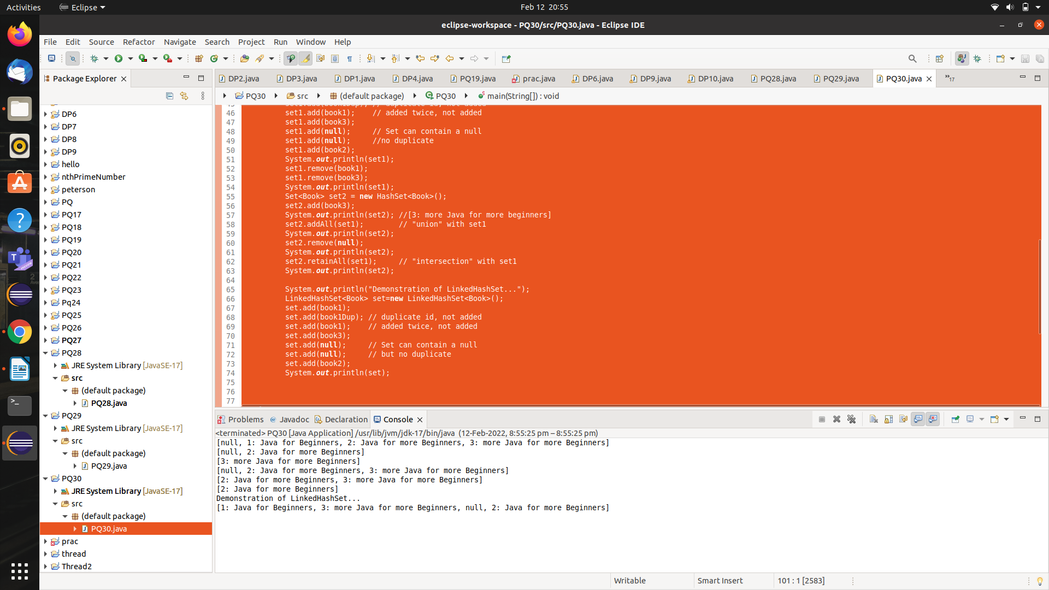

**PQ31:- Demonstration of HashMap.**

Soln:-

**import** java.util.Map;

**import** java.util.HashMap;

**import** java.util.Iterator;

**public** **class** PQ31

{

**public** **static** **void** main(String[] args)

{

Map<String,Double> map=**new** HashMap<>();

map.put("espresso", 1.1);

map.put("latte", 2.2);

map.put("cappuccino", 3.3);

System.***out***.println(map);

// Using .entrySet() which returns a Set<Map.Entry> to iterate through the map

System.***out***.println("Traversing using .entrySet()...");

**for**(Map.Entry<String,Double> e : map.entrySet())

{

e.setValue(e.getValue() + 10.0); //modify value

System.***out***.println(e.getKey() + ":" + e.getValue());

}

// Using for-each loop on .keySet() which returns a Set to iterate

//through the map .keySet() returns a Set of keys

System.***out***.println("Keys= "+map.keySet());

System.***out***.println("Traversing using keySet() and for each loop...");

**for**(String key:map.keySet())

{

System.***out***.println(key + "=" + map.get(key));

}

// Using Iterator on .keySet() to iterate through the map

System.***out***.println("Traversing using keySet() and iterator()...");

Iterator<String> itr=map.keySet().iterator();

**while** (itr.hasNext())

{

String key = itr.next();

System.***out***.println(key + ":" + map.get(key));

}

// .values() returns a Collection of values

System.***out***.println("Values= "+map.values());

}

}

OUTPUT:-

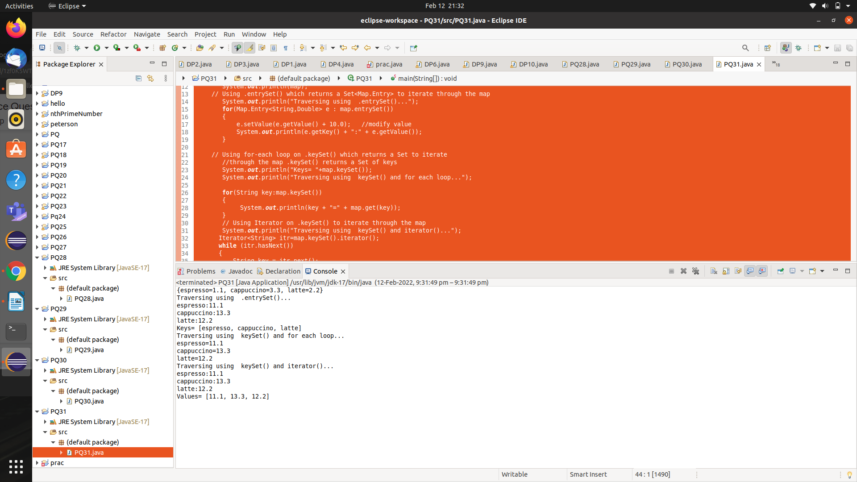

**PQ32:-****Java program to demonstrate the working of ArrayList and LinkedList.**

**SOLN:-**

**import** java.util.*;

**import** java.io.*;

**public** **class** PQ32

{

**public** **static** **void** main(String[] args)

{

//ArrayList can not be used for primitive types, like int, char, etc.

//We will need a wrapper class for such cases.

ArrayList<Integer> al = **new** ArrayList<Integer>();

LinkedList<Integer> ll = **new** LinkedList<Integer>();

// Appending new elements at the end of the list

**for** (**int** i = 10; i <= 15; i++)

{

al.add(i);

ll.add(i);

}

// Printing elements

System.***out***.println(al);

System.***out***.println(ll);

// Remove element at index 3

al.remove(3);

ll.remove(3);

// Displaying the ArrayList after deletion

System.***out***.println(al);

System.***out***.println(ll);

// Printing elements one by one

**for** (**int** i = 0; i < al.size(); i++)

{

System.***out***.print(al.get(i) + " ");

System.***out***.print(ll.get(i)+" ");

}

}

}

**OUTPUT:-**

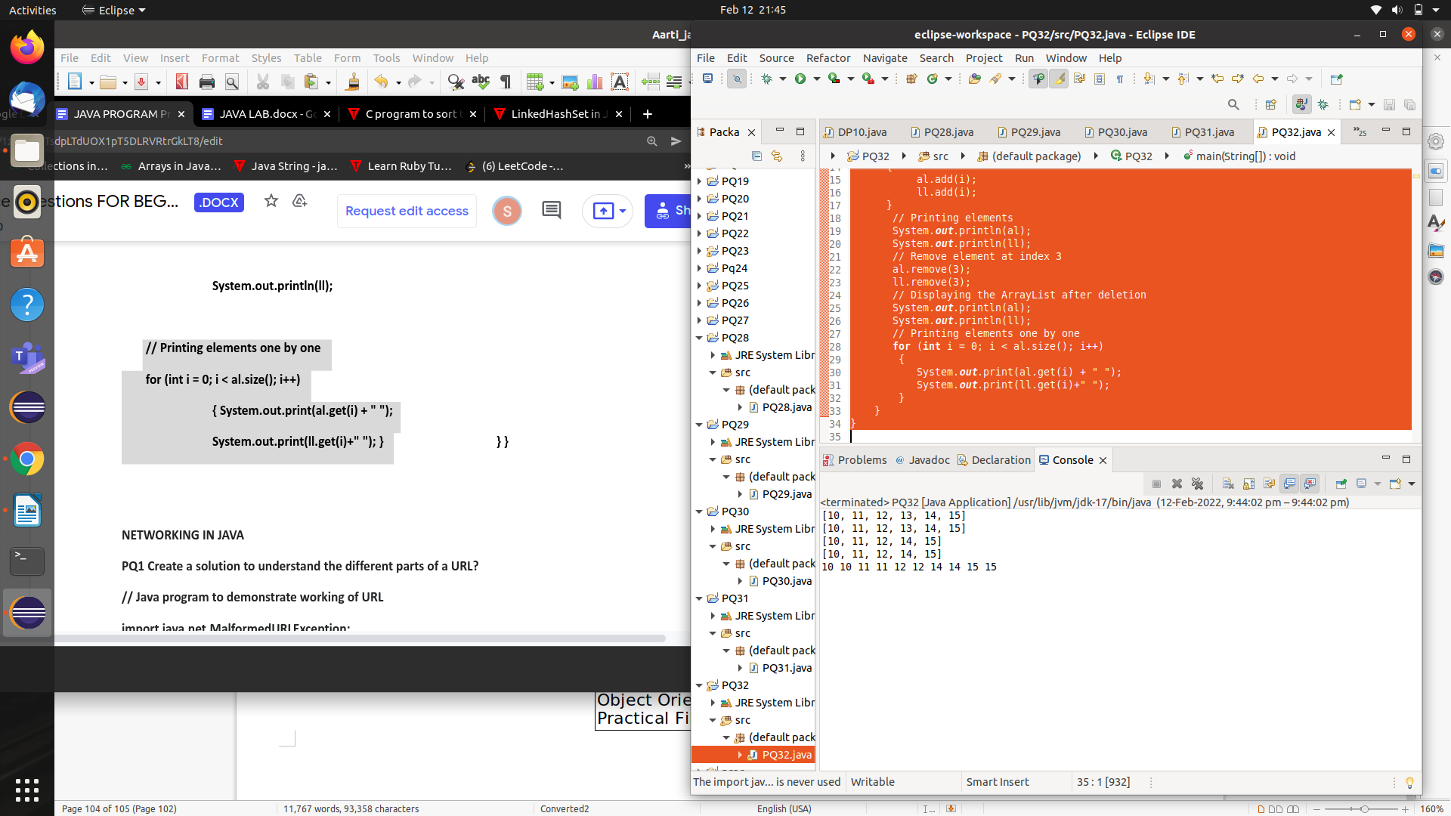

**EP1:-** **Model Person with name and age.Manage instances of Person by ensuring that no two instances are duplicated?**

**SOLN:-**

**import** java.util.*;

**class** person

{

**private** String name;

**private** **int** age;

**public** person(String name,**int** age)

{

**this**.name=name;

**this**.age=age;

}

**public** String getName()

{

**return** name;

}

**public** **int** getAge()

{

**return** age;

}

**public** String toString()

{

**return** name+"("+age+")";

}

**public** **void** sayHello()

{

System.***out***.println(name+" says hello");

}

**public** **boolean** equals(Object o)

{

**return** o!=**null** && o **instanceof** person && **this**.name.equalsIgnoreCase(((person) o).name);

}

**public** **int** hashCode()

{

**return** **this**.name.toLowerCase().hashCode();

}

}

**public** **class** EP1

{

**public** **static** **void** main(String[] args)

{

Set<person> personSet = **new** HashSet<>();

personSet.add(**new** person("Peter",21));

personSet.add(**new** person("Paul",18));

personSet.add(**new** person("John",60));

System.***out***.println("Elements of set are : "+personSet);

//unlike set, a set is not ordered

**for**(person p: personSet)

p.sayHello();

System.***out***.println("Duplicate element added/not added? : "+ (personSet.add(**new** person("Peter",21))));

Scanner s=**new** Scanner(System.***in***);

System.***out***.println("Hello , What is your name : ");

String name=s.nextLine();

System.***out***.println("Hello "+name+" What is your age : ");

**int** age=s.nextInt();

personSet.add(**new** person(name,age));

System.***out***.println(personSet);

}

}

OUTPUT:-

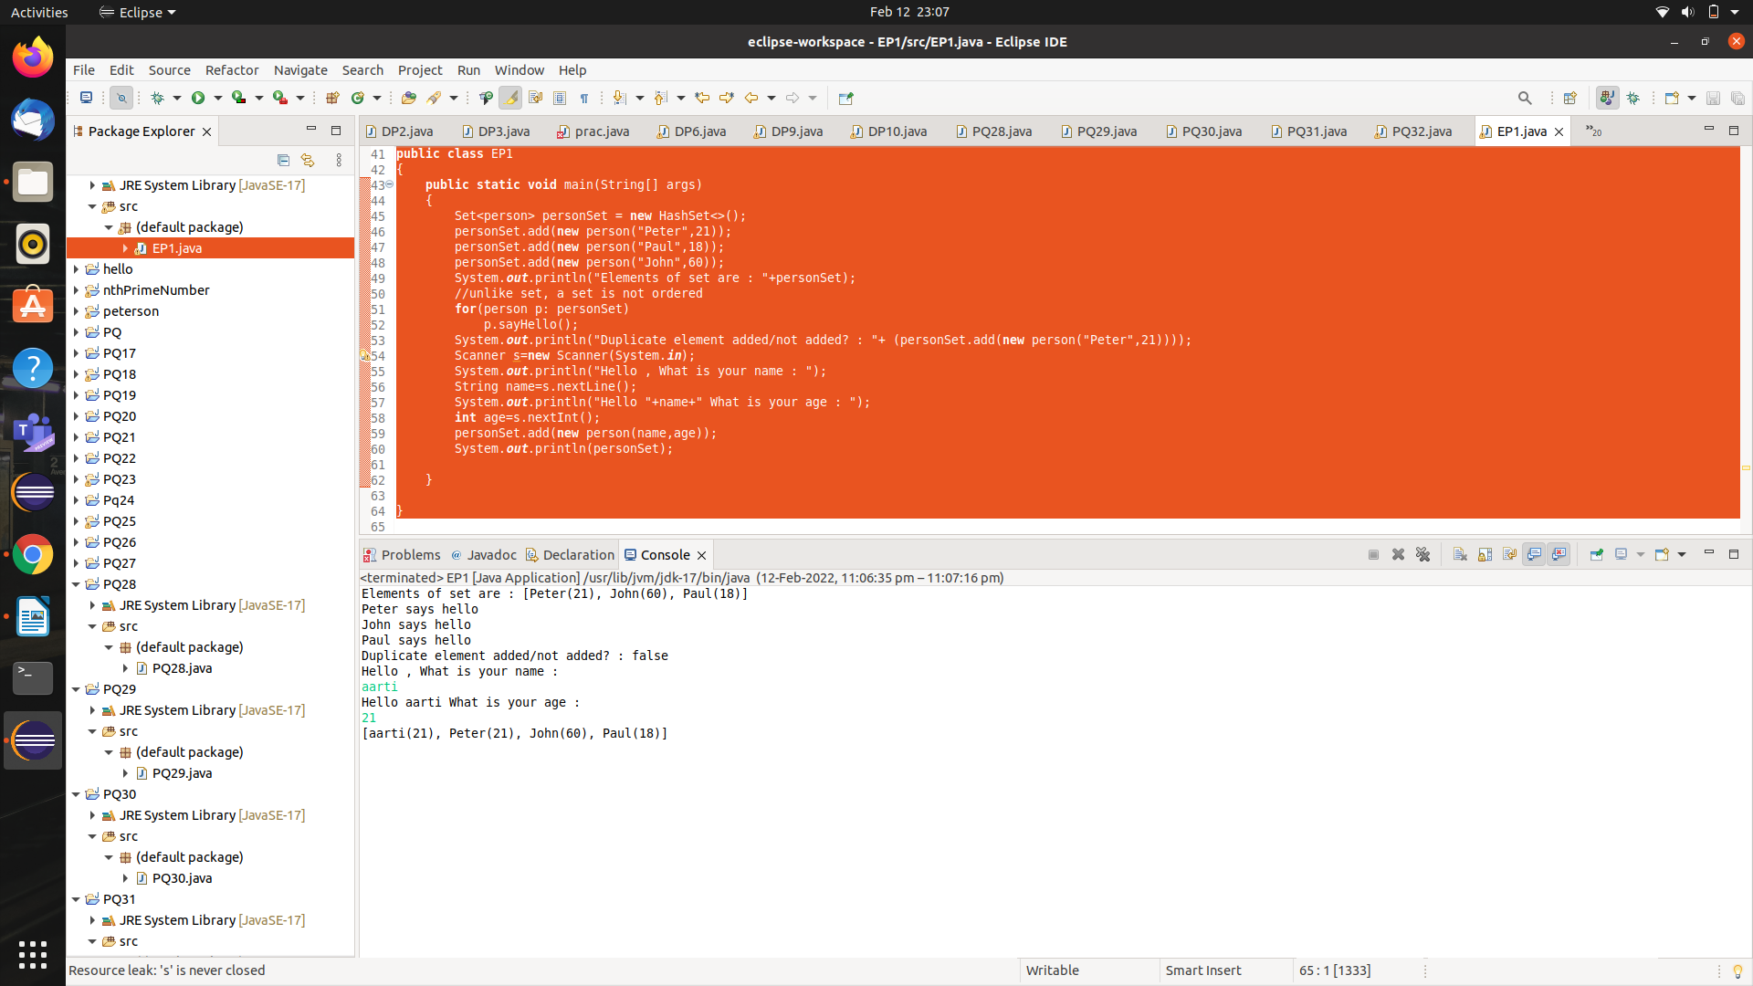

**EP2:-** **Create a subclass of Person (in EP1 above), called ComparablePerson which implements Comparable<Person> interface, and try out the Collections.sort() and Collections.binarySearch() methods on the same.**

**SOLN:-**

**import** java.util.*;

**class** person

{

**private** String name;

**private** **int** age;

**public** person(String name,**int** age)

{

**this**.name=name;

**this**.age=age;

}

**public** String getName()

{

**return** name;

}

**public** **int** getAge()

{

**return** age;

}

**public** String toString()

{

**return** name+"("+age+")";

}

**public** **void** sayHello()

{

System.***out***.println(name+" says hello");

}

**public** **boolean** equals(Object o)

{

**return** o!=**null** && o **instanceof** person && **this**.name.equalsIgnoreCase(((person) o).name);

}

**public** **int** hashCode()

{

**return** **this**.name.toLowerCase().hashCode();

}

}

**class** comparablePerson **extends** person **implements** Comparable<person>

{

**public** comparablePerson(String name,**int** age)

{

**super**(name,age);

}

**public** **int** compareTo(person p)

{

**return** **this**.getName().compareToIgnoreCase(p.getName());

}

}

**public** **class** EP2

{

**public** **static** **void** main(String[] args)

{

List<comparablePerson> pLst= **new** ArrayList<>();

pLst.add(**new** comparablePerson("Peter",21));

pLst.add(**new** comparablePerson("Paul",18));

pLst.add(**new** comparablePerson("John",81));

System.***out***.println("Elements of the list are: "+pLst);

Collections.*sort*(pLst); //mutable

System.***out***.println("Sorted list: "+pLst);

System.***out***.println(Collections.*binarySearch*(pLst,**new** comparablePerson("Paul",18)));

System.***out***.println(Collections.*binarySearch*(pLst,**new** comparablePerson("Peter",21)));

System.***out***.println(Collections.*binarySearch*(pLst,**new** comparablePerson("Kelly",18)));

}

}

**OUTPUT:-**

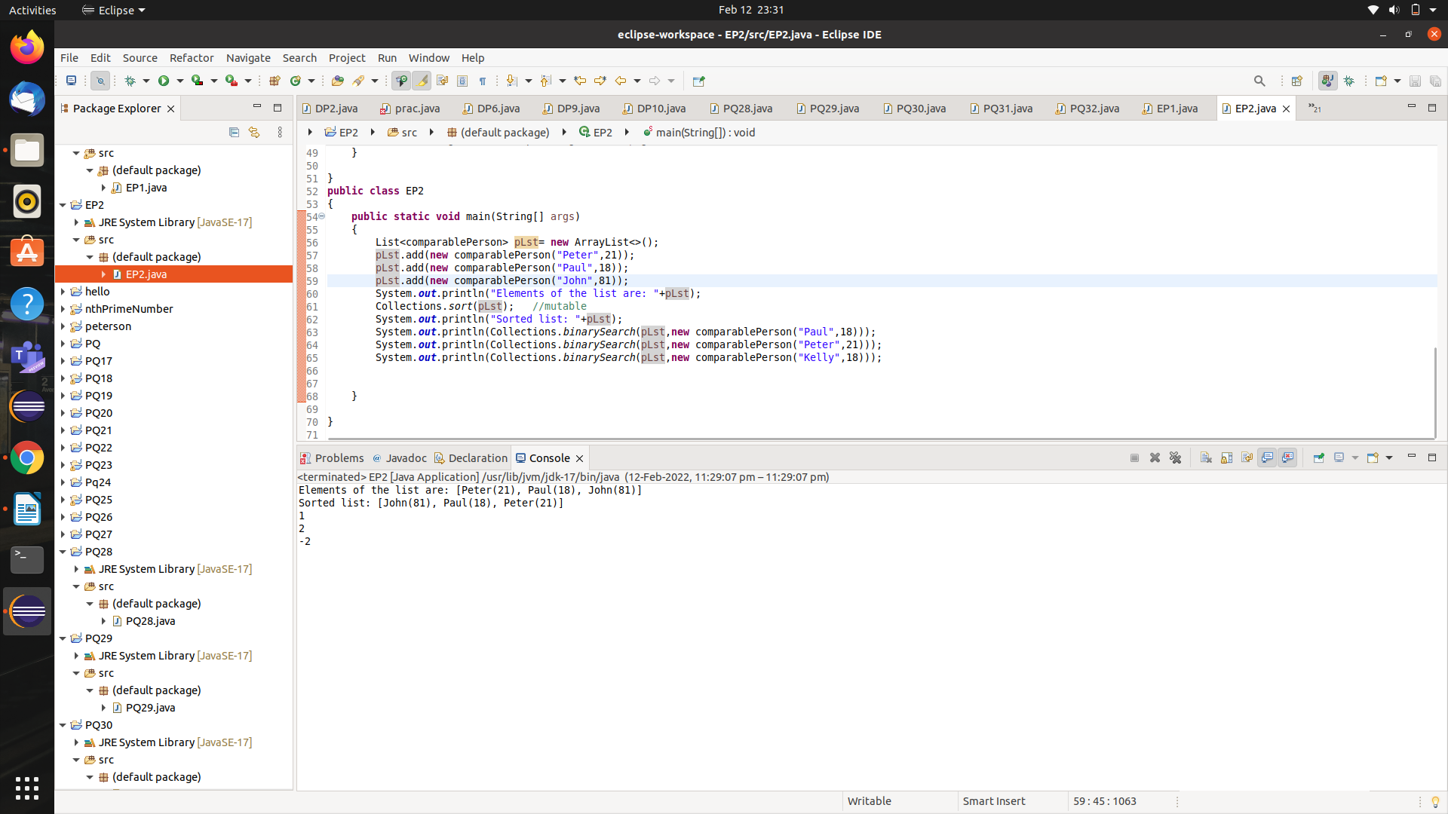

**EP3:-** **Model AddressBookEntry that prints name,address and phone of a person. Allow comparison of AddressBookEntry to compare name in a case sensitive manner?**

**SOLN:-**

**import java.util.TreeSet;**

**class** AddressBookEntry **implements** Comparable<AddressBookEntry>

{

**private** String name,address,phone;

**public** AddressBookEntry(String name) //ignore address and phone

{

**this**.name=name;

}

//override

**public** String toString()

{

**return** name;

}

**public** **int** compareTo(AddressBookEntry other)

{

**return** **this**.name.compareToIgnoreCase(other.name);

}

**public** **boolean** equals(Object o)

{

**return** o!=**null** && o **instanceof** AddressBookEntry && **this**.name.equalsIgnoreCase(((AddressBookEntry)o).name);

}

//two objects which are equal shall have same hashcode

//override

**public** **int** hashCode()

{

**return** name.toLowerCase().hashCode();

}

}

**public** **class** EP3 {

**public** **static** **void** main(String[] args)

{

AddressBookEntry addr1= **new** AddressBookEntry("Peter");

AddressBookEntry addr2= **new** AddressBookEntry("PAUL");

AddressBookEntry addr3= **new** AddressBookEntry("Patrick");

TreeSet<AddressBookEntry> set=**new** TreeSet<>();

set.add(addr1);

set.add(addr2);

set.add(addr3);

System.***out***.println(set);

System.***out***.println(set.floor(addr2)); //Paul //equal or closest least element

System.***out***.println(set.lower(addr2)); //Patrick //closest least element

System.***out***.println(set.headSet(addr2)); //[Patrick] //It returns the group of elements that are less than or equal to(if, inclusive is true) the specified element.

System.***out***.println(set.tailSet(addr2)); //[Paul,Peter] //It returns a set of elements that are greater than or equal to the specified element.

}

}

**OUTPUT:-**

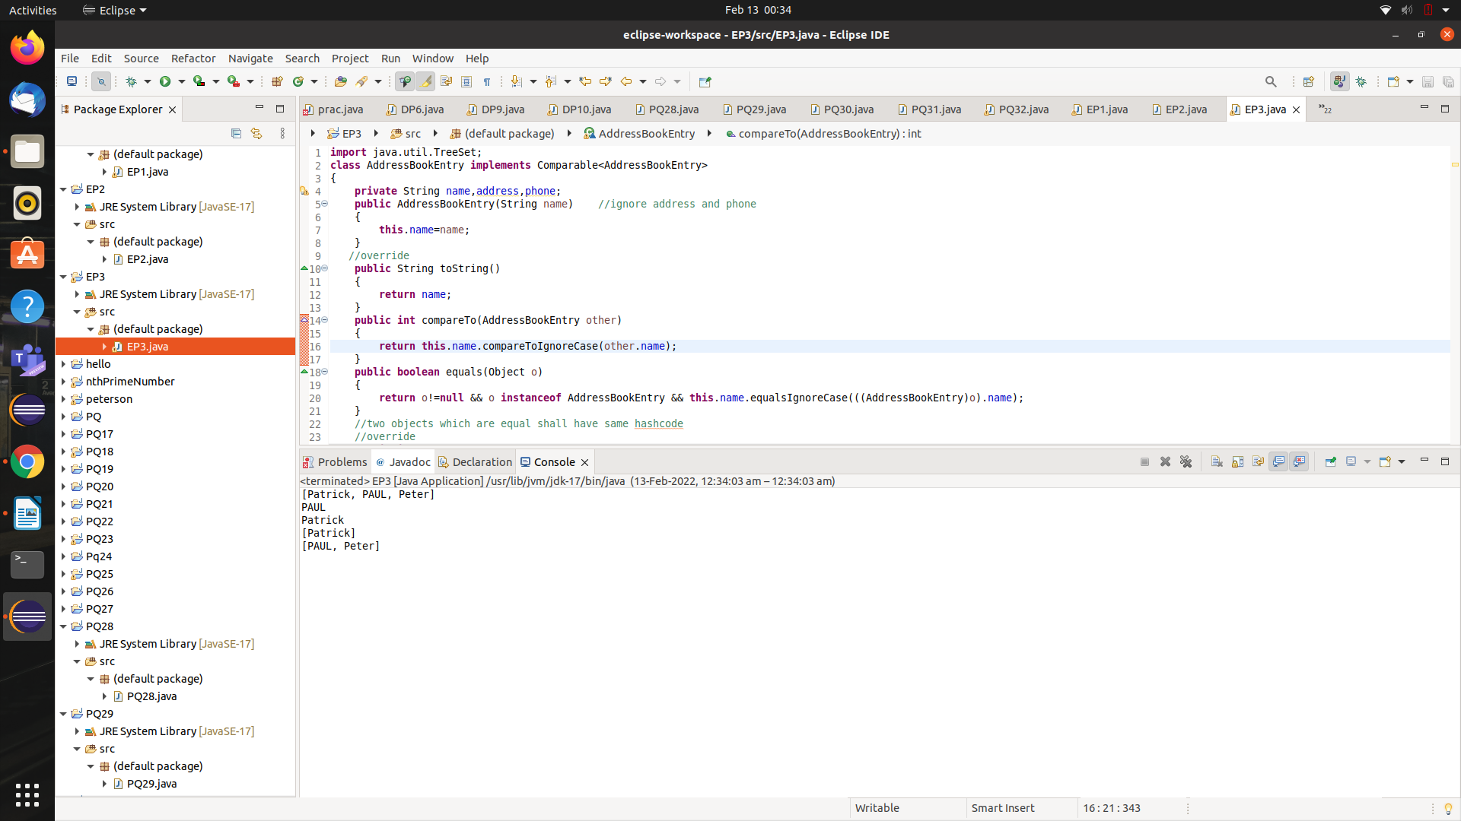

**EP4:-** **Counts the frequency of each of the words in a file given in the command-line,and save in a map of {word, freq}.**

**SOLN:**

**import java.util.Map;**

**import** java.util.HashMap;

**import** java.util.Scanner;

**import** java.io.*;

**public** **class** EP4

{

**public** **static** **void** main(String[] args) **throws** Exception

{

System.***out***.println(args[0]);

Scanner in=**new** Scanner(**new** File(args[0]));

Map<String,Integer> map=**new** HashMap<>();

**while**(in.hasNext())

{

String word = in.next();

**int** freq = (map.get(word) == **null**) ? 1: map.get(word)+1; //type safe

map.put(word, freq);

}

System.***out***.println(map);

}

}

**OUTPUT:-**

**//create a .txt file(word.txt) in the same folder and pass it as command line argument.**

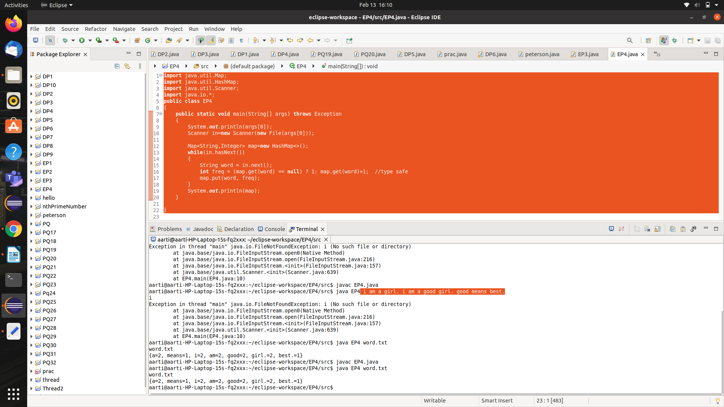

**PQ33:-** **Create a solution to understand the different parts of a URL?**

SOLN:-

import java.net.MalformedURLException;

import java.net.URL;

public class Pq33

{

public static void main(String[] args) throws MalformedURLException

{

//create a url with with string representation

URL url1= new URL("http://bvicam.in/spec-subject-files/Object%20Oriented%20Programming%20and%20JAVA%20");

//create a url with protocol,hostname and path

URL url2= new URL("http","www,bvicam.ac.in","/bjit/");

URL url3= new URL("http://bvicam.in/search/node/faculty");

System.out.println("URL1: "+url1.toString());

System.out.println("URL2 : "+ url2.toString());

System.out.println();

System.out.println("Different components of the URL3 : ");

System.out.println("Protocol: "+url3.getProtocol());

System.out.println("Hostname: "+url3.getHost());

System.out.println("Default port: "+ url3.getDefaultPort());

System.out.println("Query : "+ url3.getQuery());

System.out.println("Path: "+url3.getPath());

System.out.println("File : "+ url3.getFile());

System.out.println("Reference : "+url3.getRef());

}

OUTPUT:-

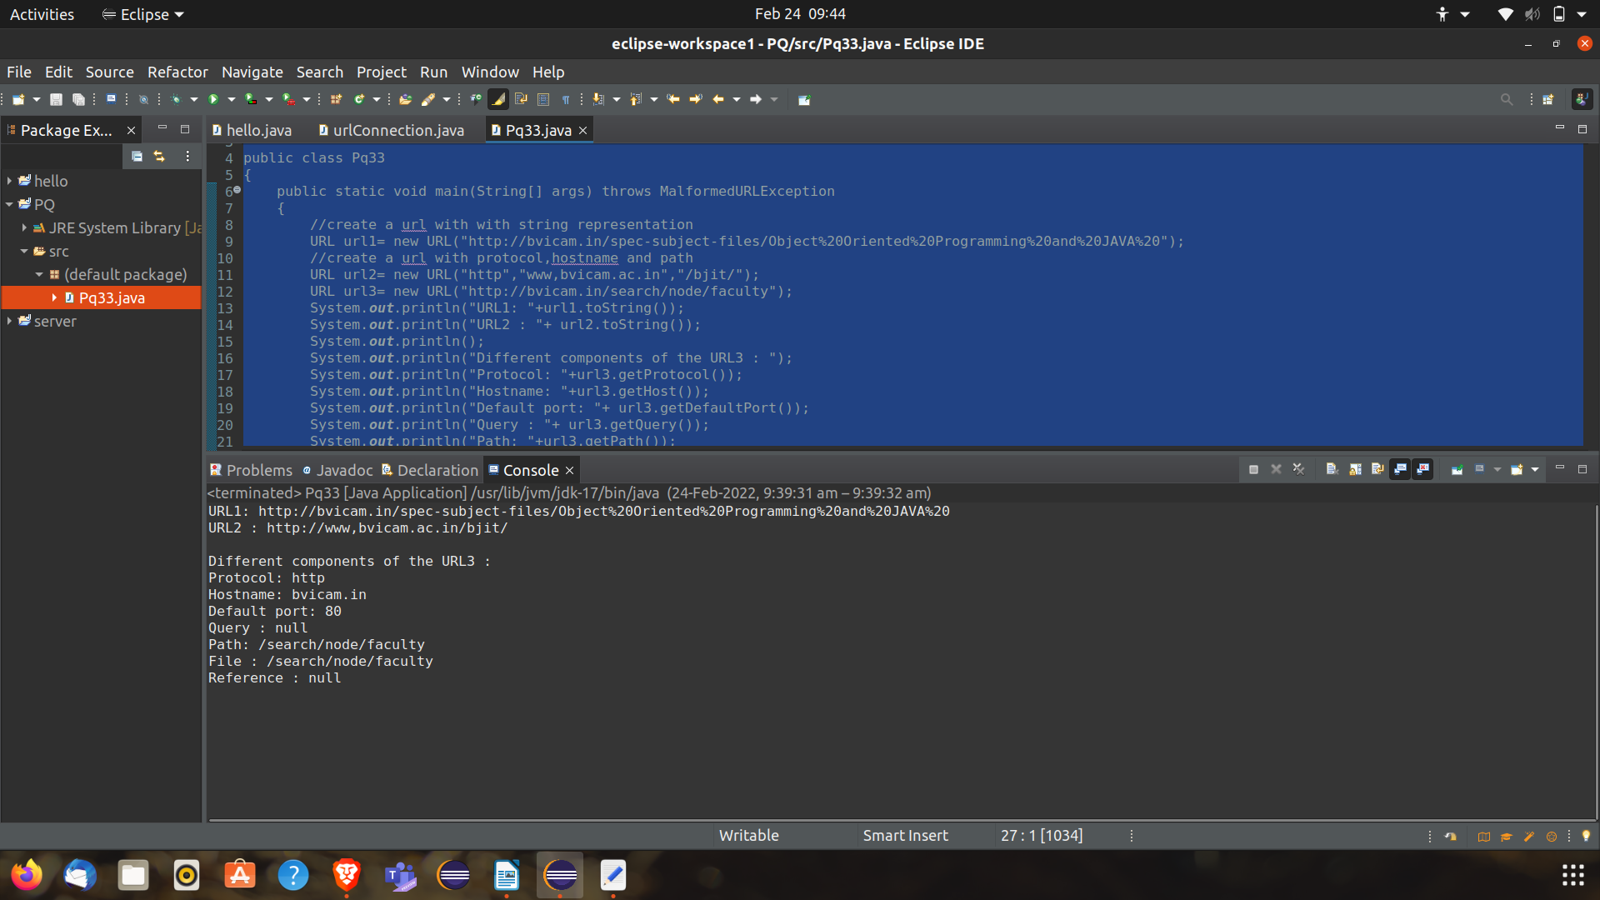

**PQ34:- Create a solution to implement a connection-less client and server?**

**Soln:-**

**import** java.net.*;

**public** **class** PQ34

{

// Specified server port

**public** **static** **int** *serverPort* = 998;

// Specified client port

**public** **static** **int** *clientPort* = 999;

**public** **static** **int** *buffer_size* = 1024;

**public** **static** DatagramSocket *ds*;

// an array of buffer_size

**public** **static** **byte** *buffer*[] = **new** **byte**[*buffer_size*];

// Function for server

**public** **static** **void** TheServer() **throws** Exception

{

**int** pos = 0;

**while** (**true**) { **int** c = System.***in***.read();

**switch** (c) {

**case** -1:

// -1 is given then server quits and returns

System.***out***.println("Server Quits.");

**return**;

**case** '\r':

**break**; // loop broken

**case** '\n':

// send the data to client

*ds*.send(**new** DatagramPacket(*buffer*, pos, InetAddress.*getLocalHost*(), *clientPort*));

pos = 0;

**break**;

**default**:

// otherwise put the input in buffer array

*buffer*[pos++] = (**byte**)c; } } }

// Function for client

**public** **static** **void** TheClient() **throws** Exception

{ **while** (**true**) {

// first one is array and later is its size

DatagramPacket p = **new** DatagramPacket(*buffer*, *buffer*.length);

*ds*.receive(p);

// printing the data which has been sent by the server

System.***out***.println(**new** String(p.getData(), 0, p.getLength())); } }

// main driver function

**public** **static** **void** main(String args[]) **throws** Exception

{ // if WriteServer 1 passed then this will run the server function

// otherwise client function will run

**if** (args.length == 1) {

*ds* = **new** DatagramSocket(*serverPort*);

*TheServer*(); }

**else**

{

*ds* = **new** DatagramSocket(*clientPort*); *TheClient*();

}

}

}

**PQ35:-   Create a solution to create a simple TCP/IP client-server where the server displays the message from the client till the client types “Over”?**

SOLN:- //client side code

import java.net.*;

import java.io.*;

public class PQ35_client {

private Socket socket = null;

private BufferedReader input = null;

private DataOutputStream out = null;

// constructor to put IP address and port

public PQ35_client(String address, int port)

{

// establish a connection

try

{

socket = new Socket(address,port);

System.out.println("Connected");

//takes input from terminal

input = new BufferedReader(new InputStreamReader(System.in));

//sends output to the socket

out = new DataOutputStream(socket.getOutputStream());

}

catch(UnknownHostException e)

{

System.out.println(e);

}

catch(IOException e)

{

System.out.println(e);

}

// string to read message from input

String line = "";

// keep reading until "Over" is input

while (!line.equals("Over"))

{

try

{

line = input.readLine();

out.writeUTF(line);

}

catch(IOException i)

{

System.out.println(i);

}

}

// close the connection

try

{

input.close();

out.close();

socket.close();

}

catch(IOException i)

{

System.out.println(i);

}

}

public static void main(String[] args)

{

PQ35_client client = new PQ35_client("localhost", 5000);

}

}

//server side code

import java.net.*;

import java.io.*;

public class PQ35_server

{

private Socket socket = null;

private ServerSocket server = null;

private DataInputStream in = null;

// constructor with port

public PQ35_server(int port)

{

//starts server and wait for a connection

try

{

server = new ServerSocket(port);

System.out.println("Server started");

System.out.println("Waiting for the client");

//accept() method blocks(just sits there) until a client connects to the server

socket = server.accept();

System.out.println("clinet accpeted");

// takes input from the client socket using getInputStream() method

in = new DataInputStream(new BufferedInputStream(socket.getInputStream()));

String line="";

//reads message from client "over" is sent

while(!line.equals("over"))

{

try

{

line = in.readUTF();

System.out.println(line);

}

catch(IOException e)

{

System.out.println(e);

}

}

System.out.println("Closing connection");

socket.close();

in.close();

}

catch(IOException i)

{

System.out.println(i);

}

}

public static void main(String[] args)

{

PQ35_server server = new PQ35_server(5000);

}

}

OUTPUT:-

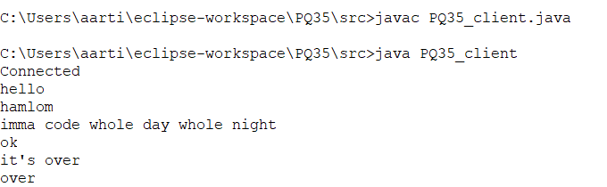

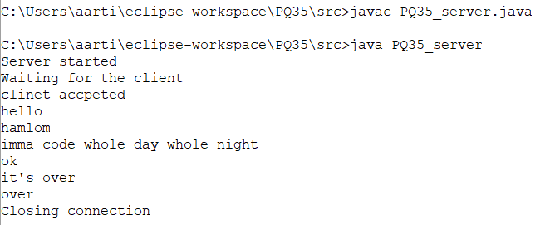

PQ36:- **File Name GreetingServer.java**

SOLN:- import java.net.*;

import java.io.*;

public class PQ36 extends Thread

{

private ServerSocket serverSocket;

public PQ36(int port) throws IOException

{

serverSocket = new ServerSocket(port);

serverSocket.setSoTimeout(10000);

}

public void run()

{

while(true)

{

try

{

System.out.println("Waiting for client on port " + serverSocket.getLocalPort() + "...");

Socket server = serverSocket.accept();

System.out.println("Just connected to " + server.getRemoteSocketAddress());

DataInputStream in = new DataInputStream(server.getInputStream());

System.out.println(in.readUTF());

DataOutputStream out = new DataOutputStream(server.getOutputStream());

out.writeUTF("Thank you for connecting to " + server.getLocalSocketAddress() + "\nGoodbye!");

server.close();

}

catch(SocketTimeoutException e)

{

System.out.println("Socket timed out!");

break;

}

catch (IOException e)

{

e.printStackTrace();

break;

}

}

}

public static void main(String[] args)

{

int port = Integer.parseInt(args[0]);

try

{

Thread t = new PQ36(port);

t.start();

}

catch(IOException e)

{

e.printStackTrace();

}

}

}

**OUTPUT:-**

**// I ran PQ35_client to get the data at port 5000**

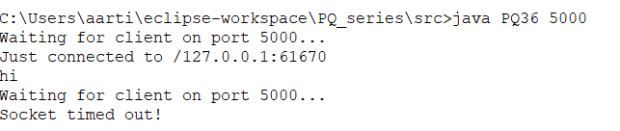

PQ 37: - **Example Program to Send and Receive a Message using Connectionless Sockets.**

Soln:-

//receiver

**import** java.net.*;

**import** java.io.*;

**public** **class** PQ37_receiver

{

**public** **static** **void** main(String[] args)

{

**try**

{

**int** max_len = 40;

**int** localPortNum = Integer.*parseInt*(args[0]);

DatagramSocket mySocket = **new** DatagramSocket(localPortNum);

**byte**[] buffer = **new** **byte**[max_len];

DatagramPacket packet = **new** DatagramPacket(buffer,max_len);

mySocket.receive(packet);

String message = **new** String(buffer);

System.***out***.println(message);

mySocket.close();

}

**catch**(Exception e)

{

e.printStackTrace( );

}

}

}

//sender

**import** java.net.*;

**import** java.io.*;

**public** **class** PQ37_sender

{

**public** **static** **void** main(String[] args)

{

**try**

{

InetAddress receiverHost = InetAddress.*getByName*(args[0]);

**int** receiverPort = Integer.*parseInt*(args[1]);

String message = args[2];

DatagramSocket mySocket = **new** DatagramSocket();

**byte**[] buffer = message.getBytes();

DatagramPacket packet = **new** DatagramPacket(buffer,buffer.length,receiverHost,receiverPort);

mySocket.send(packet);

mySocket.close();

}

**catch**(Exception e)

{

e.printStackTrace();

}

}

}

**FP1:- Create a solution to know the address and name of your local machine?**

**SOLN:-**

import java.io.*;

import java.net.InetAddress;

public class FP1

{

public static void main(String[] args) throws Exception

{

// a variable of type InetAddress to store the address of the local host

InetAddress address = InetAddress.*getLocalHost*();

//return the IP address string in textual presentation

System.*out*.println("Local Host Address: "+address.getHostAddress());

//get the host name for IP address

System.*out*.println("Local host name: "+ address.getHostName());

}

}

**OUTPUT:-**

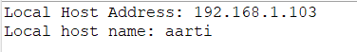

**FP2:- Create a solution to understand the different components of a URL?**

**SOLN:-**

**import** java.util.*;

//importing UL class

**import** java.net.URL;

**public** **class** FP2

{

**public** **static** **void** main(String[] args) **throws** Exception

{

URL url = **new** URL("https://leetcode.com/");

System.***out***.println("URL is : "+ url.toString());

System.***out***.println("protocol is: "+ url.getProtocol());

System.***out***.println("file name is: "+ url.getFile());

System.***out***.println("host is: " + url.getHost());

System.***out***.println("path is: " + url.getPath());

System.***out***.println("port is: " + url.getPort());

System.***out***.println("default port is: "+ url.getDefaultPort());

}

}

**OUTPUT:-**

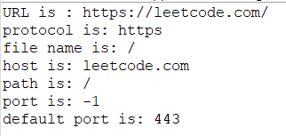

**FP3:- Create a connection-less client/server application using UDP protocol that sends system date and time in the format requested by the client.**

1. **Client: Reads a string representing the required format from the end-user**
2. **Server:returns the system date and time in the requested format or a default format if received format is not understandable**

SOLN:-

//client code

**import** java.net.*;

**import** java.util.Scanner;

**public** **class** FP3_client

{

**public** **static** **int** *serverPort*=3902;

**public** **static** DatagramSocket *ds*;

**public** **static** **void** main(String[] args) **throws** Exception

{

System.***out***.println("Client Started..");

System.***out***.println("Enter Date Format: ");

**var** scan =**new** Scanner(System.***in***);

**while**(**true**)

{

*ds* = **new** DatagramSocket();

String str=scan.nextLine();

**if**(str=="exit")

{

System.*exit*(0);

}

DatagramPacket p = **new** DatagramPacket(str.getBytes(), str.length(),InetAddress.*getLocalHost*(),*serverPort*);

*ds*.send(p);

}

}

}

//server code

**import** java.net.*;

**import** java.text.DateFormat;

**import** java.text.SimpleDateFormat;

**import** java.util.Date;

**class** FP3_server{

**public** **static** **int** *clientPort*=3901;

**public** **static** **int** *buffer_size* =1024;

**public** **static** **byte** *buffer*[] =**new** **byte**[*buffer_size*];

**public** **static** DatagramSocket *ds* ;

**public** **static** **void** main(String[] args) **throws** Exception{

System.***out***.println("server Strted..");

*ds* = **new** DatagramSocket(*clientPort*);

**while**(**true**){

DatagramPacket p = **new** DatagramPacket(*buffer*, *buffer*.length);

*ds*.receive(p);

// printing the data which has been sent by the server

String datepattern=**new** String(p.getData(), 0, p.getLength());

**if**(datepattern=="close"){

System.*exit*(0);

}

**try** {

DateFormat dateFormat = **new** SimpleDateFormat(datepattern);

Date date = **new** Date();

*println*(dateFormat.format(date));

} **catch** (Exception e) {

Date date = **new** Date();

*println*(date);

}

}

}

**public** **static** **void** println(Object line){

System.***out***.println(line);

}

}

OUTPUT:-

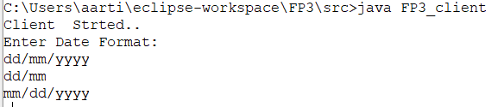

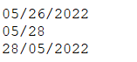

**FP4:- Client: Display the required contents. A connection-oriented client/server application using TCP/IP protocol where the client-server has the following responsibilities:**

1. **Server: Creates an Employee class having fields like employeeName, employeeID, and department. Server holds an array of employee objects.**
2. **Client : accepts the employeeID of an employee as an integer from the user.**
3. **Server:Searches for the corresponding employee object, in the array and writes its details to the client stream.**
4. **Client: displays the received object’s information.**

SOLN:-

//server side code

**import** java.net.*;

**import** java.io.*;

**class** Employee

{

**private** String EmpName;

**private** **int** EmpId;

**private** String EmpDept;

**public** Employee(String EmpName, **int** EmpId, String EmpDept)

{ **this**.EmpName = EmpName;

**this**.EmpId = EmpId;

**this**.EmpDept = EmpDept;

}

**public** String getEmpName()

{

**return** **this**.EmpName;

}

**public** **int** getEmpId()

{

**return** **this**.EmpId;

}

**public** String getEmpDept()

{ **return** **this**.EmpDept;

}

}

**class** FP4_server

{

**private** Socket socket = **null**; **private** ServerSocket server = **null**; **private** DataInputStream in = **null**;

**private** DataOutputStream out = **null**;

**public** FP4_server(**int** port)

{ String id = "";

**int** i = 0;

**try**

{

Employee[] empObj = **new** Employee[3];

empObj[0] = **new** Employee("Ram", 1, "IT");

empObj[1] = **new** Employee("Joker", 2, "Marketing");

empObj[2] = **new** Employee("shyamu", 3, "Sales");

server = **new** ServerSocket(port);

System.***out***.println("Server started");

socket = server.accept();

System.***out***.println("Client is now connected");

in = **new** DataInputStream(**new** BufferedInputStream(socket.getInputStream()));

out = **new** DataOutputStream(socket.getOutputStream());

id = in.readUTF();

i = Integer.*parseInt*(id);

**for** (**int** j = 0; j < empObj.length; j++)

{ **if** (empObj[j].getEmpId() == i)

{

**int** ids = empObj[j].getEmpId();

String empId = Integer.*toString*(ids);

String empName = empObj[j].getEmpName();

String empDept = empObj[j].getEmpDept();

String empInfo = "Emp Id = " + empId + "\n" + "Emp Name = " + empName + "\n" + "Emp Department = " + empDept;

out.writeUTF(empInfo); **break**;

}

}

in.close();

out.close();

socket.close();

}

**catch** (Exception e)

{

System.***out***.println("Exception found in TCPIPServer constructor" + e.getMessage());

}

}

**public** **static** **void** main(String[] args)

{ FP4_server server = **new** FP4_server(5000);

}

}

//client side code

**import** java.net.*;

**import** java.io.*;

**class** TCPIPClient{

**private** Socket socket = **null**;

**private** BufferedReader input = **null**;

**private** DataInputStream in = **null**;

**private** DataOutputStream out = **null**;

**public** TCPIPClient(String address, **int** port)

{ **try**

{

socket = **new** Socket(address,port);

System.***out***.println("Conncted with server");

input = **new** BufferedReader(**new** InputStreamReader(System.***in***));

out = **new** DataOutputStream(socket.getOutputStream());

in = **new** DataInputStream(socket.getInputStream());

}

**catch**(Exception e)

{

System.***out***.println("Exception in TCPIPClient found "+e.getMessage());

}

String id = "";

**try**

{

System.***out***.println("Enter employee id: "); id = input.readLine();

out.writeUTF(id);

}

**catch**(Exception e)

{

System.***out***.println("Exception in TCPIPClient user read value "+e.getMessage());

}

String empInfo = "";

**try**

{

empInfo = in.readUTF(); System.***out***.println(empInfo);

}

**catch**(Exception e)

{

System.***out***.println("Exception found in TCPIPClient empinfo "+e.getMessage());

}

**try**

{

in.close();

out.close(); input.close(); socket.close();

}

**catch**(Exception e)

{

System.***out***.println("Exception found in TCPIPClient closing "+e.getMessage());

}

}

**public** **static** **void** main(String[] args)

{

TCPIPClient client = **new** TCPIPClient("localhost",5000);

}

}

OUTPUT:-

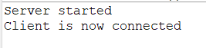

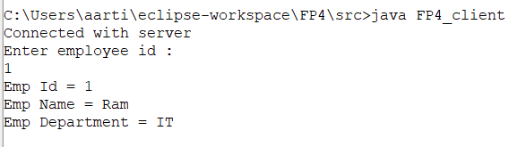

**FP5:- Create a calculator based client/server application where the client sends request to the server in the form of an arithmetic equation of the form “operand1 operator operator2”. The server should respond back to answer the equation?**

SOLN:-

//server side code

**import** java.io.DataInputStream;

**import** java.io.DataOutputStream;

**import** java.io.IOException;

**import** java.net.ServerSocket;

**import** java.net.Socket;

**import** java.util.StringTokenizer;

**public** **class** FP5_server

{

**public** **static** **void** main(String[] args) **throws** IOException

{

//step 1: Establish the socket connection

ServerSocket ss = **new** ServerSocket(4444);

Socket s = ss.accept();

//step 2: Processing the request

DataInputStream dis = **new** DataInputStream(s.getInputStream());

DataOutputStream dos = **new** DataOutputStream(s.getOutputStream());

**while**(**true**)

{

//wait for input

String input = dis.readUTF();

**if**(input.equals("bye"))

{

**break**;

}

System.***out***.println("Equation Received : "+input);

**int** result=0;

//use StringTokenizer to break the equation into operand and operation

StringTokenizer st = **new** StringTokenizer(input);

**int** operand1 = Integer.*parseInt*(st.nextToken());

String operation = st.nextToken();

**int** operand2 = Integer.*parseInt*(st.nextToken());

//perform the required operation

**if**(operation.equals("+"))

{

result = operand1 + operand2;

}

**else** **if**(operation.equals("-"))

{

result = operand1 - operand2;

}

**else** **if**(operation.equals("*"))

{

result = operand1 * operand2;

}

**else** **if**(operation.equals("/"))

{

result = operand1 / operand2;

}

System.***out***.println("Sending the result");

//send the result back to the client

dos.writeUTF(Integer.*toString*(result));

}

}

}

// client side code

**import** java.io.DataInputStream;

**import** java.io.DataOutputStream;

**import** java.io.IOException;

**import** java.net.InetAddress;

**import** java.net.Socket;

**import** java.net.UnknownHostException;

**import** java.util.Scanner;

**public** **class** FP5_client

{

**public** **static** **void** main(String[] args) **throws** IOException

{

InetAddress ip = InetAddress.*getLocalHost*();

**int** port = 4444;

Scanner sc = **new** Scanner(System.***in***);

//Step1: open the socket connection.

Socket s = **new** Socket(ip,port);

//step 2: communication - get the input and output stream

DataInputStream dis = **new** DataInputStream(s.getInputStream());

DataOutputStream dos = **new** DataOutputStream(s.getOutputStream());

**while**(**true**)

{

//Enter the equation in the form

//operand1 operation operand1

System.***out***.println("Enter the equation in the form");

System.***out***.println("operand1 operation operand1");

String inp = sc.nextLine();

**if**(inp.equals("bye"))

**break**;

//send the equation to the server

dos.writeUTF(inp);

//wait till request is processed and sent back to client

String ans = dis.readUTF();

System.***out***.println("Answer : "+ ans);

}

}

}

OUTPUT:-

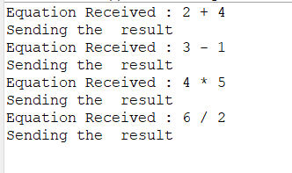

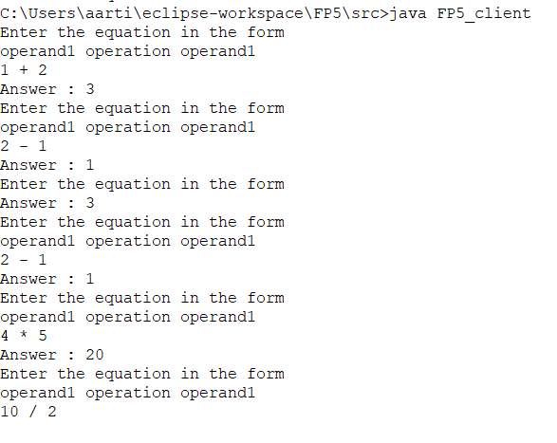

***GP1:- create a class called fruits that has a method mango() that tells if the mango is sweet or sour. Suppose we need a sour mango in taste for only 1 time. Realize this temporary requirement through an anonymous inner class?***

***SOLN:-***

**class** Fruits

{

**void** mango()

{

System.***out***.println("Mango is sweet");

}

**void** apple()

{

System.***out***.println("Apple is sweet");

}

**void** orange()

{

System.***out***.println("Orange is sour");

}

**void** grapes()

{

System.***out***.println("Grapes are sour");

}

}

**class** Taste

{

**void** taste()

{

Fruits f1 = **new** Fruits(){

**void** mango()

{

System.***out***.println("Mango is sour");

}

};

f1.mango();

}

}

**class** GP1

{

**public** **static** **void** main(String[] args)

{

Taste t1 = **new** Taste();

t1.taste();

}

}

OUTPUT:-

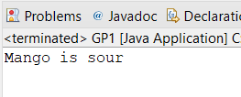

**GP2:- Create a class AWTCounter that starts a counter from 0 and increments its value on every button click?**

**SOL:-**

**import** java.awt.*; // Using AWT container and component classes

**import** java.awt.event.*; // Using AWT event classes and listener interfaces

// An AWT program inherits from the top-level container java.awt.Frame

**public** **class** GP2 **extends** Frame {

**private** Label lblCount; // Declare a Label component

**private** TextField tfCount; // Declare a TextField component

**private** Button btnCount; // Declare a Button component

**private** **int** count = 0; // Counter's value

// Constructor to setup GUI components and event handlers

**public** GP2 () {

setLayout(**new** FlowLayout());

// "super" Frame, which is a Container, sets its layout to FlowLayout to arrange

// the components from left-to-right, and flow to next row from top-to-bottom.

lblCount = **new** Label("Counter"); // construct the Label component

add(lblCount); // "super" Frame container adds Label component

tfCount = **new** TextField(count + "", 10); // construct the TextField component with initial text

tfCount.setEditable(**false**); // set to read-only

add(tfCount); // "super" Frame container adds TextField component

btnCount = **new** Button("Count"); // construct the Button component

add(btnCount); // "super" Frame container adds Button component

BtnCountListener listener = **new** BtnCountListener();

btnCount.addActionListener(listener);

// "btnCount" is the source object that fires an ActionEvent when clicked.

// The source object adds an instance of BtnCountListener as an ActionEvent listener,

// which provides an ActionEvent handler called actionPerformed().

// Clicking "Count" button calls back actionPerformed().

setTitle("AWT Counter"); // "super" Frame sets its title

setSize(300, 100); // "super" Frame sets its initial window size

// For inspecting the Container/Components objects

// System.out.println(this);

// System.out.println(lblCount);

// System.out.println(tfCount);

// System.out.println(btnCount);

setVisible(**true**); // "super" Frame shows

// System.out.println(this);

// System.out.println(lblCount);

// System.out.println(tfCount);

// System.out.println(btnCount);

}

// The entry main() method

**public** **static** **void** main(String[] args) {

// Invoke the constructor to setup the GUI, by allocating an instance

GP2 app = **new** GP2();

// or simply "new AWTCounter();" for an anonymous instance

}

// Define an inner class to handle the "Count" button-click

**private** **class** BtnCountListener **implements** ActionListener {

// ActionEvent handler - Called back upon button-click.

@Override

**public** **void** actionPerformed(ActionEvent evt) {

++count; // Increase the counter value

// Display the counter value on the TextField tfCount

tfCount.setText(count + ""); // Convert integer to String

}

}

}

OUTPUT:-

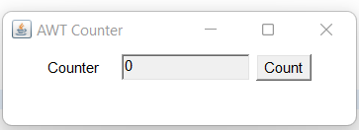

GP3:- Create the following layout using awt/swing

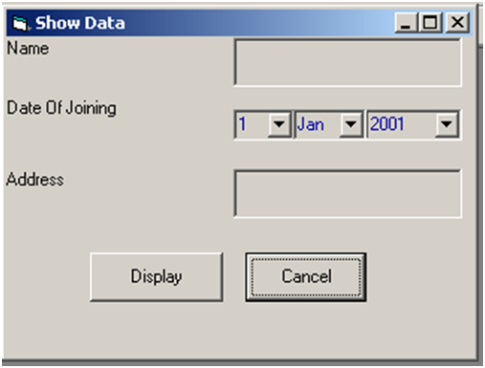

When user clicks the “Display” button the data entered by the user should be displayed in another frame window.

When user clicks the “Cancel” button the data fields should get cleared.

SOLN:-

import java.awt.*;

import java.awt.event.*;

public class GP3_AwtForm extends Frame implements ActionListener{

TextField firstNameTF;

TextField lastNameTF;

TextField dobTF;

GP3_AwtForm(){

setSize(300,300);

setLayout(null);

setVisible(true);

setTitle("AWT Form");

addWindowListener (new WindowAdapter() {

public void windowClosing (WindowEvent e) {

dispose();

}

});

Label firstName = new Label("First Name");

firstName.setBounds(20, 50, 80, 20);

Label lastName = new Label("Last Name");

lastName.setBounds(20, 80, 80, 20);

Label dob = new Label("Date of Birth");

dob.setBounds(20, 110, 80, 20);

firstNameTF = new TextField();

firstNameTF.setBounds(120, 50, 100, 20);

lastNameTF = new TextField();

lastNameTF.setBounds(120, 80, 100, 20);

dobTF = new TextField();

dobTF.setBounds(120, 110, 100, 20);

Button sbmt = new Button("Submit");

sbmt.setBounds(20, 160, 80, 30);

sbmt.addActionListener(

new ActionListener() {

public void actionPerformed(ActionEvent e) {

String fnString = firstNameTF.getText();

String lnString = lastNameTF.getText();

String dobString = dobTF.getText();

GP3_AwtForm awt2 = new GP3_AwtForm(fnString, lnString, dobString);

}

}

);

Button reset = new Button("Reset");

reset.setBounds(140,160,80,30);

reset.addActionListener(

new ActionListener() {

public void actionPerformed(ActionEvent e) {

firstNameTF.setText(null);

lastNameTF.setText(null);

dobTF.setText(null);

}

}

);

add(firstName);

add(lastName);

add(dob);

add(firstNameTF);

add(lastNameTF);

add(dobTF);

add(sbmt);

add(reset);

}

GP3_AwtForm(String fnString, String lnString, String dobString){

setSize(300,300);

setLayout(null);

setVisible(true);

setTitle("AWT Form Display");

addWindowListener (new WindowAdapter() {

public void windowClosing (WindowEvent e) {

dispose();

}

});

Label displayFirst = new Label("First Name: ");

displayFirst.setBounds(20, 50, 80, 20);

Label displayFName = new Label(fnString);

displayFName.setBounds(100, 50, 80, 20);

Label displayLast = new Label("Last Name: ");

displayLast.setBounds(20, 80, 80, 20);

Label displayLName = new Label(lnString);

displayLName.setBounds(100, 80, 80, 20);

Label displayDob = new Label("Date of Birth: ");

displayDob.setBounds(20, 110, 80, 20);

Label displayDobS = new Label(dobString);

displayDobS.setBounds(100, 110, 80, 20);

add(displayFirst);

add(displayFName);

add(displayLast);

add(displayLName);

add(displayDob);

add(displayDobS);

}

@Override

public void actionPerformed(ActionEvent evt) {}

public static void main(String[] args) {

GP3_AwtForm awt = new GP3_AwtForm();

}

}

OUTPUT:-

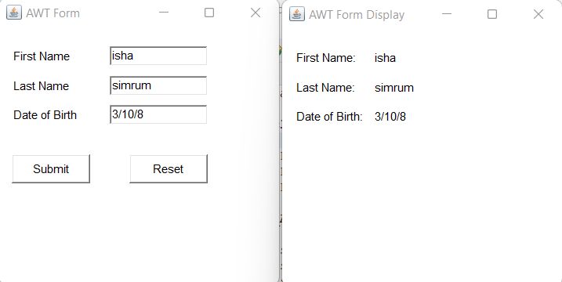

**GP4:- Create a class MessageBox that extends Frame. The class should have a constructor that takes a String as a parameter to construct a dialog box that displays the message and OK & CANCEL buttons. The dialog box should get closed when the cancel buttons is clicked. Provide some mechanism in the MessageBox class that can be used by the calling program to check which button was pressed by the user. The class should have functions to:**

**a) Check which button was pressed by the user.**

**b) Retrieve the string entered by the user, if user pressed OK, null if user pressed CANCEL.**

**Test this class to get a message from a user and display it on a Frame window.**

SOLN:-

**import** java.awt.*;

**import** java.awt.event.*;

**public** **class** GP4_messageBox {

**private** **static** Dialog *d*;

**private** **static** **int** *c*;

GP4_messageBox(String str) {

Frame f= **new** Frame();

f.setVisible(**false**);

*d* = **new** Dialog(f , "Message Box", **false**);

*d*.setLayout( **new** FlowLayout() );

*d*.setSize(400,150);

*d*.setVisible(**true**);

Button ok = **new** Button ("OK");

Button cancel = **new** Button ("Cancel");

TextField message = **new** TextField();

message.setText(str);

*d*.add(message);

*d*.add(ok);

*d*.add(cancel);

ok.addActionListener (

**new** ActionListener() {

**public** **void** actionPerformed( ActionEvent e ) {

Frame s = **new** Frame();

s.setSize(300,300);

s.setLayout(**null**);

s.setVisible(**true**);

s.setTitle("Message Display");

Label lbl = **new** Label("User Pressed Okay. Message:-");

lbl.setBounds(20, 80, 500, 30);

s.add(lbl);

Label display = **new** Label(message.getText());

display.setBounds(20, 120, 100, 30);

s.add(display);

s.addWindowListener (**new** WindowAdapter() {

**public** **void** windowClosing (WindowEvent e) {

s.dispose();

}

});

}

}

);

cancel.addActionListener (

**new** ActionListener() {

**public** **void** actionPerformed( ActionEvent e ) {

System.***out***.println("User Pressed CANCEL Button");

System.***out***.println("GUI Closed");

*d*.dispose();

f.dispose();

}

}

);

}

**public** **static** **void** main(String args[]) {

**new** GP4_messageBox("Hello");

**if**(*c* == 1){

}

}

}

OUTPUT:-

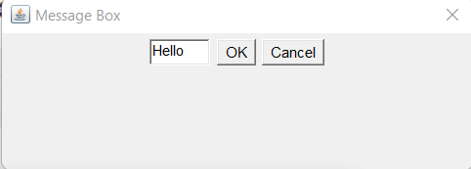

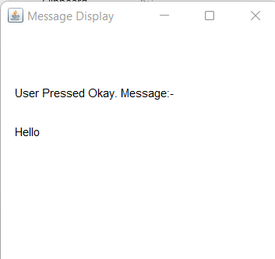

**GP5:- Use AWT /Swings to develop a Contact Manager. The GUI application maintains a simple list of contacts storing contact name and number. It provides basic features of CRUD (Create, Update, Retrieve and Delete) as per user choice. The application also supports search feature.**

**SOLN:-**

//(Only Front End)

**import** javax.swing.*;

**import** java.awt.event.*;

**import** java.util.ArrayList;

**class** Contact{

**private** String Name, Mobile;

Contact(String Name, String Mobile){

**this**.Name = Name;

**this**.Mobile = Mobile;

}

**public** String toString(){

**return** Name+ " "+ Mobile;

}

**public** String getName(){

**return** **this**.Name;

}

}

**public** **class** GP5_contact {

ArrayList<Contact> ContactList = **new** ArrayList<>();

**public** GP5_contact(){

JFrame f=**new** JFrame();

f.setSize(350,350);

f.setLayout(**null**);

f.setVisible(**true**);

f.setTitle("Contact Manager");

f.addWindowListener (**new** WindowAdapter() {

**public** **void** windowClosing (WindowEvent e) {

f.dispose();

}

});

JLabel lbl = **new** JLabel("Contact Manager App");

lbl.setBounds(100, 60, 150, 30);

JButton c = **new** JButton("Create");

c.setBounds(60, 120, 100, 30);

JButton r = **new** JButton("Retrieve");

r.setBounds(170, 120, 100, 30);

JButton u = **new** JButton("Update");

u.setBounds(60, 160, 100, 30);

JButton d = **new** JButton("Delete");

d.setBounds(170, 160, 100, 30);

JButton all = **new** JButton("Display all Contacts");

all.setBounds(65, 200, 200, 30);

f.add(lbl); f.add(c); f.add(r); f.add(u); f.add(d); f.add(all);

c.addActionListener (

**new** ActionListener() {

**public** **void** actionPerformed( ActionEvent e ) {

JFrame f=**new** JFrame();

f.setSize(300,300);

f.setLayout(**null**);

f.setVisible(**true**);

f.setTitle("Create");

f.addWindowListener (**new** WindowAdapter() {

**public** **void** windowClosing (WindowEvent e) {

f.dispose();

}

});

JLabel name = **new** JLabel("Name: ");

name.setBounds(20, 70, 70, 30);

JLabel mobile = **new** JLabel("Mobile No: ");

mobile.setBounds(20, 110, 70, 30);

JTextField nameTF = **new** JTextField();

nameTF.setBounds(100, 70, 100, 30);

JTextField mobileTF = **new** JTextField();

mobileTF.setBounds(100, 110, 100, 30);

JButton sbmt = **new** JButton("Submit");

sbmt.setBounds(70, 150, 120, 30);

f.add(name); f.add(mobile); f.add(nameTF); f.add(mobileTF); f.add(sbmt);

sbmt.addActionListener (

**new** ActionListener() {

**public** **void** actionPerformed( ActionEvent e ) {

ContactList.add(**new** Contact(nameTF.getText(), mobileTF.getText()));

f.dispose();

}

}

);

}

}

);

r.addActionListener (

**new** ActionListener() {

**public** **void** actionPerformed( ActionEvent e ) {

JFrame f=**new** JFrame();

f.setSize(300,300);

f.setLayout(**null**);

f.setVisible(**true**);

f.setTitle("Retrieve");

f.addWindowListener (**new** WindowAdapter() {

**public** **void** windowClosing (WindowEvent e) {

f.dispose();

}

});

}

}

);

u.addActionListener (

**new** ActionListener() {

**public** **void** actionPerformed( ActionEvent e ) {

JFrame f=**new** JFrame();

f.setSize(300,300);

f.setLayout(**null**);

f.setVisible(**true**);

f.setTitle("Update");

f.addWindowListener (**new** WindowAdapter() {

**public** **void** windowClosing (WindowEvent e) {

f.dispose();

}

});

}

}

);

d.addActionListener (

**new** ActionListener() {

**public** **void** actionPerformed( ActionEvent e ) {

JFrame f=**new** JFrame();

f.setSize(300,300);

f.setLayout(**null**);

f.setVisible(**true**);

f.setTitle("Delete");

f.addWindowListener (**new** WindowAdapter() {

**public** **void** windowClosing (WindowEvent e) {

f.dispose();

}

});

JLabel lbl = **new** JLabel("Enter the Contact name to delete: ");

lbl.setBounds(20, 50, 150, 30);

JTextField TF = **new** JTextField();

TF.setBounds(40, 90, 70, 30);

JButton dl = **new** JButton("Delete Contact");

dl.setBounds(60, 130, 80, 30);

f.add(lbl); f.add(TF); f.add(dl);

}

}

);

all.addActionListener (

**new** ActionListener() {

**public** **void** actionPerformed( ActionEvent e ) {

JFrame f=**new** JFrame();

f.setSize(300,300);

f.setLayout(**null**);

f.setVisible(**true**);

f.setTitle("Contact List");

f.addWindowListener (**new** WindowAdapter() {

**public** **void** windowClosing (WindowEvent e) {

f.dispose();

}

});

**for** (**int** i=0; i<ContactList.size(); i++) {

JLabel dl = **new** JLabel((ContactList.get(i)).toString());

dl.setBounds(20, 80+i*20, 100, 15);

f.add(dl);

}

}

} );

}

**public** **static** **void** main(String[] args) {

**new** GP5_contact();

}

}

OUTPUT:-

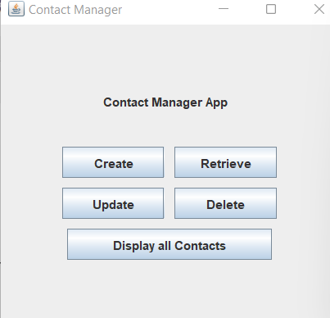 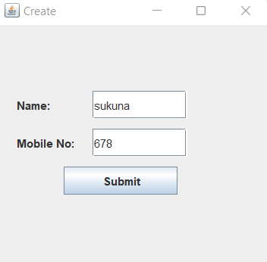

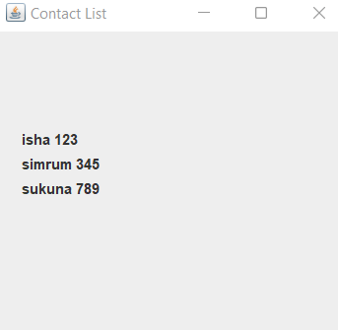 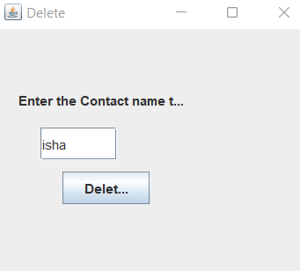

**GP6:- Create a class MyTextEditor to simulate a notepad using Swings?**

**SOLN:-**

**import** javax.swing.*;

**import** java.awt.event.*;

**public** **class** GP6_textEditor **extends** JFrame **implements** ActionListener {

JFrame f = **new** JFrame("Text Editor");

JMenuBar m = **new** JMenuBar();

JTextArea t = **new** JTextArea();

GP6_textEditor() {

JMenu m1 = **new** JMenu("File");

JMenu m2 = **new** JMenu("Edit");

m.add(m1);

m.add(m2);

JMenuItem m11 = **new** JMenuItem("new");

JMenuItem m12 = **new** JMenuItem("close");

JMenuItem m21 = **new** JMenuItem("cut");

JMenuItem m22 = **new** JMenuItem("copy");

JMenuItem m23 = **new** JMenuItem("paste");

m1.add(m11);

m1.add(m12);

m2.add(m21);

m2.add(m22);

m2.add(m23);

m11.addActionListener(**this**);

m12.addActionListener(**this**);

m21.addActionListener(**this**);

m22.addActionListener(**this**);

m23.addActionListener(**this**);

f.setSize(500, 500);

f.setVisible(**true**);

f.setJMenuBar(m);

f.add(t);

f.addWindowListener (**new** WindowAdapter() {

**public** **void** windowClosing (WindowEvent e) {

f.dispose();

}

});

}

**public** **void** actionPerformed(ActionEvent e) {

String s = e.getActionCommand();

**if** (s.equals("new")) {

t.setText("");

}

**else** **if** (s.equals("close")) {

f.dispose();

}

**else** **if** (s.equals("cut")) {

t.cut();

}

**else** **if** (s.equals("copy")) {

t.copy();

}

**else** **if** (s.equals("paste")) {

t.paste();

}

}

**public** **static** **void** main(String args[]) {

**new** GP6_textEditor();

}

}

**OUTPUT:-**

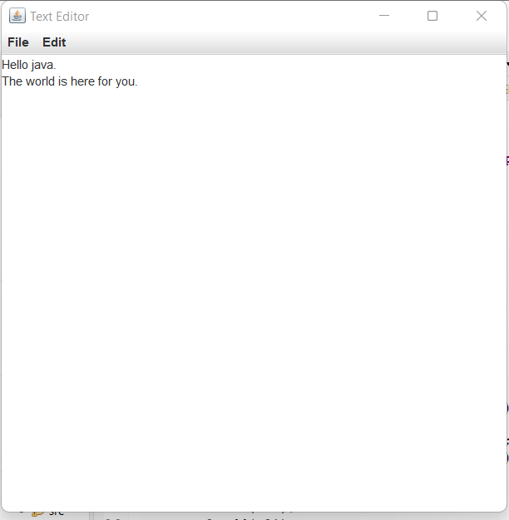

***Assignment H: java.io, JDBC, RMI***

**HP1:- A String tokenizer application to store the input string contents in a file. Read the file and count vowels, consonants and spaces in each line. Create another file to write the vowel and consonant count besides each line. For eg:- Hi this is java(vowels-5, consonents-7, spaces- 3). I like studying it(vowels-6, consonants-9, spaces-4). Perform this operation using:**

**a) BufferedReader and BufferedWriter**

**b) FileReader and FileWriter**

**SOLN:-**

**import** java.io.*;

**public** **class** HP1_files {

**public** **void** readVCS(){

BufferedWriter bw = **null**;

BufferedReader br = **null**;

String line = **null**;

**char** ch =' ';

**int** consonants = 0, vowels = 0, spaces = 0;

**try** {

//creating object to read from initial file

br = **new** BufferedReader(**new** FileReader("test.txt"));

//creating object to write output in another file

bw = **new** BufferedWriter(**new** FileWriter("test2.txt", **true**));

//reading text from file

**while**((line = br.readLine())!= **null**){

**for**(**int** i=0; i<line.length(); i++){

ch = line.charAt(i);

**if**(ch=='a' ||ch=='e' ||ch=='i' ||ch=='o' ||ch=='u' ||

ch=='A' ||ch=='E' ||ch=='I' ||ch=='O' ||ch=='U'){

vowels++;

}

**else** **if**(ch==' '){

spaces++;

}

**else**{

consonants++;

}

}

//printing output to console

System.***out***.println("Line:- '"+ line+ "'");

System.***out***.println("Vowels: "+ vowels);

System.***out***.println("Consonants: "+ consonants);

System.***out***.println("Spaces: "+ spaces);

System.***out***.println("---------------------------------");

**try** {

//writing output to second file

bw.write("Line:- '"+ line+ "'");

bw.write("\nVowels: "+ vowels);

bw.write("\nConsonants: "+ consonants);

bw.write("\nSpaces: "+ spaces);

bw.write("\n---------------------------------");

} **catch** (Exception e) {

System.***out***.println("bw:- "+ e);

}

vowels = 0; consonants = 0; spaces = 0;

}

br.close();

bw.close();

} **catch** (Exception e) {

System.***out***.println("br:- "+ e);

}

}

**public** **static** **void** main(String[] args) {

HP1_files st = **new** HP1_files();

st.readVCS();

}

}

OUTPUT:-

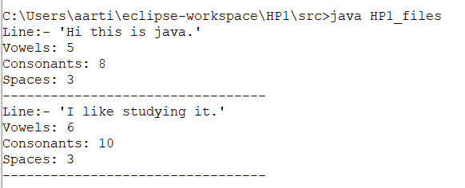

**HP2:- A File Parser a file and store the following text in it-**

**“Dwelling and speedily ignorant any steepest. Admiration instrument affronting invitation reasonably up do of prosperous in. Shy saw declared age debating ecstatic man. Call in so want pure rank am dear were. Remarkably to continuing in surrounded diminution on. In unfeeling existence objection immediate repulsive on he in. Imprudence comparison uncommonly me he difficulty diminution resolution. Likewise proposal differed scarcely dwelling as on raillery. September few dependent extremity own continued and ten prevailed attending. Early to weeks we could.**

**Unpleasant astonished an diminution up partiality. Noisy an their of meant. Death means up civil do an offer wound of. Called square an in afraid direct. Resolution diminution conviction so mr at unpleasing simplicity no. No it as breakfast up conveying earnestly immediate principle. Him son disposed produced humoured overcame she bachelor improved. Studied however out wishing but inhabit fortune windows.”**

**Accept a SearchToken from the user. Open the file and read it using RandomFileAccess and search and display total occurrences of the search string in given text.**

**SOLN:-**

**import** java.util.Scanner;

**import** java.io.*;

**public** **class** HP2 {

**public** **void** searchToken(){

**int** count = 0;

String line = **null**;

Scanner input = **new** Scanner(System.***in***);

System.***out***.println("\nProgram to search a word in file (case sensitive)");

System.***out***.print("\nEnter a word to search in the file: ");

String word = input.nextLine();

input.close();

**try** {

RandomAccessFile raf = **new** RandomAccessFile(**new** File("HP2.txt"),"r");

//reading text from file

**while**((line = raf.readLine())!= **null**){

String words[] = line.split(" ");

**for**(String a:words){

**if**(a.equals(word) || a.equals(word+".")){

count++;

}

}

}

System.***out***.println("\nTotal occurence of '"+ word+ "' : "+ count);

} **catch** (Exception e) {

System.***out***.println("br:- "+ e);

}

}

**public** **static** **void** main(String[] args) {

HP2 fp = **new** HP2();

fp.searchToken();

}

}

OUTPUT:-

